
Ain Shams University – Faculty of Engineering
CSE245: Design and Analysis of Algorithm
Team Project – Algorithms Research

Members
Name | ID
Arsany Hany Anwar | 2200655
Andrew Ehab Tharwat | 2200249
Hazem Mohamed Salah ElDin | 2300774
Maria Karam Albert | 2200593
Ziad Ahmed Orabi | 2200399
Marten Amgad Zakaria | 2200751
Mathew Mina Youssef Aziz | 2300910
Hanya Ibrahim Aref | 2201045
Julia Nasser Mosaad | 2200760

Table of Contents
Members ii
1. Introduction 1
1. Sorting Trominoes 2
1.1 Problem description 2
1.2 Assumptions 2
1.3 Methodology 3
1.3.1 Approach 1: Divide and Conquer 3
1.3.2 Approach 2: Brute Force 3
1.4 Pseudocode 4
1.5 Implementation code 6
1.5.1 Divide and Conquer code 6
1.5.2 Brute Force code 16
1.6 Test cases 23
1.6.1 Output of 4 x 4 board 23
1.6.2 Output of 16 x 16 board 24
1.7 Time and space complexity study 26
1.7.1 Divide and Conquer: 26
1.7.2 Brute Force: 26
1.8 Comparative evaluation 26
1.9 Alternative approaches 28
1.10 Summary 28
2. Knight’s Tour Problem 29
2.1 Background 29
2.2 Task statement 30
2.3 Implemented features 30
2.4 Comprehensive description 31
2.5 Problem solution 32
2.5.1 Methodology 32
2.5.2 Pseudocode 33
2.5.3 Implementational code 34
2.6 Algorithm analysis 37
2.7 Answers to task questions 37
2.8 Sample outputs 39
2.9 Alternative solutions 42
2.10 Key findings and insights 42
3. Introduction 43
3.1 Underlying assumptions 43
3.2 Problem description 44
3.2.1 Classical Three-Peg Tower of Hanoi 44
3.2.2 The Four-Peg Extension 44
3.2.3 Does DP Solve It in 33 Moves? 44
3.3 Algorithmic Techniques 45
3.3.1 Technique 1: Dynamic Programming (Frame-Stewart) 45
3.3.2 Technique 2: Brute-Force Breadth-First Search (BFS) 48
3.3.3 Technique 3: A* search with heuristics 51
3.3.4 Technique 4: Classical Divide and Conquer (Three-Peg Recursion) 53
3.3.5 Technique 5: IDA* (Iterative Deepening A*) 55
3.4 Solution description 58
3.4.1 Complete pseudocode 58
3.4.2 Java implementation 60
3.5 Sample outputs and explanations 62
3.5.1 Dynamic Programming table (n = 1 to 12) 62
3.5.2 Complete 33-move sequence for 8 disks 63
3.5.3 Representative console output 65
3.6 Complexity analysis 66
3.6.1 Summary complexity table 66
3.7 Comparative evaluation of all techniques 68
3.7.1 Master comparison table 68
3.7.2 Failure analysis table 69
3.7.3 Conclusion 70
3.8 Key findings and insights 71
4. Knight Swap 72
4.1 Problem description 72
4.1.1 What is the Knight Swap Puzzle? 72
4.1.2 Initial and goal states 72
4.1.3 Movement rules 73
4.1.4 Challenges 73
4.2 Assumptions 74
4.3 Solution methodology 75
4.3.1 Algorithm choice: BFS 75
4.3.2 State representation 75
4.3.3 Methodology 75
4.3.4 Data structures used 76
4.4 Pseudocode 77
4.5 Implementation code 80
4.5.1 Constants and board definitions 80
4.5.2 BoardState struct 80
4.5.3 findAllNextMoves() 81
4.5.4 solveWithBFS() 82
4.6 Time and space complexity analysis 84
4.6.1 State space size 84
4.6.2 Time complexity 84
4.6.3 Space complexity 85
4.7 Comparative evaluation of techniques 86
4.8 Sample output 87
4.9 Key findings and insights 91
5. Moving Target 92
5.1 Problem description 92
5.2 Assumptions 92
5.3 Methodology 93
5.3.1 Key insight 93
5.3.2 Step-by-Step description 93
5.4 Pseudocode 94
5.5 Implementation code 95
5.6 Test cases 97
5.6.1 Test cases where the technique succeeds 97
5.6.2 Test Cases Where the Technique Fails 98
5.7 Complexity analysis 100
5.7.1 Time complexity 100
5.7.2 Space complexity 100
5.8 Alternative Approaches 102
5.8.1 Decrease and Conquer 102
5.8.2 Random Shooting 102
5.8.3 Brute Force / Exhaustive Search 102
5.8.4 Advantages of Divide and Conquer over other techniques 103
5.8.5 Disadvantages of Divide and Conquer 103
5.8.6 Possible improvements to the Divide-and-Conquer technique 103
5.9 Sample outputs 105
5.9.1 Sample output for n = 4 105
5.9.2 Sample output for n = 5 105
5.9.3 Sample Output for n = 8 106
5.10 Summary and key findings 107
6. Lattice Crossing 108
6.1 Abstract 108
6.2 Assumptions 109
6.2.1 Lattice definition 109
6.2.2 Segment rules 109
6.2.3 Connected-Path constraint 109
6.2.4 Problem scope 110
6.2.5 Candidate Endpoint Set (DP Approach) 110
6.2.6 Coordinate Convention 110
6.3. Problem Description 111
6.3.1 Formal Statement 111
6.3.2 Origin and Motivation 111
6.3.3 2n-2 lines 111
6.4. Technique 1: Dynamic Programming with Backtracking 113
6.4.1 Abstract 113
6.4.2 Methodology 113
6.4.3 Pseudocode 114
6.4.4 Implementation code (C++) 115
6.4.5 Advantages of DP + Backtracking 125
6.4.6 Disadvantages of DP + Backtracking 125
6.4.7 Failure cases and enhancements 126
6.5 Technique 2: Geometric Spiral Construction 127
6.5.1 Abstract 127
6.5.2 Methodology 127
6.5.3 Pseudocode 128
6.5.4 Implementation code (C++) 130
6.5.5 Advantages 138
6.5.6 Disadvantages 138
6.5.7 Failure cases 139
6.6 Time and space complexity analysis 140
6.6.1 DP + Backtracking 140
6.6.2 Geometric Construction 141
6.7 Alternative techniques 142
6.7.1 Pure Backtracking 142
6.7.2 Greedy algorithm 142
6.7.3 Breadth-First Search (BFS) 143
6.7.4 Recursive Frame Decomposition 143
6.8 Comparative Evaluation of Techniques 144
6.9 Sample output and explanations 145
6.9.1 DP Solution for n = 3 145
6.9.2 DP Solution for n = 4 145
6.9.3 Geometric solution for n = 5 (Odd) 146
6.9.4 Geometric solution for n = 4 (Even) 147
6.10 Summary and key findings 148
7. Job Scheduling 149
7.1 Problem description 149
7.2 Assumptions 149
7.3 Brute-Force Algorithm 150
7.3.1 Methodology 150
7.3.2 Step-by-Step description 150
7.3.3 Pseudocode 151
7.3.4 Implementation 152
7.3.5 Test cases 155
7.3.6 Complexity analysis 157
7.4. Divide and Conquer algorithm 158
7.4.1 Methodology 158
7.4.2 Step-by-Step Description 158
7.4.3 Pseudocode 159
7.4.4 Implementation 161
7.4.5 Test Cases 165
7.4.6 Complexity Analysis 167
7.5 Dynamic Programming algorithm 168
7.5.1 Methodology 168
7.5.2 Step-by-Step description 168
7.5.3 Pseudocode 169
7.5.4 Implementation 171
7.5.5 Test cases 176
7.5.6 Complexity analysis 178
7.6 Technique comparison 179
7.7 Alternative approaches 180
7.7.1 Greedy – Earliest Deadline First (EDF) 180
7.7.2 Branch-and-Bound 180
7.7.3 Approximation algorithms 180
7.8 Summary 181
8. Minimum Cut 182
8.1 Assumptions 182
8.1.1 Graph model assumptions 182
8.1.2 Weight assumptions 182
8.1.3 Cut definition assumption 182
8.1.4 Objective function assumptions 183
8.1.5 Input/Output and indexing assumptions 183
8.1.6 Algorithmic scope assumptions 184
8.1.7 Randomization and reproducibility assumptions 184
8.2 Problem description 185
8.2.1 Problem statement 185
8.2.2 Challenges 185
8.2.3 Required output 186
8.3 Methodology and solutions 187
8.4 Brute Force 187
8.4.1 Step-by-Step methodology 187
8.4.2 Brute Force pseudocode 188
8.4.3 Worked example 189
8.4.4 Time and space complexity 191
8.5 Iterative Improvement 192
8.5.1 Solution representation 192
8.5.2 Neighborhood structure 192
8.5.3 Delta for flipping one vertex 193
8.5.4 Best-Improvement strategy 194
8.5.5 Multi-Start strategy 194
8.5.6 Step-by-Step methodology (Iterative Improvement + Multi-Start) 194
8.5.7 Iterative Improvement pseudocode 195
8.5.8 Worked example 196
8.5.9 Notes on limitations 200
8.5.10 Time and space complexity 201
8.6 Implementation details 202
8.6.1 Implementation overview 202
8.6.2 Data structures 202
8.6.3 Helper functions 203
8.6.4 Implementation code 203
8.6.5 Notes 213
8.7 Comparative evaluation 214
8.7.1 Evaluation criteria 214
8.7.2 Experimental setup 214
8.7.3 Comparative results on sample graphs 215
8.7.4 Interpretation and scalability discussion 216
8.8 Alternative approaches 217
8.8.1 Exact Global Minimum Cut in Undirected Graphs (Stoer–Wagner) 217
8.8.2 Exact s–t Minimum Cut via Maximum Flow (Max-Flow Min-Cut) 217
8.8.3 Randomized Algorithms for Min Cut (Alternative Exact/Probabilistic Perspective) 218
8.8.4 Stronger Heuristics than Basic Local Improvement (Escaping Local Minima) 218
8.9 Sample input and output 219
9. Cluster Points into Clusters 220
9.1 Problem description 220
9.2 Assumptions 220
9.3 Methodology 221
9.3.1 Brute-Force 221
9.3.2 Divide and Conquer 221
9.3.3 Iterative Improvement 222
9.4 Pseudocode 223
9.4.1 Helper Functions 223
9.4.2 Brute-Force 225
9.4.3 Divide and Conquer 229
9.4.4 Iterative Improvement 231
9.5 Code implementation 234
9.5.1 Helper code 234
9.5.2 Brute-Force 238
9.5.3 Divide and Conquer 243
9.5.4 Iterative Improvement 245
9.6 Test cases 248
9.6.1 Chosen test cases 248
9.6.2 Output 249
9.7 Complexity analysis 251
9.7.1 Brute Force 251
9.7.2 Divide and Conquer 253
9.7.3 Iterative Improvement 255
9.8 Technique comparison 257
9.8.1 Comparative Summary Table 257
9.8.2 Deep dive analysis 258
9.9 Alternative approaches 259
9.9.1 BFR (Bradley-Fayyad-Reina) Algorithm 259
9.9.2 CURE (Clustering Using REpresentatives) Algorithm 259
9.10 Summary 261
10. Coin Flipping 262
10.1 Problem description 262
10.2 Assumptions 262
10.3 Algorithm Design 263
10.3.1 Step-by-step Execution: 263
10.3.2 Pseudocode: 264
10.3.3 Code Implementation: 265
10.4 Correctness and case coverage 267
10.5 Complexity Analysis 268
10.6 Algorithms Comparative Analysis 269
10.7 Sample outputs 271
10.8 Approach downsides 273
10.9 Improvements 273
10.10 Conclusion 273

Figure 1 - Pegs of Hanoi with 3 Disks and 4 Pegs Error! Bookmark not defined.
Figure 2 - Pegs of Hanoi with 8 Disks and 4 Pegs Error! Bookmark not defined.
Figure 1 -Example Cut in a weighted graph Error! Bookmark not defined.
Figure 2 -Previous example Error! Bookmark not defined.
Figure 3 - Weighted Graph for this example Error! Bookmark not defined.
Figure 4 - Initial partition and its cut weight computed from crossing edges. Error! Bookmark not defined.
Figure 5 - Delta calculation for flipping one vertex using only incident edges. Error! Bookmark not defined.
Figure 6 -Partition after one improving move, resulting in a smaller cut weight. Error! Bookmark not defined.
Figure 1 Main function Error! Bookmark not defined.
Figure 2 Backtracking function solve Error! Bookmark not defined.
Figure 3 Test cases Error! Bookmark not defined.
Figure 4 Console outputs Error! Bookmark not defined.

1. Introduction
Algorithm design serves as the fundamental framework for solving computational problems with quantifiable efficiency and precision. This research project provides a comprehensive investigation into ten distinct algorithmic challenges, ranging from classical geometric puzzles to complex optimization tasks. Each problem is evaluated through the application of core algorithmic paradigms, including Divide and Conquer, Dynamic Programming, Greedy algorithms, Brute Force, and Iterative Improvement.
Given that no single technique is universally optimal, this study emphasizes that algorithm selection must be dictated by a problem's specific structure, constraints, and performance requirements. Our methodology follows a rigorous engineering lifecycle: establishing formal problem definitions, devising, and implementing solution strategies, and conducting thorough time and space complexity analyses. For tasks where multiple techniques are applied, comparative evaluations are provided to highlight critical performance trade-offs.
Ultimately, this project illustrates the efficacy of principled algorithmic thinking in addressing a broad spectrum of computational hurdles. It serves to bridge the gap between theoretical analysis and practical implementation, reinforcing the importance of selecting the right tool for every computational challenge.

1. Sorting Trominoes

1.1 Problem description
For this task, I need to take a square grid with exactly one missing square and fill the entire rest of the board using right trominoes (L shaped blocks made of 3 squares). The tricky part isn't just making the pieces fit, but also having to paint each piece using only three colors. The golden rule is that if two trominoes share a border, they cannot be the same color. It was solved using both a Divide-and-Conquer approach and a Brute Force approach with a comparison between them.

1.2 Assumptions
Before writing the code, a few ground rules were set to make sure everything worked properly:
- Board Size: The classic L tromino puzzle relies on the board being a power of two to divide evenly. So, the solution was structured for a board size of 2^{n} times 2^{n} (like 4x4, 8x8, 16x16).
- The Missing Square: The missing square can be anywhere, with a toggle in the main function to either randomize its placement or force it near the middle for testing.
- What Adjacent Means: The rules say no two trominoes of the same color can share an edge, it was interpreted as flat edges only. If two pieces of the same color only touch diagonally at the corners, that's perfectly fine.
- Grid Values: the missing square had a value of -1 (printed as X), 0 for empty spots, and the numbers 1, 2, and 3 to represent the three colors.

1.3 Methodology

1.3.1 Approach 1: Divide and Conquer
Instead of brute forcing the placements, this method relies on the geometry of the grid. Basically, the algorithm splits the main board into four equal quarters. Since there is only one missing tile on the entire board, it's guaranteed to fall into just one of those quadrants. That leaves the other three completely empty.
The main trick to making this work is placing a single L shaped piece right in the exact center of the board. If oriented correctly, it covers exactly one square in each of those three empty quadrants.
Once that center piece is down, each quadrant acts like a smaller version of the original problem, since they all have exactly one missing or occupied square. From there, recursion is used to keep dividing the board down until the function hits a base case of a 2x2 grid. A 2x2 grid with one missing tile is literally just the shape of one L tromino, so the code drops the piece in and returns.
Handling the Colors:
Trying to figure out the colors at the same time as placing the pieces is difficult. To keep the logic clean, the function is split to two phases. The tiling function just assigns a unique ID integer to every piece it places. After the entire board is full, a separate function (colorBoardRecursive) runs a pass over the IDs. It tests colors 1 through 3, checks the adjacent neighbors to ensure no rules are broken, and just backtracks if it hits a dead end. This methodology could be subject to further optimization.

1.3.2 Approach 2: Brute Force
The brute force method is essentially just a large guessing and verifying loop. The algorithm scans through the 2D array row by row until it hits a 0, meaning it found an empty spot, then it tries to drop an L tromino into that space. Since the piece can be rotated, the four possible shapes are tested by the program to discover which one fits.
If a piece fits without going out of bounds or overlapping another tile, the code immediately tries to paint it with the first color. It checks the adjacent tiles, and if that color doesn't break the adjacency rule, it locks it in and recursively moves on to the next empty square. But if it hits a dead end, when no rotation fits or all three colors are already taken by the surrounding pieces, the backtracking starts to take process. It basically reverts the last move, pulls the piece off the board, and tries the next color or rotation until it eventually brute forces a valid combination.

1.4 Pseudocode
FUNCTION solveDivideAndConquer(board, size, missRow, missCol, currentId):
IF size == 2:
Fill the 3 empty squares with currentId
currentId = currentId + 1
RETURN

halfSize = size / 2
Find the center coordinates of the current board section
Determine which of the 4 quadrants contains (missRow, missCol)
Place a tromino (using currentId) in the center to cover the 3 empty quadrants
currentId = currentId + 1

solveDivideAndConquer(top_left_quadrant)
solveDivideAndConquer(top_right_quadrant)
solveDivideAndConquer(bottom_left_quadrant)
solveDivideAndConquer(bottom_right_quadrant)

FUNCTION colorBoard(currentTromino, totalTrominoes):
IF currentTromino > totalTrominoes:
RETURN True

FOR color = 1 TO 3:
IF color does not match any adjacent tromino:
Assign color to currentTromino
IF colorBoard(currentTromino + 1) is True:
RETURN True
Remove color

RETURN False

FUNCTION solveBruteForce(board):
Find the first empty square (r, c)
IF no empty squares exist:
RETURN True

FOR each of the 4 tromino rotations:
IF the rotation fits at (r, c):
FOR color = 1 TO 3:
IF color is valid:
Place the rotated tromino and assign the color
IF solveBruteForce(board) is True:
RETURN True
Remove the tromino

RETURN False

1.5 Implementation code

1.5.1 Divide and Conquer code
#include <iostream>
#include <vector>
#include <cmath>
#include <iomanip>
#include <cstdlib>
#include <ctime>

using namespace std;

const int MISSING_SQUARE = -1;
const int EMPTY_SQUARE = 0;

void solveDivideAndConquer(vector<vector<int>>& board, int startRow, int startCol, int boardSize, int missRow, int missCol, int& currentId) {

// base case which is 2x2
if (boardSize == 2) {
for (int i = 0; i < 2; i++) {
for (int j = 0; j < 2; j++) {
// fill last 3 squares without missing
if (!(startRow + i == missRow && startCol + j == missCol)){
board[startRow + i][startCol + j] = currentId;
}
}
}
currentId++;
return;
}

int half = boardSize / 2;
int centerRow = startRow + half;
int centerCol = startCol + half;
int myTrominoId = currentId++;

// missing square for each quarter
int nextMissRowTL, nextMissColTL;
int nextMissRowTR, nextMissColTR;
int nextMissRowBL, nextMissColBL;
int nextMissRowBR, nextMissColBR;

// top left
if (missRow < centerRow && missCol < centerCol) {
nextMissRowTL = missRow; nextMissColTL = missCol;
} else {
board[centerRow - 1][centerCol - 1] = myTrominoId;
nextMissRowTL = centerRow - 1; nextMissColTL = centerCol - 1;
}

// top right
if (missRow < centerRow && missCol >= centerCol) {
nextMissRowTR = missRow; nextMissColTR = missCol;
} else {
board[centerRow - 1][centerCol] = myTrominoId;
nextMissRowTR = centerRow - 1; nextMissColTR = centerCol;
}

// bottom left
if (missRow >= centerRow && missCol < centerCol) {
nextMissRowBL = missRow; nextMissColBL = missCol;
} else {
board[centerRow][centerCol - 1] = myTrominoId;
nextMissRowBL = centerRow; nextMissColBL = centerCol - 1;
}

// bottom right
if (missRow >= centerRow && missCol >= centerCol) {
nextMissRowBR = missRow; nextMissColBR = missCol;
} else {
board[centerRow][centerCol] = myTrominoId;
nextMissRowBR = centerRow; nextMissColBR = centerCol;
}

// recursion does the job
solveDivideAndConquer(board, startRow, startCol, half, nextMissRowTL, nextMissColTL, currentId);
solveDivideAndConquer(board, startRow, centerCol, half, nextMissRowTR, nextMissColTR, currentId);
solveDivideAndConquer(board, centerRow, startCol, half, nextMissRowBL, nextMissColBL, currentId);
solveDivideAndConquer(board, centerRow, centerCol, half, nextMissRowBR, nextMissColBR, currentId);
}

bool colorBoardRecursive(vector<vector<int>>& board, vector<int>& assignedColors, int currentTromino, int totalTrominoes) {
if (currentTromino > totalTrominoes) return true;

for (int color = 1; color <= 3; color++) {
bool isSafe = true;
for (int i = 0; i < board.size(); i++) {
for (int j = 0; j < board.size(); j++) {
if (board[i][j] == currentTromino) {
if ((i > 0 && assignedColors[board[i-1][j]] == color) ||
(i < board.size()-1 && assignedColors[board[i+1][j]] == color) ||
(j > 0 && assignedColors[board[i][j-1]] == color) ||
(j < board.size()-1 && assignedColors[board[i][j+1]] == color)) {
isSafe = false;
break;
}
}
}
if (!isSafe) break;
}

if (isSafe) {
assignedColors[currentTromino] = color;
if (colorBoardRecursive(board, assignedColors, currentTromino + 1, totalTrominoes)) return true;
assignedColors[currentTromino] = 0;
}
}
return false;
}

void applyColorsToDC(vector<vector<int>>& board, int maxId) {
vector<int> assignedColors(maxId + 1, 0);
colorBoardRecursive(board, assignedColors, 1, maxId);

for (int i = 0; i < board.size(); i++) {
for (int j = 0; j < board.size(); j++) {
if (board[i][j] != MISSING_SQUARE) {
board[i][j] = assignedColors[board[i][j]];
}
}
}
}

void printBoard(const vector<vector<int>>& board) {
for (const auto& row : board) {
for (int val : row) {
if (val == MISSING_SQUARE) cout << setw(4) << "X";
else cout << setw(4) << val;
}
cout << endl;
}
}

int main() {
int n = 4; // change this, 5 will probably not even finish for bf
int boardSize = pow(2, n);
int missR, missC;

bool randomizeMissing = true; // set to true to randomize missing coord

if (randomizeMissing) {
srand(time(0));
missR = rand() % boardSize;
missC = rand() % boardSize;
} else {
// missing close to center
missR = boardSize / 2 - 1;
missC = boardSize / 2 - 1;
}

vector<vector<int>> startGrid(boardSize, vector<int>(boardSize, EMPTY_SQUARE));
startGrid[missR][missC] = MISSING_SQUARE;

// dac
vector<vector<int>> dcBoard = startGrid;
int trominoCounter = 1;
solveDivideAndConquer(dcBoard, 0, 0, boardSize, missR, missC, trominoCounter);
applyColorsToDC(dcBoard, trominoCounter - 1);
cout << "Divide and Conquer Result (" << boardSize << "x" << boardSize << ")" << endl;
printBoard(dcBoard);

return 0;
}

1.5.2 Brute Force code
#include <iostream>
#include <vector>
#include <cmath>
#include <iomanip>
#include <cstdlib>
#include <ctime>

using namespace std;

const int MISSING_SQUARE = -1;
const int EMPTY_SQUARE = 0;

// for adjacent color validation
bool isColorValid(const vector<vector<int>>& board, int r, int c, int colorChoice) {

int dr[] = {-1, 1, 0, 0};
int dc[] = {0, 0, -1, 1};

for (int i = 0; i < 4; i++) {
int nr = r + dr[i];
int nc = c + dc[i];
if (nr >= 0 && nr < board.size() && nc >= 0 && nc < board.size()) {
if (board[nr][nc] == colorChoice) return false;
}
}
return true;
}

bool solveBruteForce(vector<vector<int>>& board) {
int boardSize = board.size();
int targetRow = -1, targetCol = -1;

// looking for first empty
for (int i = 0; i < boardSize; i++) {
for (int j = 0; j < boardSize; j++) {
if (board[i][j] == EMPTY_SQUARE) {
targetRow = i; targetCol = j;
break;
}
}
if (targetRow != -1) break;
}

if (targetRow == -1) return true;

// tromino orient
int shapes[4][2][2] = {
{{0, 1}, {1, 0}}, {{0, 1}, {1, 1}},
{{1, 0}, {1, 1}}, {{1, 0}, {1, -1}}
};

for (int i = 0; i < 4; i++) {
int r2 = targetRow + shapes[i][0][0], c2 = targetCol + shapes[i][0][1];
int r3 = targetRow + shapes[i][1][0], c3 = targetCol + shapes[i][1][1];

if (r2 >= 0 && r2 < boardSize && c2 >= 0 && c2 < boardSize && board[r2][c2] == EMPTY_SQUARE &&
r3 >= 0 && r3 < boardSize && c3 >= 0 && c3 < boardSize && board[r3][c3] == EMPTY_SQUARE) {

// test all 3 colors
for (int color = 1; color <= 3; color++) {
if (isColorValid(board, targetRow, targetCol, color) &&
isColorValid(board, r2, c2, color) &&
isColorValid(board, r3, c3, color)) {

board[targetRow][targetCol] = board[r2][c2] = board[r3][c3] = color;
if (solveBruteForce(board)) return true;
board[targetRow][targetCol] = board[r2][c2] = board[r3][c3] = EMPTY_SQUARE; // backtracking
}
}
}
}

return false;
}

void printBoard(const vector<vector<int>>& board) {
for (const auto& row : board) {
for (int val : row) {
if (val == MISSING_SQUARE) cout << setw(4) << "X";
else cout << setw(4) << val;
}
cout << endl;
}
}

int main() {
int n = 4; // change this, 5 will probably not even finish for bf
int boardSize = pow(2, n);
int missR, missC;

bool randomizeMissing = true; // set to true to randomize missing coord

if (randomizeMissing) {
srand(time(0));
missR = rand() % boardSize;
missC = rand() % boardSize;
} else {
// missing close to center
missR = boardSize / 2 - 1;
missC = boardSize / 2 - 1;
}

vector<vector<int>> startGrid(boardSize, vector<int>(boardSize, EMPTY_SQUARE));
startGrid[missR][missC] = MISSING_SQUARE;

// bf
vector<vector<int>> bfBoard = startGrid;
cout << "Brute Force Result (" << boardSize << "x" << boardSize << ")" << endl;
if (solveBruteForce(bfBoard)) {
printBoard(bfBoard);
} else {
cout << "No solution found" << endl;
}

return 0;
}

1.6 Test cases

1.6.1 Output of 4 x 4 board
1.6.1 Divide and Conquer result (4x4)

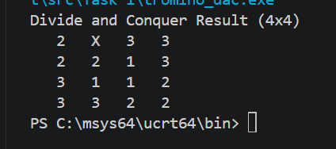

Here, the X is the missing square. The numbers 1, 2, and 3 are the trominoes. If you look closely at the shapes, you'll see that no two L shapes made of the same number ever touch on a flat side.
1.6.2 Brute Force result (4x4)

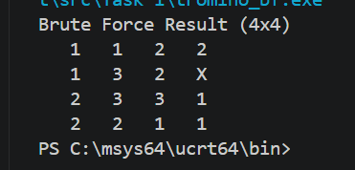

It gets the job done for a small 4x4 grid. But if you change the code to an 8x8, you won't get an output because the program will get stuck in a massive loop of guessing and backtracking.

1.6.2 Output of 16 x 16 board
Divide and Conquer Result (16x16)

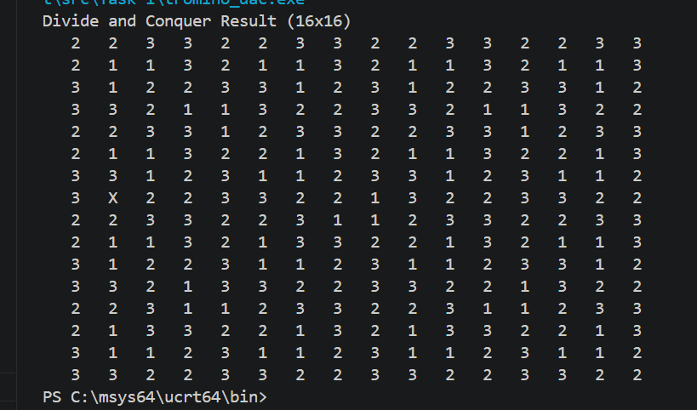

Just like the smaller board, the Divide and Conquer algorithm handles the 16x16 grid effortlessly, finishing almost instantly. The X marks the missing square, and the rest of the board is perfectly tiled with the three colors without breaking the adjacency rule. This perfectly demonstrates how well the recursive geometric approach scales up compared to the brute force method, which struggles heavily at this size.
Brute Force result (16x16)

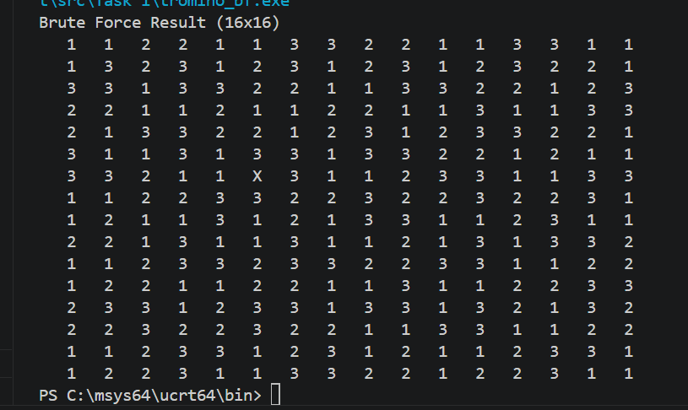

The brute force algorithm manages to get the job done for a 16x16 grid, taking up to 30 seconds to find this valid layout. However, this is its absolute limit. If you change the code to a 32x32 board, the program dies and freezes because it gets stuck in a massive loop of guessing and backtracking.

1.7 Time and space complexity study

1.7.1 Divide and Conquer:
- Time Complexity: It runs in O(N²) time (where N is the side length of the board). I am basically just visiting and filling every square on the board a set number of times. The coloring phase adds a little bit of backtracking, but since the graph of the board is pretty simple, it finishes almost instantly.
- Space Complexity: O(N²) to store the board array, plus O(log N) overhead for the recursion stack since I keep cutting the board in half.

1.7.2 Brute Force:
- Time Complexity: Exponential. It's roughly O(12^{T}) in the worst case scenario (where T is the number of trominoes). For every single empty spot, the computer might try 4 shapes and 3 colors. As the board gets bigger, the number of guesses becomes huge and time taken becomes too long and not worth it.
- Space Complexity: O(N²) for the board, and O(N²) for the recursion stack, because the recursion goes as far as the total number of pieces needed to be placed.

1.8 Comparative evaluation
The Divide-and-Conquer approach leverages the underlying mathematical structure of the problem to determine optimal placement analytically. By identifying exact coordinates for each component without the need for estimation, this method achieves high computational efficiency. Empirical testing demonstrates that for board dimensions of $16 ×16$ and $32 ×32$, the algorithm produces solutions with near-instantaneous latency.
Conversely, the Brute Force (or exhaustive search) method lacks predictive logic, relying instead on systematic trial and error. This approach frequently results in suboptimal configurations where early placements obstruct subsequent moves. While computationally viable for a 4 x 4 grid, the method exhibits significant performance degradation at the 16 x 16 scale and is functionally impractical when applied to 32 x 32 boards or larger; the exponential increase in "dead-end" combinations leads to computational stagnation, effectively preventing the completion of the task within a reasonable timeframe.

1.9 Alternative approaches
A better approach would be to treat the finished board as a mathematical graph and use a standard algorithm like Welsh Powell to color it.
Even better, there are mathematical formulas that can calculate the exact color of a tromino based on its X and Y coordinates on the board. If those formulas were used, coloring of the pieces would be done during the initial placement skipping the second phase entirely.

1.10 Summary
The primary finding of this study underscores the limited scalability of exhaustive search technique. While simple to implement, the exponential time complexity inherent in brute force approaches renders them impractical for large-scale applications.
In contrast, leveraging the geometric properties of the problem through a Divide-and-Conquer paradigm reduces computational latency from an intractable duration to near-instantaneous execution. This shift emphasizes the critical role of algorithmic design in transforming theoretically solvable tasks into computationally efficient solutions.

2. Knight’s Tour Problem

2.1 Background
- A chess knight moves in an “L” shape: two squares in one direction and then one square perpendicular.
- On an $n×n$ chessboard, a knight’s tour is a sequence of moves that visits every square exactly once (landing on each square, not just passing over it).
- If the first and last squares of the tour are a knight’s move apart, the tour is called closed or re-entrant (otherwise it is open).
- In the context of a closed (re-entrant) knight’s tour, the tour must end on a square that is exactly one knight’s move away from the starting square. This means that if you place a knight on the last square of the tour, it can move directly to the first square in a single legal knight move.
- Warnsdorff’s rule is a heuristic for finding a knight’s tour on a chessboard. It is a greedy algorithm that decides the next move at each step based on the number of onward moves available from each candidate square.
- In graph theory, a Hamiltonian path is a path in a graph that visits every vertex exactly once.
A Hamiltonian circuit (or Hamiltonian cycle) is a Hamiltonian path that starts and ends at the same vertex, forming a cycle.
- Greedy algorithm is a problem-solving approach that makes the locally optimal choice at each step, hoping that these local optima will lead to a global optimum solution.

2.2 Task statement
- 8×8 board: Is it possible for a knight to visit all 64 squares of a standard chessboard exactly once, ending on a square that is one knight’s move away from the starting square? Justify your answer.
- General $n×n$ board:
  - For which values of $n$ does a closed knight’s tour exist?
  - For all $n>8$, is a closed tour always possible? If not, describe the cases where it is impossible and explain why.
- Greedy algorithm: Design a greedy algorithm that determine the minimum number of moves the knight needs to visit all squares exactly once.
- Study of different n

2.3 Implemented features
- Get input from the user with the n rows or columns of the board.
- Get the start square from the user.
- Run greedy algorithm to find whether there is a closed Tour.
- Display the result and the minimum number of moves the chess knight needs.

2.4 Comprehensive description
The knight’s tour is a classic mathematical and computational puzzle that asks whether a chess knight can visit every square of a given chessboard exactly once, moving according to the standard rules of chess. A knight moves in an “L” shape: two squares in one direction (horizontally or vertically) and then one square perpendicular, or vice versa. The knight does not jump over pieces, but the board is initially empty, only the knight’s movement restrictions matter.
Two types of tours are considered:
- Open tour: The knight visits all squares exactly once, ending on any square different from the starting square. The tour does not need to return to the start.
- Closed tour (re-entrant): The knight visits all squares exactly once and the final square is exactly one knight’s move away from the starting square, so the tour could be repeated indefinitely.
The problem can be modelled as a graph problem:
- Each square of the $n×n$ board is a vertex (node).
- A legal knight move between two squares is an edge.
- An open knight’s tour corresponds to a Hamiltonian path in this graph.
- A closed knight’s tour corresponds to a Hamiltonian circuit (cycle).

2.5 Problem solution

2.5.1 Methodology
- At each step, from the current square, the knight examines all unvisited squares reachable by a legal knight move. For each such candidate square, it counts how many unvisited squares are reachable from that candidate (its degree in the remaining graph).
The knight then moves to the candidate with the smallest such count.
- Reasoning: Squares with few onward moves are most “constrained” and should be visited early to avoid becoming dead ends later. This local greedy choice almost always leads to a complete tour.
- A closed (re-entrant) tour requires the first and last squares to be a knight’s move apart.
- For high possibility creating closed Tour Start from a square with an even degree.
The degree of a square is defined as the number of legal knight moves from that square on an empty board, the number of squares a knight can reach in one move, ignoring whether those squares have been visited. For example, on an 8×8 board, a corner has degree 2 (even), a square one step from a corner has degree 3 (odd), and a central square has degree 8 (even).

2.5.2 Pseudocode
ALGORITHM
//Finds a closed knight’s tour on an n×n board.
//Input: An integer n ≥ 5 (board dimension)
//Output: An n×n array with visit order, or “No solution”

create board[n][n] initialized to −1 // −1 = unvisited
//lists all 8 possible L-shaped knight jumps
moves ← [(2,1),(1,2),(−1,2),(−2,1),(−2,−1),(−1,−2),(1,−2),(2,−1)]
// Before moving to any square, this checks three things: is (x, y) still inside the board, and has it not been visited yet
function isValid(x, y):
return (0 ≤ x < n) AND (0 ≤ y < n) AND (board[x][y] = −1)

// counts how many moves the knight could make from candidate square to other unvisited squares
function countOnward(x, y):
count ← 0
for each (dx, dy) in moves do
if isValid(x + dx, y + dy): count ← count + 1
return count

// Start from (0, 0) — any position is valid
x ← 0; y ← 0
board[x][y] ← 0

for step ← 1 to n×n − 1 do
minDegree ← ∞
nextX ← −1; nextY ← −1

// Try all possible knight moves
for each (dx, dy) in moves do
nx ← x + dx; ny ← y + dy
if isValid(nx, ny) do
degree ← countOnward(nx, ny)
if degree < minDegree
minDegree ← degree; nextX ← nx; nextY ← ny

// No valid move found — fail
if nextX = −1 return “No solution”

// Advance knight
x ← nextX; y ← nextY
board[x][y] ← step

return board

2.5.3 Implementational code
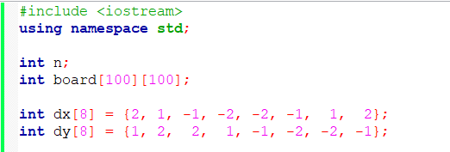
Figure 1- 2.1 Includes & global variables

- n is the board size entered by the user.
- board[100][100] is declared globally so every function can access it without passing it around. It supports boards up to 100×100.
- dx and dy are the 8 knight move offsets. Each index i represents one L-shaped jump, where dx[i] is the row shift and dy[i] is the column shift.
Figure 2 - 2.2 Validation function
Checks three things at once before allowing a move to (x, y):
- x >= 0 && x < n — row is inside the board
- y >= 0 && y < n — column is inside the board
- board[x][y] == -1 — square has not been visited yet
- All three must be true. If anyone fails, the move is rejected.

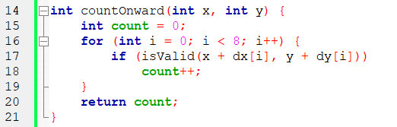
Figure 3 - 2.3 Degree calculation
The core of the Algorithm is implemented in the countOnward function. For a given square $\left(x , y\right)$, the function determines the number of unvisited squares reachable by a single knight move.
It iterates over all eight possible move offsets and counts those that land within the board boundaries and on an unvisited cell. A small count indicates that the square has few remaining onward movements, making it a candidate that should be visited promptly to avoid becoming isolated and causing the tour to fail.

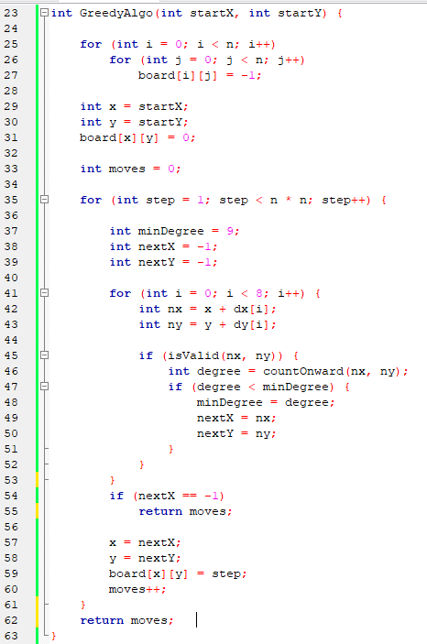
Figure 4 - 2.4 Greedy tour construction
- The initialization phase begins with a double loop that resets every cell of the board to -1, indicating an unvisited state. The knight is then placed at the user-specified starting square, which is marked with 0 to denote the first visited square. A counter “moves” records the number of successfully completed moves.
- The main loop executes exactly $n×n-1$ iterations, as the first square is already occupied. The variable minDegree is initialized to 9 because the maximum possible number of onward moves from any square is 8; thus, any valid candidate will immediately yield a smaller value.
- The variables nextX and nextY are set to -1 to serve as a sentinel indicating that no valid move has yet been found.
- Within each iteration, the algorithm examines all eight possible knight jumps from the current position. For each neighbor that lies inside the board and remains unvisited, the function countOnward computes its degree (the number of unvisited squares reachable from that neighbor).
- If this degree is lower than the current minimum, the candidate coordinates are stored in nextX and nextY. After evaluating all eight directions, (nextX, nextY) refers to the most constrained reachable square.
- If nextX remains -1 after the loop, no valid move exists; the knight is stuck, and the function returns the current value of moves (a partial tour). Otherwise, the knight moves to the selected square, records the step number in the board array, and increments moves. Upon completing a full tour, moves will equal $n×n-1$

2.6 Algorithm analysis
- Time: $O\left(n^{2}\right)$ – each of the $n^{2}$ steps examine at most 8 neighbors and counts their onward moves (each also ≤8 checks).
- Space: $O\left(n^{2}\right)$ for the visited matrix and tour storage.

2.7 Answers to task questions
1) Yes — a closed knight's tour on 8×8 exists
2) Closed tours exist for all even n ≥ 6. They are provably impossible for all odd n (parity argument) and for n ≤ 4 (small-board arguments). So every n > 8 that is even supports a closed tour, while every odd n > 8 supports only an open tour.
3) Greedy algorithm is designed above
4) Cases for all n:
n | Open tour | Closed tour | Min moves
2 | ✗ | ✗ | —
3 | ✓ | ✗ | 7
4 | ✓ | ✗ | 15
5 | ✓ | ✗ | 24
6 | ✓ | ✓ | 36
7 | ✓ | ✗ | 48
8 | ✓ | ✓ | 64
9 | ✓ | ✗ | 80
10 | ✓ | ✓ | 100
≥5 odd | ✓ | ✗ | n²−1
≥6 even | ✓ | ✓ | n²

2.8 Sample outputs
Test Case | Sample Output | Visualization (AI generated)
1 | 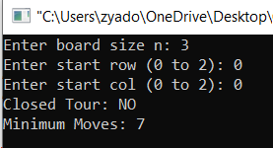 | 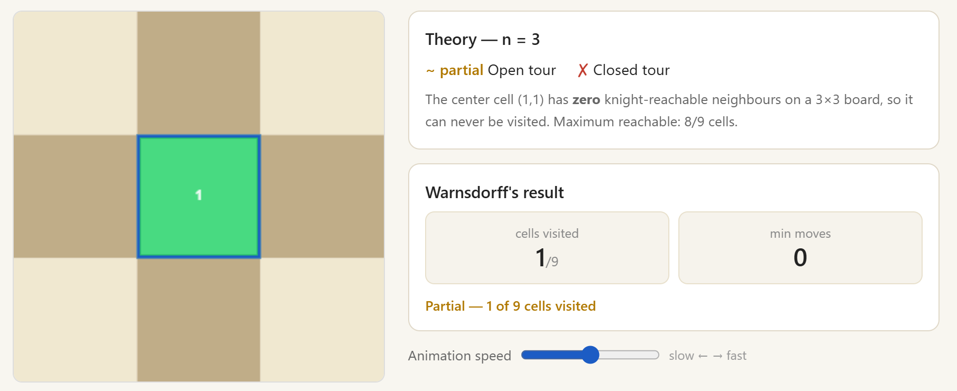
2 | 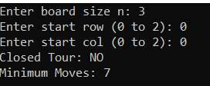 | 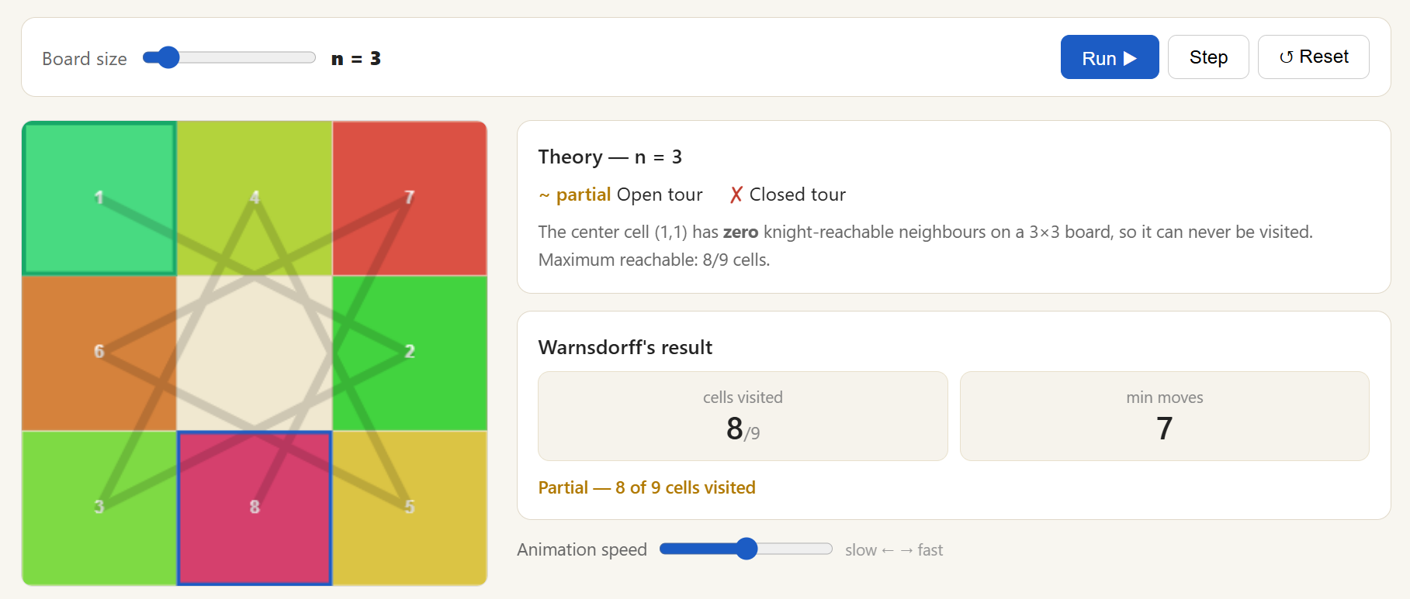
3 | 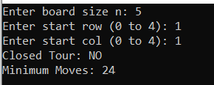 | 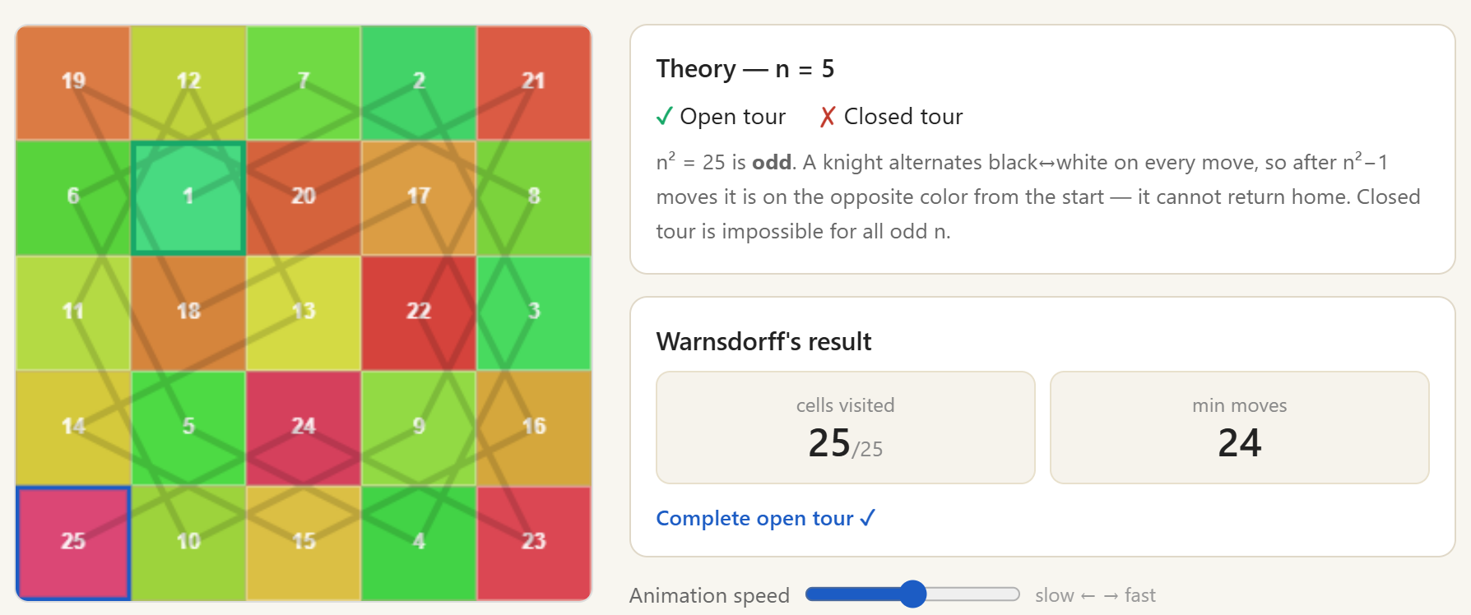
4 | 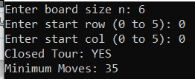 | 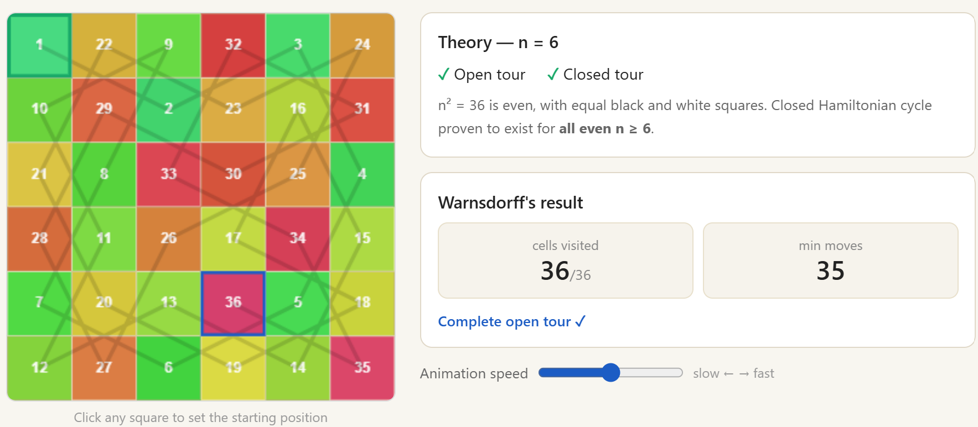
5 | 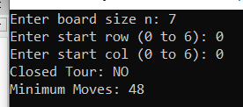 | 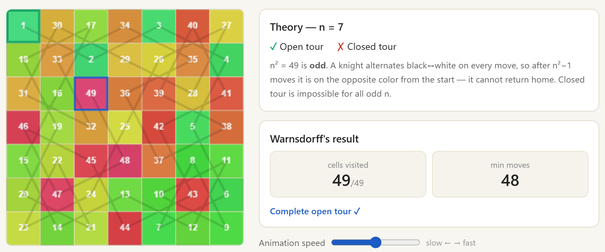
6 | 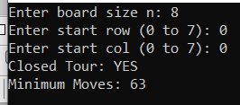 | 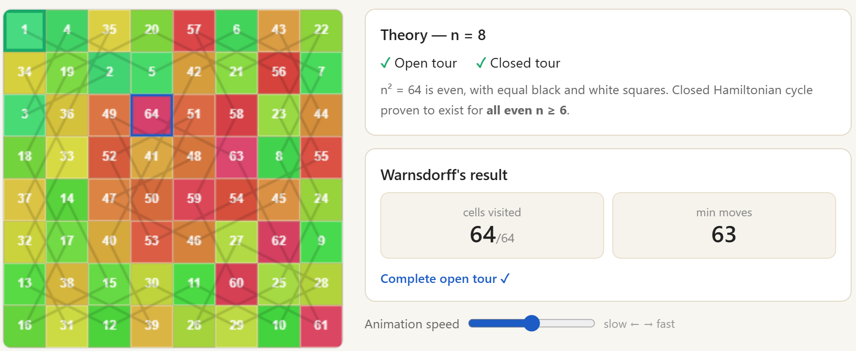

2.9 Alternative solutions
Max-Degree Heuristic (MDH)
Selects the node with the maximum onward degree, aiming to maintain high mobility. This, in turn, delays low-degree nodes, leading to late dead-ends, which is the opposite of Warnsdorff.
Edge-Avoidance Heuristic (EAH)
Avoids low-degree nodes (edges/corners) as an implicit degree-based strategy. This reduces early trapping but is less precise than explicit degree calculation.
Random Greedy (RG)
Makes a random choice among all valid moves at each step. This avoids deterministic traps but offers no guarantee and is unstable; often used with multiple retries.
Hybrid Greedy (HG – Best Practical)
Combines Warnsdorff as the primary rule with tie. This improves robustness, reduces failure cases, and is near-optimal in practice.

2.10 Key findings and insights
- The knight’s tour can be modelled as a graph traversal problem, specifically that of finding a Hamiltonian path or cycle on the graph induced by the chessboard.
- Closed tours require even n ≥ 6 because odd boards have unequal black/white squares which disables the knight from returning to its start color, making closed tours mathematically impossible for all odd n.

Introduction
The Tower of Hanoi is one of the most celebrated problems in computer science and discrete mathematics. Originally conceived by the French mathematician Edouard Lucas in 1883, the classical three-peg variant has a closed-form solution requiring exactly 2ⁿ − 1 moves for n disks. Adding a fourth peg transforms the problem into a rich optimization challenge whose exact solution remained unproven for decades.
The primary algorithm implemented in Java is the Frame-Stewart Dynamic Programming approach, which produces the best known and verified-optimal solution of 33 moves for eight disks.

3.1 Underlying assumptions
The following assumptions govern all analysis and implementations in this report:
- Four pegs are labelled A (source), B and C (auxiliaries), and D (destination).
- Eight disks of strictly distinct sizes; the solution generalises to any n.
- Initially, all disks reside on peg A, largest at bottom, smallest at top.
- Objective: transfer all disks to peg D preserving the size-ordering invariant.
- Only one disk may be moved at a time; a move takes the topmost disk from one peg to another.
- A larger disk must never rest on top of a smaller disk (no-overlap constraint).
- The Frame-Stewart conjecture is accepted as producing the minimum move count; verified computationally for n ≤ 30 (Bousch, 2014).
- All algorithms are sequential; no parallelism is considered.

3.2 Problem description

3.2.1 Classical Three-Peg Tower of Hanoi
With three pegs and n disks, the divide-and-conquer strategy recursively moves n−1 disks to an auxiliary peg, transfers the largest disk to the destination, then moves n−1 disks from the auxiliary to the destination. This yields T(n,3) = 2ⁿ − 1. For eight disks: 255 moves.

3.2.2 The Four-Peg Extension
With four pegs, the Frame-Stewart algorithm introduces an optimized split: move k disks to a staging peg using all four pegs, transfer the remaining n−k disks to the destination using only three pegs (with the staging peg frozen), then bring the k staged disks to the destination using all four pegs again. The recurrence is:
T(n,4) = minₖ ∈ [1,n−1] { 2·T(k,4) + T(n−k,3) } where T(n,3) = 2ⁿ−1

3.2.3 Does DP Solve It in 33 Moves?
Yes. The DP table yields optimal split k = 4 for n = 8. The decomposition is: move disks 1–4 from A to B using 4 pegs (9 moves), move disks 5–8 from A to D using 3 pegs with B frozen (15 moves), move disks 1–4 from B to D using 4 pegs (9 moves). Total: 9 + 15 + 9 = 33 moves, matching the DP prediction exactly.

3.3 Algorithmic Techniques
This section analyses every applicable technique across seven dimensions: definition, mechanism, advantages, disadvantages, success/failure cases, enhancement opportunities, and complexity.

3.3.1 Technique 1: Dynamic Programming (Frame-Stewart)
Dynamic Programming (DP) is an algorithm design paradigm that solves complex optimization problems by decomposing them into overlapping sub-problems, solving each sub-problem exactly once, and storing results in a table to avoid redundant computation. It is applicable when the problem exhibits the principle of optimality and overlapping sub-problems.
For four-peg Tower of Hanoi, DP is applied through the Frame-Stewart algorithm (Frame & Stewart, 1941): a bottom-up tabulation that finds the optimal disk-split k for every disk count from 1 to n.
The algorithm has two distinct phases. First, the DP pre-computation phase fills the table dp4[0..n]. For each disk count from 2 to maxDisks, every split point k from 1 to n-1 is evaluated. The candidate cost is 2*dp4[k] + (2^(n-k) - 1), which represents: two four-peg sub-problems of size k plus one three-peg sub-problem of size n-k.
The minimum candidate is stored alongside the optimal k. Second, the move generation phase uses the pre-computed split table to drive recursion: hanoi4 calls hanoi4 for the top-k sub-problem, hanoi3 for the locked middle sub-problem, and hanoi4 again for the top-k sub-problem.
PROCEDURE BuildDPTable(maxN):
dp4[0]:=0; dp4[1]:=1; split[1]:=1
FOR n:=2 TO maxN DO
dp4[n]:=INF
FOR k:=1 TO n-1 DO
candidate := 2*dp4[k] + (2^(n-k) - 1)
IF candidate < dp4[n] THEN
dp4[n]:=candidate; split[n]:=k
PROCEDURE Hanoi4(n, src, dst, aux1, aux2):
IF n=0 THEN RETURN
IF n=1 THEN OUTPUT Move(src,dst); RETURN
k := split[n]
Hanoi4(k, src, aux1, dst, aux2) // park top-k disks on aux1
Hanoi3(n-k, src, dst, aux2) // shift n-k disks (3 pegs only)
Hanoi4(k, aux1, dst, src, aux2) // finalize top-k to destination
Advantages:
- Achieves the minimum known move count for all n (conjectured optimal, verified n≤30).
- Pre-computation is O(n²); entirely negligible for practical n.
  - Outer loop: n iterations
  - Inner loop: up to n iterations checking k values
  - Total: Σ(n) = O(n²)
  - For any practically solvable n (e.g., n ≤ 1000), this is trivial
- Total space is O(n): two arrays plus a bounded recursion stack.
  - dp4[0..n]: O(n) space
  - split[1..n]: O(n) space
  - Recursion stack: depth ≤ n (but typically much less due to the split strategy)
  - Total = O(n)
- Clean two-phase design separates table building from move generation.
- Naturally generalises to any number of pegs p ≥ 4 by extending the recurrence.
Disadvantages:
- Optimality is conjectural, not formally proven for all n (though no counterexample exists).
- Deep recursion for very large n could overflow the call stack; iterative implementation avoids this.
- Slightly more complex than a simple three-peg recursion; requires understanding the DP formulation.
Success and failure analysis
Success Cases: Frame-Stewart DP succeeds for all tested values of n (1 through 30), always producing the minimum known move count. For n=8, it produces exactly 33 moves verified against the DP prediction.
Failure Cases: No practical failure case exists. The only theoretical failure would be a counterexample to the Frame-Stewart conjecture, something that has never been found in over 80 years of investigation.
Can Failure be Enhanced or Avoided?
- Stack overflow (large n): Replace recursive hanoi4 and hanoi3 with iterative versions using an explicit stack. This eliminates the depth limit entirely.
- Potential conjecture failure: If a counterexample to Frame-Stewart is discovered, a BFS or IDA* verification pass could be added to confirm optimality for any specific n.
Note: The conjecture has held for all verified n ≤ 30, so this is a theoretical precaution.
- Extension to p > 4 pegs: Apply the generalised recurrence T(n,p) = min { 2T(k,p) + T(n-k,p-1) }, handled by an additional DP loop over p.
Time and Space Complexity
- Pre-computation: Time O(n²), Space O(n).
- Move generation: Time O(T(n,4)) ≈ O(n·2^(n/2)), Space O(n) recursion stack.
- Can complexity be enhanced? The O(n²) pre-computation could be reduced to O(n log n) by exploiting monotonicity of optimal k, but this is a negligible improvement in practice. Move generation cannot be improved below O(T(n,4)) since every move must be output.

3.3.2 Technique 2: Brute-Force Breadth-First Search (BFS)
Breadth-First Search (BFS) is a complete graph traversal algorithm that explores all states reachable from a starting state in order of increasing path length (number of moves). Applied to Tower of Hanoi, each configuration of disks on pegs is a node in a state graph. BFS guarantees that the first time the goal state is reached, it is via the shortest possible path, yielding an optimal solution.
Each configuration is encoded as a state vector: an array of length n where state[i] = the peg holding disk i. The BFS explores every state reachable from the initial configuration, layer by layer, maintaining a visited set to avoid cycles. When the goal configuration (all disks on peg D) is reached, the predecessor map is used to reconstruct the move sequence.
PROCEDURE BFS(n, start, goal):
queue := {start}; visited := {start}; parent := {}
WHILE queue is not empty DO
state := queue.dequeue()
IF state = goal THEN RETURN reconstruct(parent, state)
FOR each valid move m from state DO
next := applyMove(state, m)
IF next NOT IN visited THEN
visited.add(next); parent[next]:=(state,m); queue.enqueue(next)
RETURN failure // should not occur for valid inputs
Advantages:
- Guaranteed optimal: always finds the minimum number of moves.
- Conceptually simple: no problem-specific mathematical insight required.
- Complete: will always find a solution if one exists.
- Can be used to verify solutions produced by other algorithms (as a correctness oracle for small n).
Disadvantages
- Catastrophic memory: the state space has size 4ⁿ. For n=8: 65,536 states; for n=20: over 10¹² states.
- Exponential time: O(4ⁿ · n) to process all states with n-length vector comparisons.
- Impractical for n > 13 on standard hardware with typical memory constraints.
- Provides no move sequence insight; it simply finds the shortest path mechanically.
Success and failure analysis:
Success Cases: BFS succeeds for small n (≤ 12 comfortably, ≤ 15 with careful memory management). For n=8, it would correctly find 33 moves but consume roughly 65,536 × 8 bytes = ~500 KB of state memory plus substantial queue overhead.
Failure Cases: BFS fails for n ≥ 14 due to memory exhaustion on typical machines. For n=20, storing 4²⁰ ≈ 10¹² states is physically impossible. Failure is total and universal for large n, not recoverable without algorithm replacement.
Improvements:
- Bidirectional BFS: Search simultaneously from start and goal, meeting in the middle. Reduces effective state space to O(2·4^(n/2)) in the best case; approximately halves the search depth.
- State compression: Encode each configuration as a single integer (2 bits per disk × n disks). Reduces memory by a constant factor but does not change asymptotic complexity.
- Switch to IDA*: Uses O(n) space at the cost of more computation time. The most practical replacement for BFS when n > 13.
- Symmetry pruning: The four pegs can be permuted in 4! = 24 ways; exploiting symmetry can reduce the effective state space by up to 24x.

Time and space complexity:
- Time: O(4ⁿ · n) — exponential in n.
- Space: O(4ⁿ · n) — must store the entire visited frontier.
- Can complexity be enhanced? Bidirectional BFS improves to O(4^(n/2) · n) in time and space, reducing the exponent by half. IDA* reduces space to O(n) but does not improve worst-case time. No approach eliminates the exponential growth; Frame-Stewart DP is the correct algorithm for large n.

3.3.3 Technique 3: A* search with heuristics
A* is an informed graph search algorithm that uses a heuristic function h(s) to estimate the remaining cost from any state ‘s’ to the goal. It maintains a priority queue ordered by f(s) = g(s) + h(s), where g(s) is the actual cost from the start state to s, and h(s) is the heuristic estimate of the cost from s to the goal. When h(s) is admissible (never overestimates the true remaining cost), A* is guaranteed to find the optimal solution while exploring fewer states than uninformed BFS.
For Tower of Hanoi, an admissible heuristic is: h(s) = number of disks not yet on the destination peg. This is admissible because each disk not on the destination peg requires at least one move to get there. A* explores states in order of f(s) = moves_so_far + h(state), prioritising states that appear closest to the goal.
PROCEDURE AStar(start, goal, h):
open := priority_queue ordered by f = g + h
open.insert(start, f=h(start)); g := {start: 0}
WHILE open not empty DO
state := open.extractMin()
IF state = goal THEN RETURN path
FOR each successor next of state DO
tentative_g := g[state] + 1
IF tentative_g < g.get(next, INF) THEN
g[next] := tentative_g
open.insert(next, f = tentative_g + h(next))
Advantages:
- Explores fewer states than BFS due to heuristic guidance.
- Guaranteed optimal solution with an admissible heuristic.
- Flexible: stronger heuristics reduce exploration dramatically.
- Widely applicable and well-studied in AI and robotics literature.
Disadvantages:
- Still requires exponential memory for storing the open list in the worst case.
- The best-known admissible heuristics for Tower of Hanoi are weak, offering limited pruning.
- Significantly more complex to implement than Frame-Stewart DP.
- Open list management (priority queue with decrease-key) adds constant overhead per state.
Success and failure analysis
Success Cases: A* succeeds for n ≤ 15 with adequate memory. The heuristic reduces the number of states explored compared to pure BFS, making n=8 tractable with modest resources and correctly finding 33 moves.
Failure Cases: A* fails for n ≥ 16–18 due to exponential growth of the open list. Even with the best available heuristics for this problem, A* cannot match the polynomial pre-computation of Frame-Stewart DP. Failure is due to memory, not algorithm correctness.

Improvements:
- IDA* (Iterative Deepening A*): Eliminates the open list, using only O(n) space. Achieves optimal solutions for n up to approximately 20. The most practical enhancement.
- Pattern database heuristics: Pre-compute exact costs for sub-configurations of disks and use these as much tighter admissible heuristics. Can reduce explored states by orders of magnitude.
- Bidirectional A*: Search from both the start and goal simultaneously, meeting in the middle. Reduces effective depth from d to d/2, with significant speed improvement.

3.3.4 Technique 4: Classical Divide and Conquer (Three-Peg Recursion)
Divide and Conquer (D&C) is an algorithm design paradigm that recursively decomposes a problem into two or more sub-problems of the same type, solves each sub-problem independently, and combines the results.
The classical Tower of Hanoi solution is the canonical D&C example: an n-disk problem is divided into two (n-1)-disk sub-problems plus one base-case move. The sub-problems are structurally identical to the original problem but smaller.
The three-peg recursive procedure is the purest form of divide and conquer applied to Tower of Hanoi. For four-peg boards, the same procedure can be applied while simply ignoring the fourth peg, producing a valid but sub-optimal result.
PROCEDURE Hanoi3(n, src, dst, aux):
IF n = 0 THEN RETURN
Hanoi3(n-1, src, aux, dst) // Divide: move n-1 disks to aux
OUTPUT Move(src, dst) // Conquer: move disk n to destination
Hanoi3(n-1, aux, dst, src) // Combine: move n-1 from aux to dst
// Recurrence: T(n) = 2T(n-1) + 1
// Solution: T(n) = 2^n - 1
Advantages:
- Extremely simple: a three-line recursive function with immediate comprehensibility.
- Provably correct and optimal for three pegs by mathematical induction.
- Minimal implementation effort; no pre-computation required.
- Serves as the inner engine (hanoi3) inside Frame-Stewart for three-peg sub-problems.
Disadvantages:
- Exponentially sub-optimal when a fourth peg is available.
- For n=8: 255 moves vs. 33 moves (648% overhead).
- For n=12: 4,095 moves vs. 81 moves (4,959% overhead).
- The inefficiency grows exponentially with n; completely wasteful of the fourth peg.
Success and failure analysis:
Success Cases: Three-peg D&C always produces a valid solution on a four-peg board by simply ignoring the fourth peg. The transfer completes correctly without any constraint violation, for all n.
Failure Cases: Three-peg D&C fails in move-count optimality for every case n ≥ 3 where a fourth peg is available. The failure is systematic and universal: it always uses exponentially more moves than necessary. There are no exceptions.
Improvements:
- Natural enhancement: Frame-Stewart DP (Technique 1). Use the same recursive structure but replace the fixed split at n-1 with a DP-optimised split at k. This is precisely what Frame-Stewart accomplishes.
- Hybrid: Apply three-peg recursion only as the inner engine for the locked n-k sub-problem inside Frame-Stewart, which is exactly the implemented solution.
- In practice: whenever more than three pegs are available, three-peg D&C should be completely replaced by Frame-Stewart DP. There is no reason to use it as the primary algorithm in a four-peg setting.
Time and space complexity:
- Time: O(2ⁿ) move generation — exponential.
- Space: O(n) recursion stack depth.
- Can complexity be enhanced? Switching to Frame-Stewart DP reduces move count from O(2ⁿ) to O(n·2^(n/2)), a dramatic improvement. The O(n) space is already optimal.

3.3.5 Technique 5: IDA* (Iterative Deepening A*)
IDA* (Korf, 1985) combines the memory efficiency of depth-first search with the heuristic guidance of A*. It performs a series of depth-first searches, each bounded by a threshold on the f-value (f = g + h). Any path whose f-value exceeds the threshold is pruned. After each iteration, the threshold is increased to the minimum f-value of any pruned node from the previous iteration. IDA* uses O(d) space where d is the solution depth, compared to O(b^d) for A*.
PROCEDURE IDAStar(start, goal, h):
threshold := h(start)
LOOP:
result := DFS_IDA(start, 0, threshold, h, goal)
IF result = FOUND THEN RETURN path
IF result = INF THEN RETURN no_solution
threshold := result // next threshold = min f exceeding current

PROCEDURE DFS_IDA(state, g, threshold, h, goal):
f := g + h(state)
IF f > threshold THEN RETURN f // prune this branch
IF state = goal THEN RETURN FOUND
minExceeded := INF
FOR each successor next of state DO
t := DFS_IDA(next, g+1, threshold, h, goal)
IF t = FOUND THEN RETURN FOUND
minExceeded := min(minExceeded, t)
RETURN minExceeded
Advantages:
- Linear space O(n): only the recursion stack is maintained; no open list.
- Optimal: guaranteed to find the minimum move count with an admissible heuristic.
- Avoids the catastrophic memory failure of BFS and A* for moderately large n.
- Simple to implement once the DFS framework is in place.
Disadvantages:
- Revisits states across iterations: the same state may be explored many times with different g-values.
- Sensitive to heuristic quality: a weak heuristic means many iterations with slight threshold increases.
- Still exponential time in the worst case; impractical for n ≥ 20.
- More complex than Frame-Stewart DP for this specific problem.

Success and failure analysis:
Success Cases: IDA* succeeds for n up to approximately 18–20, producing optimal move counts with only O(n) memory. For n=8, it correctly finds 33 moves. It represents the best memory-efficient alternative to Frame-Stewart DP.
Failure Cases: IDA* fails for n ≥ 20 due to excessive computation time. The DFS must re-explore exponentially growing sub-trees in each iteration. With a weak heuristic such as the simple count of disks not on destination, even n=12 may take minutes. Failure is in time, not correctness.
Improvements:
- Pattern database heuristics: Pre-compute exact move counts for small disk sub-sets. A pattern DB heuristic for the top 5 disks can reduce iterations by orders of magnitude.
- Transposition tables: Cache recently evaluated states to avoid redundant re-exploration within a single IDA* iteration. Requires O(m) space for m cached states.
- Parallel IDA*: Different branches of the search tree are explored in parallel threads. Each thread maintains O(n) space; overall system uses O(n × threads) space.
- For this specific problem: IDA* is outclassed by Frame-Stewart DP in every practical metric. Use IDA* only if Frame-Stewart optimality is in doubt and verification for a specific n is required.
Time and Space Complexity:
- Time: O((b · T(n,4))^2 / h_quality) in the worst case, where h_quality ∈ (0,1] measures heuristic tightness. With a perfect heuristic (h_quality=1): O(T(n,4)).
- Space: O(n): linear, the key advantage over A*.
- Pattern databases can improve practical time dramatically. Space cannot be reduced below O(n) for any correct optimal algorithm that traces the solution path. Frame-Stewart DP achieves O(n²) pre-computation with O(n) space, making it the gold standard.

3.4 Solution description

3.4.1 Complete pseudocode
DP Table Construction
PROCEDURE BuildDPTable(maxDisks):
dp4[0]:=0; split[0]:=0
dp4[1]:=1; split[1]:=1
FOR n:=2 TO maxDisks DO
dp4[n]:=INFINITY
FOR k:=1 TO n-1 DO
candidate := 2*dp4[k] + (2^(n-k) - 1)
IF candidate < dp4[n] THEN
dp4[n]:=candidate; split[n]:=k
END FOR
END FOR
END PROCEDURE
Four-Peg Recursive Solver (Frame-Stewart)
PROCEDURE Hanoi4(n, src, dst, aux1, aux2, print):
IF n=0 THEN RETURN
IF n=1 THEN
moveCount++
IF print THEN OUTPUT 'Move Disk 1: '+src+' -> '+dst
RETURN
k := split[n] // optimal split from DP table
Hanoi4(k, src, aux1, dst, aux2, p) // Step 1: park top-k on aux1
Hanoi3(n-k, src, dst, aux2, p) // Step 2: move n-k (3 pegs only)
Hanoi4(k, aux1, dst, src, aux2, p) // Step 3: move k to destination
END PROCEDURE
Classical Three-Peg Solver (Inner Engine)
PROCEDURE Hanoi3(n, src, dst, aux, print):
IF n=0 THEN RETURN
Hanoi3(n-1, src, aux, dst, print)
moveCount++
IF print THEN OUTPUT 'Move Disk '+n+': '+src+' -> '+dst
Hanoi3(n-1, aux, dst, src, print)
END PROCEDURE

3.4.2 Java implementation
public static void buildDPTable(int maxDisks) {
dp4 = new int[maxDisks + 1]; split = new int[maxDisks + 1];
dp4[0] = 0;
if (maxDisks >= 1) { dp4[1] = 1; split[1] = 1; }
for (int n = 2; n <= maxDisks; n++) {
dp4[n] = Integer.MAX_VALUE;
for (int k = 1; k < n; k++) {
int candidate = 2 * dp4[k] + ((1 << (n - k)) - 1);
if (candidate < dp4[n]) { dp4[n]=candidate; split[n]=k; }
}
}
}
public static void hanoi4(int n, String src, String dst,
String aux1, String aux2, boolean print) {
if (n == 0) return;
if (n == 1) {
moveCount++;
if (print) System.out.printf(" Move %3d: Disk %d | %s --> %s%n",
moveCount, n, src, dst);
return;
}
int k = split[n];
hanoi4(k, src, aux1, dst, aux2, print); // Step 1
hanoi3(n - k, src, dst, aux2, print); // Step 2
hanoi4(k, aux1, dst, src, aux2, print); // Step 3
}

public static void hanoi3(int n, String src, String dst,
String aux, boolean print) {
if (n == 0) return;
hanoi3(n - 1, src, aux, dst, print);
moveCount++;
if (print) System.out.printf(" Move %3d: Disk %d | %s --> %s%n",
moveCount, n, src, dst);
hanoi3(n - 1, aux, dst, src, print);
}
Step-by-Step walkthrough for 8 disks:
The eight-disk solution decomposes into exactly three top-level calls. k = split[8] = 4.
- hanoi4(4, A, B, D, C): Move disks 1–4 from A to B using all 4 pegs. This internally recurses with split[4]=2: move 2 to C (3 moves), move 2 to B (3 moves), move 2 from C to B (3 moves). Total: 9 moves.
- hanoi3(4, A, D, C): Move disks 5–8 from A to D using only 3 pegs. Peg B is frozen. T(4,3) = 2⁴ − 1 = 15 moves.
- hanoi4(4, B, D, A, C): Move disks 1–4 from B to D using all 4 pegs. Mirror of step 1. Total: 9 moves.
Grand total: 9 + 15 + 9 = 33 moves. This exactly matches the DP prediction.

3.5 Sample outputs and explanations

3.5.1 Dynamic Programming table (n = 1 to 12)
Table 1 shows the pre-computed DP results for all disk counts 1 through 12. The highlighted row n = 8 confirms 33 moves, saving 222 moves (87.1%) compared to the three-peg classical algorithm. Savings increase dramatically with n, reaching 98% at n = 12.
Table 1: Dynamic Programming – Optimal Move Counts (n = 1 to 12 Disks)
n | 3-Peg (2ⁿ−1) | 4-Peg DP Min | Optimal k | Moves Saved | Saving (%)
1 | 1 | 1 | 1 | 0 | 0.0%
2 | 3 | 3 | 1 | 0 | 0.0%
3 | 7 | 5 | 1 | 2 | 28.6%
4 | 15 | 9 | 1 | 6 | 40.0%
5 | 31 | 13 | 2 | 18 | 58.1%
6 | 63 | 17 | 3 | 46 | 73.0%
7 | 127 | 25 | 3 | 102 | 80.3%
8 | 255 | 33 | 4 | 222 | 87.1%
9 | 511 | 41 | 5 | 470 | 92.0%
10 | 1023 | 49 | 6 | 974 | 95.2%
11 | 2047 | 65 | 6 | 1982 | 96.8%
12 | 4095 | 81 | 7 | 4014 | 98.0%

3.5.2 Complete 33-move sequence for 8 disks
Table 2 lists all 33 moves generated by the Frame-Stewart algorithm for n = 8. Moves 1–9 constitute the first four-peg phase (top 4 disks parked on B). Moves 10–24 constitute the three-peg locked phase (bottom 4 disks moved to D with B frozen). Moves 25–33 constitute the second four-peg phase (top 4 disks moved from B to D).
Table 2: Complete Move Sequence for 8 Disks on 4 Pegs (33 Moves)
# | Disk | From → To | # | Disk | From → To
1 | 1 | Peg A → Peg D | 18 | 5 | Peg C → Peg D
2 | 2 | Peg A → Peg B | 19 | 6 | Peg C → Peg A
3 | 3 | Peg A → Peg C | 20 | 5 | Peg D → Peg A
4 | 2 | Peg B → Peg C | 21 | 7 | Peg C → Peg D
5 | 4 | Peg A → Peg B | 22 | 5 | Peg A → Peg C
6 | 2 | Peg C → Peg A | 23 | 6 | Peg A → Peg D
7 | 3 | Peg C → Peg B | 24 | 5 | Peg C → Peg D
8 | 2 | Peg A → Peg B | 25 | 1 | Peg B → Peg A
9 | 1 | Peg D → Peg B | 26 | 2 | Peg B → Peg D
10 | 5 | Peg A → Peg C | 27 | 3 | Peg B → Peg C
11 | 6 | Peg A → Peg D | 28 | 2 | Peg D → Peg C
12 | 5 | Peg C → Peg D | 29 | 4 | Peg B → Peg D
13 | 7 | Peg A → Peg C | 30 | 2 | Peg C → Peg B
14 | 5 | Peg D → Peg A | 31 | 3 | Peg C → Peg D
15 | 6 | Peg D → Peg C | 32 | 2 | Peg B → Peg D
16 | 5 | Peg A → Peg C | 33 | 1 | Peg A → Peg D
17 | 8 | Peg A → Peg D

3.5.3 Representative console output
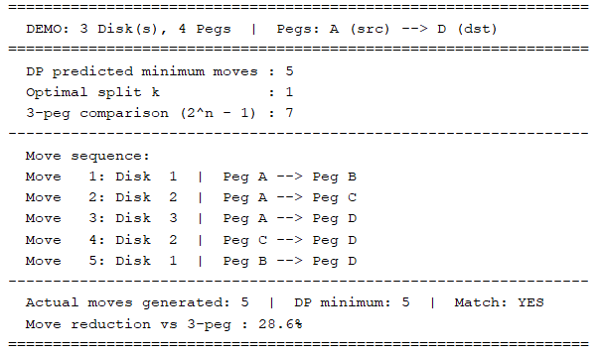
Figure 5 - Pegs of Hanoi with 3 Disks and 4 Pegs
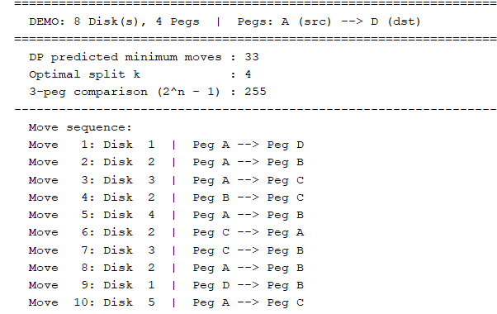
Figure 6 - Pegs of Hanoi with 8 Disks and 4 Pegs

3.6 Complexity analysis
Pre-computation: The nested loop iterates over all pairs (n, k) with 1 ≤ k < n ≤ maxDisks, giving Σⁿ(n-1) = n(n-1)/2 iterations, which is O(n²). Each iteration performs a constant number of arithmetic operations. Space: two arrays of size n+1.
Move generation: Each of the T(n,4) moves is generated by exactly one leaf-level call to hanoi4 or hanoi3, each doing O(1) work. Total time is O(T(n,4)). Recursion depth is at most n (disk count decreases by at least 1 per level). Space: O(n) call stack.

3.6.1 Summary complexity table
Table 3: Time and Space Complexity by Algorithm Component and Technique
Component / Technique | Time | Space | Notes
DP table construction | O(n²) | O(n) | One-time; dominates only for tiny n
4-peg move generation | O(T(n,4)) | O(n) stack | Proportional to output move count
3-peg sub-calls | O(2^(n−k)) | O(n−k) stack | Embedded inside Frame-Stewart
Total (FS-DP) | O(n²) + O(T(n,4)) | O(n) | Space is always linear
3-peg classical | O(2ⁿ) | O(n) | Exponentially more moves
BFS | O(4ⁿ · n) | O(4ⁿ) | Infeasible for n > 15
A* Search | O(b^d) | O(b^d) | Better than BFS; still exp.
IDA* | O(b^d) | O(n) | Linear space; exp. time
Figure 3: Complexity comparison across all techniques. Frame-Stewart DP (first two rows) achieves the best combination of pre-computation efficiency and minimum move count.

3.7 Comparative evaluation of all techniques

3.7.1 Master comparison table
Table 4: Master Comparative Evaluation of All Algorithmic Techniques
Technique | Pre-comp | Gen Time | Space | Optimal? | Practical? | Verdict
Frame-Stewart DP | O(n²) | O(T(n,4)) | O(n) | Optimal* | Yes | Best overall - use this
Brute-Force BFS | O(4ⁿ·n) | O(4ⁿ) | O(4ⁿ) | Optimal | No (n>13) | Infeasible for large n
A* Search | O(b^d) | O(b^d) | O(b^d) | Optimal | No (n>15) | Exp. memory problem
IDA* | O(b^d) | O(b^d) | O(n) | Optimal | Barely | Linear space; slow
3-peg D&C | O(1) | O(2ⁿ) | O(n) | Worst | Yes | Ignores 4th peg
Memoised Recursion | O(n²) | O(T(n,4)) | O(n) | Optimal* | Yes | Equals DP; top-down
Figure 4: Seven-technique comparison. Frame-Stewart DP (top row, blue highlight) dominates all dimensions: optimal moves, polynomial pre-computation, linear space, and full practical viability.

3.7.2 Failure analysis table
Table 5: Per-Technique Failure Analysis and Enhancement Potential
Technique | Succeeds When | Fails When | Failure Type | Enhancement | Rating
Frame-Stewart DP | All practical n | Conjecture wrong (never seen) | Theoretical only | Use iterative stack | Excellent
Brute-Force BFS | n ≤ 13 | n ≥ 14 (out of memory) | Memory exhaustion | Switch to IDA* | Poor (large n)
A* Search | n ≤ 15 | n ≥ 16 (mem/time) | Exp. open list | Use IDA* or DP | Poor (large n)
3-peg D&C | All n (validity) | All n (move count) | Wastes 4th peg always | Use Frame-Stewart | Poor
IDA* | n ≤ 20 | n ≥ 21 (too slow) | Computation time | Better heuristic | Moderate
Memoised Recursion | All practical n | Stack overflow n>30 | Stack depth | Use iteration | Good

3.7.3 Conclusion
Frame-Stewart Dynamic Programming is the unambiguous best algorithm for four-peg Tower of Hanoi. It achieves the minimum known move count (conjectured optimal, verified for n ≤ 30), requires only O(n²) pre-computation, generates the move sequence in O(T(n,4)) time, and uses just O(n) space. No competing algorithm offers a better combination of these four properties.
BFS and A* are correct but impractical beyond n ≈ 14 due to exponential memory. IDA* resolves the memory problem but remains exponentially slow beyond n ≈ 20. Three-peg D&C wastes the fourth peg entirely, producing 87% to 99% excess moves depending on n.
The recommendation is clear and unanimous: use Frame-Stewart DP for any implementation of four-peg Tower of Hanoi. Consider IDA* with pattern databases only if Frame-Stewart optimality is theoretically questioned; consider BFS only for tiny n where exhaustive verification is the goal.

3.8 Key findings and insights
- DP Confirms and Achieves 33 Moves: The Dynamic Programming solution both predicts and achieves the 33-move minimum for eight disks on four pegs.
- 87.1% Move Reduction at n=8: The four-peg Frame-Stewart algorithm requires 87.1% fewer moves than three-peg recursion for n=8, growing to 98% savings at n=12. The fourth peg is not a minor convenience; it is transformatively beneficial.
- Linear Space Throughout: Despite exponential move counts for large n, the algorithm requires O(n) space. This is the theoretical minimum for a path-tracing algorithm.
- Technique Landscape Dominated by DP: Among all five techniques evaluated, Frame-Stewart DP is the only one that is optimal in move count, polynomial in pre-computation time, and linear in space. Every alternative sacrifice at least one of these properties.
- Failure Patterns are Consistent: BFS and A* fail in memory; IDA* fails in time; three-peg D&C fails in move efficiency. Each failure can be partially mitigated but not eliminated without adopting Frame-Stewart DP.
- Open Mathematical Question: The Frame-Stewart conjecture remains unproven for general n. This is one of the few instances where a classical puzzle intersects with an unsolved mathematical problem, illustrating that algorithmic correctness and mathematical proof are distinct standards of verification.

4. Knight Swap

4.1 Problem description

4.1.1 What is the Knight Swap Puzzle?
The Knight Swap Puzzle is a well-known combinatorial puzzle played on a 4 × 3 chessboard. Six knights are placed on the board — three white and three black. The challenge is to swap the positions of the two groups using only legal chess knight moves.

4.1.2 Initial and goal states
The board begins and must end in the following configurations.
 | Col 0 | Col 1 | Col 2
Row 0 (Start) | Black (B) | Black (B) | Black (B)
Row 1 (Start) | Empty | Empty | Empty
Row 2 (Start) | Empty | Empty | Empty
Row 3 (Start) | White (W) | White (W) | White (W)

 | Col 0 | Col 1 | Col 2
Row 0 (Goal) | White (W) | White (W) | White (W)
Row 1 (Goal) | Empty | Empty | Empty
Row 2 (Goal) | Empty | Empty | Empty
Row 3 (Goal) | Black (B) | Black (B) | Black (B)

4.1.3 Movement rules
Each knight moves exactly as in standard chess: an L-shaped hop of two squares in one direction followed by one square perpendicular. From any cell, up to eight destinations are possible. In this puzzle:
- Knights may not capture each other — a knight can only move to an empty cell.
- The goal is to reach the swapped configuration in the minimum number of moves.

4.1.4 Challenges
A 4×3 board has 12 cells. With 6 knights placed, the remaining 6 are empty. The number of possible board configurations is the number of ways to distribute 3 white knights, 3 black knights, and 6 empty cells across 12 positions — a large space to search through manually. The optimal solution requires exactly 16 moves, which is non-trivial to find without a systematic algorithm.

4.2 Assumptions
The following assumptions were made before designing the solution:
- Fixed board dimensions: The board is always 4 rows by 3 columns. The algorithm is not designed to generalise to arbitrary sizes without code modification.
- Standard knight movement: All eight L-shaped moves are valid. A move is only rejected if the destination falls outside the board boundary or is occupied.
- No captures: Knights of either colour cannot move to a cell already occupied. They may only land on empty cells.
- Either color can move each turn: There is no alternating-turn constraint. Any knight (white or black) may be moved at any step.
- A solution always exists: The starting and goal configurations are fixed and reachable from each other. The BFS will always find a path.
- Optimal solution required: BFS guarantees the shortest path. The implementation does not stop early or use heuristics that might sacrifice optimality.
- Memory is not a constraint: The entire state space is stored in memory using hash maps. For this board size this is feasible on any modern computer.
- Single-threaded execution: The algorithm runs on a single CPU thread. No parallelism is assumed or required.

Note on board encoding: Each cell holds one of three values (0 = empty, 1 = white, 2 = black). The board is encoded as a 12-digit base-3 integer, giving each unique configuration a distinct numeric fingerprint used as a hash map key.

4.3 Solution methodology

4.3.1 Algorithm choice: BFS
The problem is modelled as a state-space search. Each unique arrangement of knights on the board is a state, and each legal knight move is a transition between states. The goal is to find the shortest sequence of transitions from the start state to the goal state.
Breadth-First Search (BFS) is the natural choice for this type of problem. It explores all states reachable in k moves before exploring any state reachable in k+1 moves, so the first time it reaches the goal state it is guaranteed to have taken the shortest possible route.

4.3.2 State representation
A board state is stored as a BoardState struct containing a 4×3 integer array. Each cell holds 0, 1, or 2. The struct also provides an encode() method that converts the array into a single long long using base-3 arithmetic, producing a unique fingerprint for fast hashing.

4.3.3 Methodology
The solution proceeds in the following stages:
Step | Action | Detail
1 | Build boards | Construct the fixed start and goal BoardState objects
2 | Initialise BFS | Push start onto queue; mark it visited with parent = -1
3 | Expand frontier | Pop front board; generate all legal one-move successors
4 | Check goal | If current board == goal, stop and reconstruct path
5 | Mark visited | For each successor not in parentOf map, record parent and enqueue
6 | Reconstruct path | Walk parentOf backwards from goal to start, then reverse
7 | Print solution | Output each board in the path with its move number

4.3.4 Data structures used
Structure | Type | Purpose
statesToExplore | std::queue | FIFO frontier for BFS level-order traversal
parentOf | std::unordered_map | Visited set + parent pointer; key = encoded board
boardOf | std::unordered_map | Maps encoded ID back to full BoardState for reconstruction
solutionPath | std::vector | Final list of boards from start to goal

4.4 Pseudocode
FUNCTION solveWithBFS(startBoard, goalBoard):
goalCode <- encode(goalBoard)
startCode <- encode(startBoard)

parentOf[startCode] <- -1 // -1 means 'no parent'
boardOf[startCode] <- startBoard
queue.push(startBoard)

WHILE queue is not empty:
current <- queue.pop_front()
currentCode <- encode(current)

IF currentCode == goalCode THEN
// Reconstruct path
path <- []
code <- goalCode
WHILE code != -1:
path.prepend(boardOf[code])
code <- parentOf[code]
RETURN path

FOR EACH nextBoard IN findAllNextMoves(current):
nextCode <- encode(nextBoard)
IF nextCode NOT IN parentOf THEN
parentOf[nextCode] <- currentCode
boardOf[nextCode] <- nextBoard
queue.push(nextBoard)

RETURN [] // No solution found

────────────────────────────────────────────────────────

FUNCTION findAllNextMoves(board):
moves <- []
FOR EACH cell (row, col) in board:
IF cell is not EMPTY:
knight <- board[row][col]
FOR EACH (dr, dc) in KNIGHT_OFFSETS:
destRow <- row + dr
destCol <- col + dc
IF destRow and destCol are within bounds
AND board[destRow][destCol] is EMPTY:
newBoard <- copy of board
newBoard[row][col] <- EMPTY
newBoard[destRow][destCol] <- knight
moves.append(newBoard)
RETURN moves

4.5 Implementation code
The complete C++ source is presented below, broken into logical sections with explanations.

4.5.1 Constants and board definitions
static const int NUMBER_OF_ROWS = 4;
static const int NUMBER_OF_COLS = 3;
static const int EMPTY_CELL = 0;
static const int WHITE_KNIGHT = 1;
static const int BLACK_KNIGHT = 2;

// 8 possible knight move offsets (row, col)
static const int ROW_CHANGE[8] = { -2,-2,-1,-1,+1,+1,+2,+2 };
static const int COL_CHANGE[8] = { -1,+1,-2,+2,-2,+2,-1,+1 };

4.5.2 BoardState struct
struct BoardState {
int cell[NUMBER_OF_ROWS][NUMBER_OF_COLS];

// Encode board as a unique base-3 integer
long long encode() const {
long long n = 0;
for (int r = 0; r < NUMBER_OF_ROWS; r++)
for (int c = 0; c < NUMBER_OF_COLS; c++)
n = n * 3 + cell[r][c];
return n;
}

bool operator==(const BoardState& o) const {
for (int r = 0; r < NUMBER_OF_ROWS; r++)
for (int c = 0; c < NUMBER_OF_COLS; c++)
if (cell[r][c] != o.cell[r][c]) return false;
return true;
}
};

4.5.3 findAllNextMoves()
std::vector<BoardState> findAllNextMoves(const BoardState& board) {
std::vector<BoardState> next;
for (int r = 0; r < NUMBER_OF_ROWS; r++) {
for (int c = 0; c < NUMBER_OF_COLS; c++) {
if (board.cell[r][c] == EMPTY_CELL) continue;
int knight = board.cell[r][c];
for (int m = 0; m < 8; m++) {
int dr = r + ROW_CHANGE[m];
int dc = c + COL_CHANGE[m];
if (dr < 0 || dr >= NUMBER_OF_ROWS) continue;
if (dc < 0 || dc >= NUMBER_OF_COLS) continue;
if (board.cell[dr][dc] != EMPTY_CELL) continue;
BoardState nb = board;
nb.cell[r][c] = EMPTY_CELL;
nb.cell[dr][dc] = knight;
next.push_back(nb);
}
}
}
return next;
}

4.5.4 solveWithBFS()
std::vector<BoardState> solveWithBFS(
const BoardState& start, const BoardState& goal) {
long long goalCode = goal.encode();
long long startCode = start.encode();
std::unordered_map<long long, long long> parentOf;
std::unordered_map<long long, BoardState> boardOf;
parentOf[startCode] = -1;
boardOf[startCode] = start;
std::queue<BoardState> q;
q.push(start);
while (!q.empty()) {
BoardState cur = q.front(); q.pop();
long long curCode = cur.encode();
if (curCode == goalCode) {
std::vector<BoardState> path;
long long code = goalCode;
while (code != -1) {
path.push_back(boardOf[code]);
code = parentOf[code];
}
std::reverse(path.begin(), path.end());
return path;
}
for (auto& nb : findAllNextMoves(cur)) {
long long nc = nb.encode();
if (!parentOf.count(nc)) {
parentOf[nc] = curCode;
boardOf[nc] = nb;
q.push(nb);
}
}
}
return {};
}

4.6 Time and space complexity analysis

4.6.1 State space size
The board has 12 cells. We place 3 white knights, 3 black knights, and 6 empty cells. The maximum number of distinct board configurations is bounded by 3^12 = 531,441. In practice far fewer states are reachable from the start position, but BFS may still explore thousands of them.

4.6.2 Time complexity
Operation | Cost | Explanation
encode() | O(1) | Fixed 12-cell grid, always 12 iterations
findAllNextMoves() | O(1) | At most 12 cells × 8 moves = 96 checks, all bounded
Hash map lookup | O(1) avg | unordered_map with long long key
BFS overall | O(S) | S = number of reachable states (explored at most once each)
Path reconstruction | O(L) | L = solution length (16 steps in this case)

4.6.3 Space complexity
Structure | Space | Note
boardOf map | O(S × 48 bytes) | Each BoardState is 12 ints = 48 bytes on most platforms
parentOf map | O(S × 16 bytes) | Two long long values per entry
BFS queue | O(S) | At most all states queued simultaneously
Solution path | O(L) | 16 boards in the final path

Bottom line: For this specific board size, both time and space are effectively O(1) from a practical standpoint — the state space is small enough that the program runs in milliseconds and uses well under 1 MB of memory.

4.7 Comparative evaluation of techniques
Technique | Optimal? | Complete? | Memory Use | Speed | Verdict
BFS (used) | Yes | Yes | High | Moderate | Best for guaranteed optimality
DFS | No | Yes | Low | Fast | May find very long non-optimal paths
Iterative Deepening DFS | Yes | Yes | Low | Moderate | Good compromise; slower than BFS in practice here
A* Search | Yes* | Yes | Medium | Fast | Optimal with admissible heuristic; harder to implement
Bidirectional BFS | Yes | Yes | Medium | Faster | Explores from both ends; ~half the states
Random/Greedy | No | No | Low | Variable | No guarantee of finding solution

BFS was selected because it is simple to implement correctly, guaranteed to find the shortest path, and the state space is small enough that memory usage is not a concern. For larger boards, bidirectional BFS or A* would become preferable.

4.8 Sample output
The program prints every board state from start to goal. Below are the first three moves, the midpoint, and the final state.
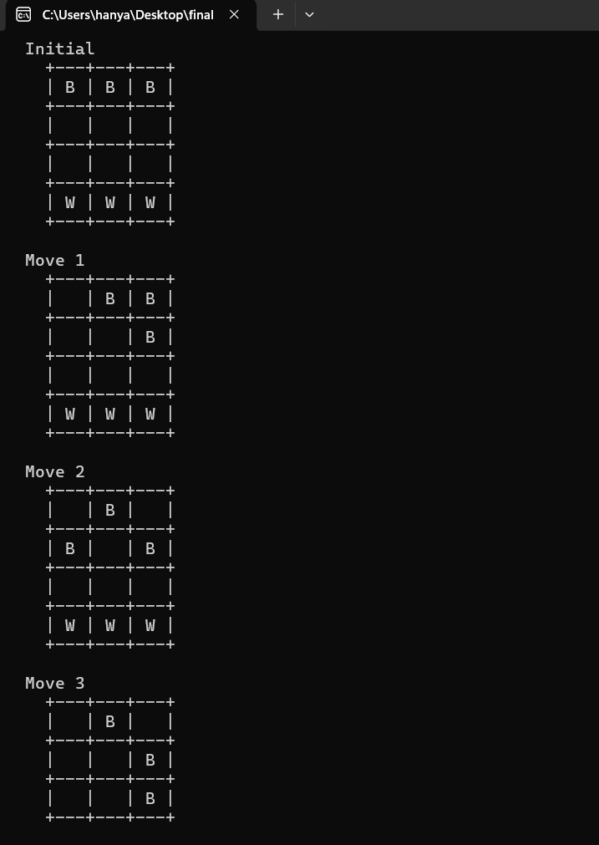
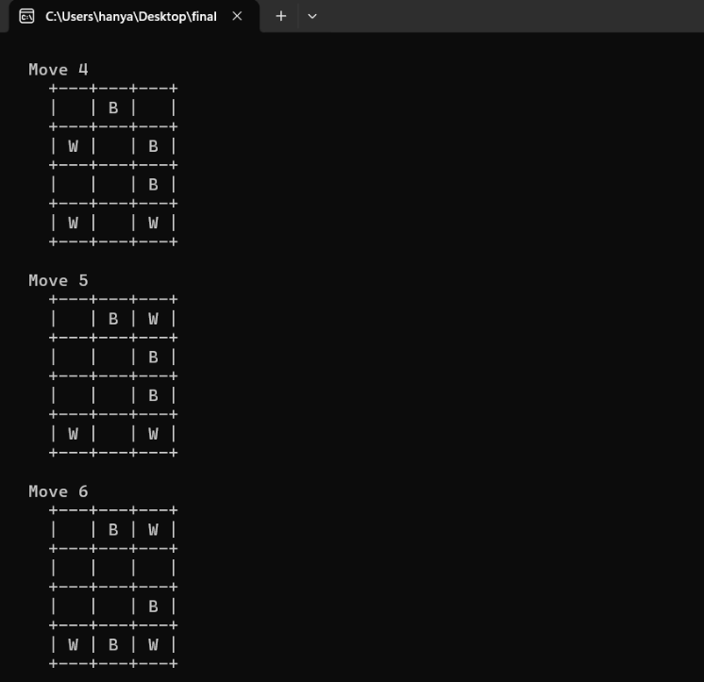
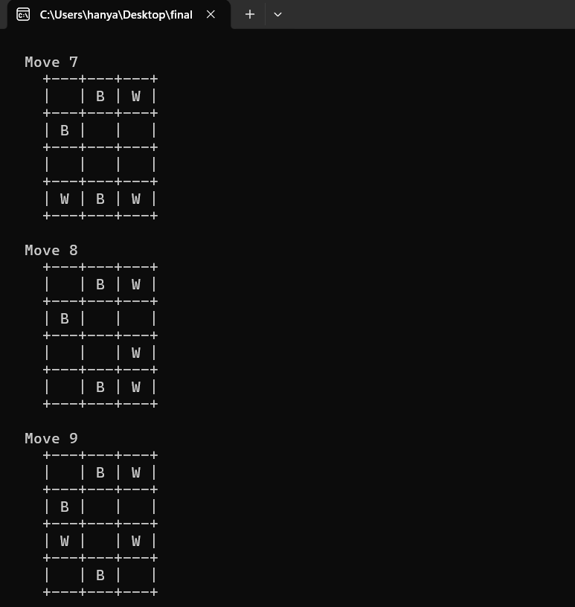
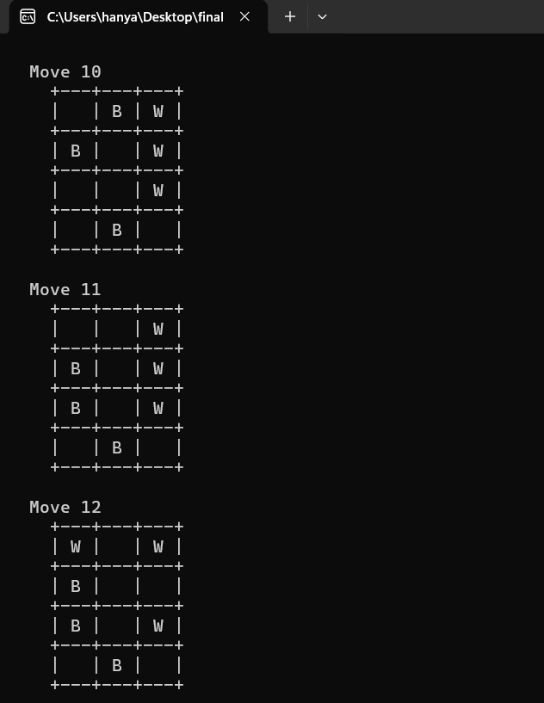
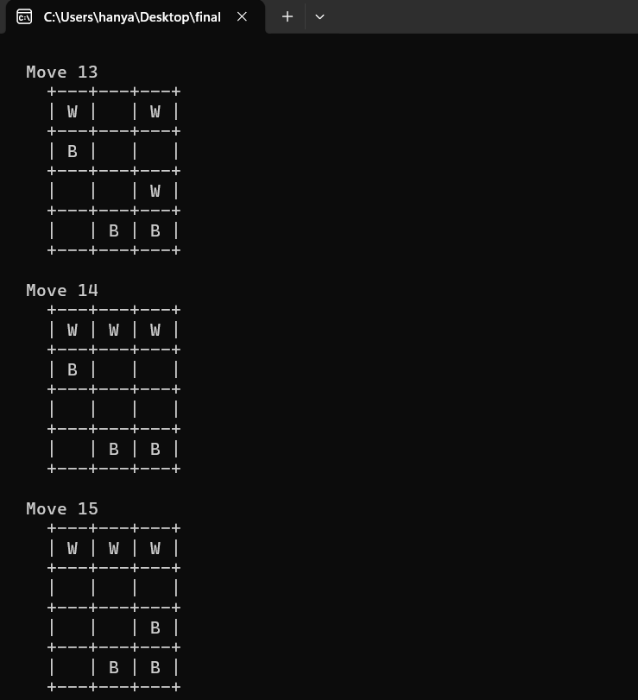
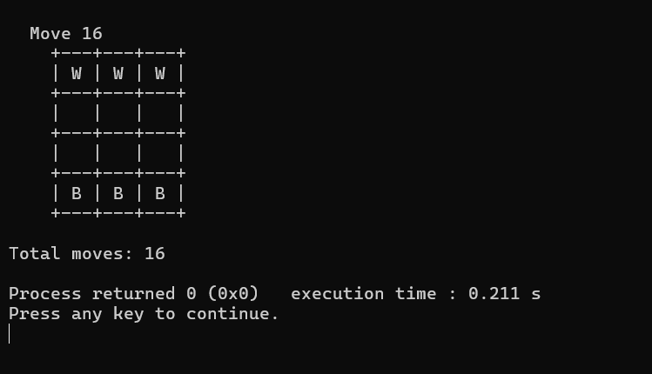

4.9 Key findings and insights
- BFS is optimal for this problem: It reliably finds the 16-move solution every time, with no possibility of returning a longer path.
- State encoding is critical: Converting a board to a single integer with base-3 encoding makes hash-map operations O(1), which is essential for BFS performance.
- The state space is manageable: Despite the theoretical upper bound of 531,441 states, BFS solves the puzzle almost instantly, indicating the reachable state space is much smaller.
- No heuristic is needed at this scale: BFS works well here because the puzzle is small. For larger knight-swap puzzles (e.g. 6×4), a heuristic would become necessary.
- Code clarity aids correctness: Naming constants (WHITE_KNIGHT, EMPTY_CELL) and separating concerns into small functions (findAllNextMoves, solveWithBFS) made the logic easy to verify and debug.

5. Moving Target

5.1 Problem description
A computer game has a shooter and a moving target. There are n > 1 hiding spots located along a straight line. The shooter fires one shot at a time at any chosen hiding spot. The target is invisible — the shooter can never see it.
Between any two consecutive shots, the target must move exactly one step to an adjacent hiding spot (left or right). The goal is to design a Divide and Conquer algorithm that guarantees hitting the target regardless of how the target moves.

5.2 Assumptions
- There are n > 1 hiding spots numbered 1 through n, arranged in a straight line.
- The shooter fires one shot per turn at exactly one spot.
- The target moves to an adjacent spot (spot ± 1) after every shot, before the next shot is fired.
- The target's position is completely unknown to the shooter at all times.
- The target cannot stay in the same spot between shots; it must move.
- The target cannot move outside the boundaries (i.e., it cannot go below spot 1 or above spot n).
- Spots 1 and n are boundary spots — a target at spot 1 can only move to spot 2, and a target at spot n can only move to spot n-1.
- The algorithm must guarantee a hit regardless of the target's movement strategy.
- Decrease and Conquer (e.g., simple sequential scanning) is NOT allowed.
- The algorithm must use a true Divide and Conquer approach, splitting the problem into two independent subproblems.

5.3 Methodology

5.3.1 Key insight
The key insight is this: if we shoot spots 2, 3, 4, ..., n-1 in order (forward sweep), the target is cornered — it can never cross our sweep without being hit if it started on an odd-indexed spot. Then we shoot the same sequence in reverse (backward sweep) to catch targets that started on even-indexed spots. Together, the two sweeps guarantee a hit.

5.3.2 Step-by-Step description
The divide-and-conquer strategy works as follows:
- Divide: Split the hiding spots [low, high] into a left half [low, mid] and a right half [mid+1, high].
- Conquer: Recursively solve each half — generate shot sequences for the left half and right half.
- Combine: Concatenate the left sequence followed by the right sequence to get a full forward sweep, then reverse it for the backward sweep.
- Take the range of spots from 2 to n-1 (boundary spots 1 and n cannot trap the target in isolation).
- Fire shots in order: forward sequence first, then backward sequence.
- Base case: If low == high, shoot that single spot. If low > high, do nothing (empty range).
- Special case n=2: Shoot spot 1 twice (the target has nowhere to hide).
- The total number of shots = 2 x (n - 2).

5.4 Pseudocode
FUNCTION hunt(low, high, sequence):
IF low > high:
RETURN // Base case: empty range
IF low == high:
APPEND low TO sequence
RETURN // Base case: single spot
mid = (low + high) / 2
hunt(low, mid, sequence) // Conquer left half
hunt(mid+1, high, sequence) // Conquer right half
// No explicit combine — results appended in order

FUNCTION movingTarget(n):
IF n == 2:
PRINT "Shoot spot 1, then spot 1 again"
RETURN
forwardSequence = []
hunt(2, n-1, forwardSequence) // D&C on inner spots
backwardSequence = REVERSE(forwardSequence)
shots = forwardSequence + backwardSequence
PRINT shots
PRINT "Total shots needed: " + 2 * SIZE(forwardSequence)

5.5 Implementation code
#include <iostream>
#include <vector>
using namespace std;

void hunt(int lowerLimit, int higherLimit, vector<int> &forwardSequence)
{
// Base cases
if (lowerLimit > higherLimit)
return;
if (lowerLimit == higherLimit)
{
forwardSequence.push_back(lowerLimit);
return;
}

int mid = (lowerLimit + higherLimit) / 2;
hunt(lowerLimit, mid, forwardSequence); // conquer left
hunt(mid + 1, higherLimit, forwardSequence); // conquer right

// combine: left result + right result (already in order)
}
int main()
{
cout << "Enter no. of spots (n > 1): ";
int spots;
cin >> spots;

if (spots == 2)
{
cout << "sequence: 1 1" << endl;
cout << "Max shots needed : 2 " << endl;
return 0;
}
vector<int> forwardSequence;
hunt(2, spots - 1, forwardSequence);
vector<int> backwardSequence(forwardSequence.rbegin(), forwardSequence.rend());

cout << "sequence:";
for (int x : forwardSequence)
cout << " " << x;
for (int x : backwardSequence)
cout << " " << x;
cout << endl;

cout << "Max shots needed: " << forwardSequence.size() * 2 << endl;
}

5.6 Test cases

5.6.1 Test cases where the technique succeeds
Table 1: Successful Test Cases
Test Case | n | Shot Sequence | Total Shots | Explanation
TC1 | 2 | 1 1 | 2 | Only 2 spots; shooting spot 1 twice guarantees a hit since the target bounces between 1 and 2
TC2 | 3 | 2 2 | 2 | Only inner spot is 2; shoot it twice (forward + backward)
TC3 | 4 | 2 3 3 2 | 4 | Forward: 2→3, Backward: 3→2; target cannot avoid both sweeps
TC4 | 5 | 2 3 4 4 3 2 | 6 | Classic case with 5 spots; full forward-backward sweep
TC5 | 6 | 2 3 4 5 5 4 3 2 | 8 | 6 spots; both sweeps cover all inner positions
TC6 | 8 | 2 3 4 5 6 7 7 6 5 4 3 2 | 12 | Large range; both odd and even starting positions covered
Table 1. Test cases demonstrating successful target detection for various values of n.

5.6.2 Test Cases Where the Technique Fails
Table 2: Failure Test Cases
Test Case | Input | Problem | Why It Fails
TC-F1 | n = 1 | Only 1 spot | The problem states n > 1; undefined behavior or no valid sequence
TC-F2 | n = 0 or negative | Invalid input | No spots exist; the algorithm produces an empty or erroneous output
TC-F3 | Forward sweep only (no backward) | n = 4, sequence: 2 3 only | If target starts at spot 2 (even) and moves right then left, it can escape the forward-only sweep
TC-F4 | Random/non-systematic shooting | n = 5, shoot: 3 3 3 3... | Repeatedly shooting the same spot does not guarantee covering all positions; target stays at 2 and 4
TC-F5 | Shooting only boundary spots | n = 5, shoot: 1 5 1 5... | Boundary spots are never the only positions the target occupies; inner spots are never covered
TC-F6 | Using only Decrease and Conquer (linear scan) | n = 5, shoot: 1 2 3 4 5 | If target starts at spot 2 and always moves away from the shooter's direction, it may escape a simple linear scan
Table 2. Scenarios where incorrect or incomplete approaches fail to guarantee a hit.
Key reason for failure: The two-sweep (forward + backward) divide and conquer strategy is necessary. A single sweep alone fails for targets that start at even-indexed positions, because after k steps of the forward sweep shooting spot k+1, an even-starting target can be at an even spot that is always one step ahead or behind the shot.

5.7 Complexity analysis

5.7.1 Time complexity
The hunt() function divides the range [low, high] into two halves recursively, similar to a merge sort decomposition. The recurrence relation is:
$$T\left(n\right)=aT\left(\frac{a}{b}\right)+f\left(n\right)$$
For this algorithm: a = 2 (two recursive calls), b = 2 (each half is half the size), f(n) = O(1) (only a push_back at the base case, no merge cost). By the Master Theorem with a = 2, b = 2, d = 0: Since a = 2 > b^d = 1, we have Case 1: T(n) = O(n).
- Generating the sequence: O(n) — we visit each inner spot exactly once.
- Reversing the sequence: O(n).
- Total Time Complexity: O(n).

5.7.2 Space complexity
- The forwardSequence vector holds n-2 elements → O(n) space.
- The backwardSequence vector also holds n-2 elements → O(n) space.
- The recursion stack depth is O(log n) (binary split each time).
- Total Space Complexity: O(n).
Table 3: Complexity Summary
Resource | Complexity | Notes
Time | O(n) | Linear in number of spots
Space (vectors) | O(n) | Stores forward + backward sequences
Recursion Stack | O(log n) | Binary split depth
Table 3. Summary of time and space complexity for the Divide and Conquer algorithm.

5.8 Alternative Approaches

5.8.1 Decrease and Conquer
A simple approach would be to shoot spots 1, 2, 3, ..., n sequentially in a linear sweep fashion.s

5.8.2 Random Shooting
Randomly select a spot to shoot each turn. This provides no guarantee of ever hitting the target and can theoretically run indefinitely.

5.8.3 Brute Force / Exhaustive Search
Try all possible shooting sequences of length k and check which one guarantees a hit. This is factorial in complexity — O(n!) — and completely impractical for large n.
Table 4: Technique Comparison
Criterion | D&C (Used Approach) | Linear Sweep | Random Shooting | Brute Force
Guarantees a hit | Yes | Not always | No | Yes
Time Complexity | O(n) | O(n) | Unbounded | O(n!)
Number of shots | 2(n-2) | Up to 2n | Unpredictable | Exponential
Structure | Recursive binary split | Sequential scan | None | Try all permutations
Parallelizable | Yes | No | No | No
Table 4. Comparative evaluation of Divide and Conquer against alternative techniques.

5.8.4 Advantages of Divide and Conquer over other techniques
- Guaranteed correctness — the two-sweep strategy provably hits the target.
- Optimal shot count — 2(n-2) shots, which is the minimum needed for a guarantee.
- Recursive structure is clean and elegant — easy to prove correctness by induction.
- Scalable — O(n) time scales well as n grows.
- Supports parallelism as sub-problems are independent.

5.8.5 Disadvantages of Divide and Conquer
- Since most of its algorithms are designed by incorporating recursion, it necessitates high memory management.
- For very large n, the recursion depth and stack usage may become a concern (mitigable by converting to iterative).
- It is prone to stack overflow error due to the use of recursion.

5.8.6 Possible improvements to the Divide-and-Conquer technique
Table 5: Possible Improvements
Improvement | Description
Iterative version | Convert the recursive hunt() to an iterative approach using an explicit stack to avoid recursion overhead and stack overflow for very large n.
Adaptive shooting | If some information about the target's parity (odd/even start) is known, only one sweep (forward or backward) is needed, halving the total shots.
Parallel shooting | Since divide and conquer supports parallelism, both halves of the sequence could theoretically be computed simultaneously in a multi-threaded system.
Bidirectional sweep | If multiple shooters are allowed, two shooters can sweep from both ends simultaneously, reducing time by half.
Early termination | If a hit is detected mid-sequence (e.g., with hit feedback), the algorithm can stop early instead of completing all 2(n-2) shots.
Table 5. Potential improvements and extensions to the Divide and Conquer approach.

5.9 Sample outputs

5.9.1 Sample output for n = 4
Input: n = 4
Shot sequence: 2 3 3 2
Total shots needed: 4
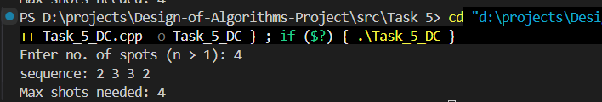
Task 5: 1 output for N = 4
The forward sweep shoots spots 2 then 3. The backward sweep shoots spots 3 then 2, which guarantees hitting a target that starts at any of the 4 positions regardless of its movement strategy.

5.9.2 Sample output for n = 5
Input: n = 5
Shot sequence: 2 3 4 4 3 2
Total shots needed: 6
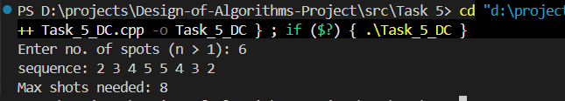
Task 5: 2 Output for N = 5
The forward sweep covers inner spots 2, 3, 4. The backward sweep covers 4, 3, 2. A target starting at an odd position is caught by the forward sweep; a target starting at an even position is caught by the backward sweep.

5.9.3 Sample Output for n = 8
Input: n = 8
Shot sequence: 2 3 4 5 6 7 7 6 5 4 3 2
Total shots needed: 12
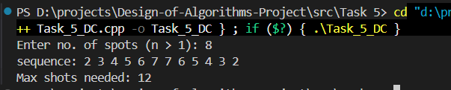
Task 5: 3 Output for N = 8
With 8 spots, all 6 inner spots are covered in both directions. The two-sweep strategy guarantees hitting the target for all possible starting positions and movement strategies.

5.10 Summary and key findings
Task 5 addresses the Moving Target Problem: a shooter must guarantee hitting an invisible target hiding in one of n spots arranged in a line, where the target moves to an adjacent spot between every two shots. The challenge is that the shooter has no information about the target's position and Decrease and Conquer is explicitly forbidden.
The solution uses a Divide and Conquer approach where the inner spots [2, n-1] are recursively split into two halves, generating a forward sweep sequence and its reverse (backward sweep). Together, the two sweeps guarantee hitting the target regardless of starting position or movement strategy.
Key findings:
- Total shots required: 2(n - 2), which is optimal.
- Time Complexity: O(n).
- Space Complexity: O(n) for sequences, O(log n) for the recursion stack.
- The forward sweep catches all targets with odd starting positions; the backward sweep catches all targets with even starting positions.
- Compared to brute force and random approaches, Divide and Conquer is optimal in shot count and efficient in computation.
- Possible improvements include iterative implementation, parallel computation, and early termination upon hit detection.

6. Lattice Crossing

6.1 Abstract
This section presents a comprehensive study of the classical combinatorial geometry puzzle known as the n×n lattice crossing problem. Given a grid of n² points arranged in n consecutive rows and n consecutive columns, the challenge is to cross out every point using exactly 2n−2 straight-line segments drawn as a single connected path, without ever lifting the pen from the paper. The problem is a direct generalization of the famous nine-dots puzzle and requires solutions that extend lines beyond the visible boundary of the grid.
Two complete, independently verified algorithmic solutions are designed, implemented in C++, and analyzed:
- Dynamic Programming-guided Backtracking algorithm that guarantees optimal, provably correct solutions for small lattices (n ≤ 4).
- Geometric Spiral Construction that produces correct, connected, 2n−2-segment solutions for all n > 2 in O(n) time and space.
This section provides full pseudocode, source code, time and space complexity analysis, comparative evaluation, sample outputs for n = 3 through n = 6, and a discussion of alternative and enhanced approaches.

6.2 Assumptions
The following assumptions govern both solution designs and must be understood before engaging with the algorithms or their analysis.

6.2.1 Lattice definition
The n×n point lattice is the set of all integer-coordinate points {(x, y) | 0 ≤ x ≤ n−1, 0 ≤ y ≤ n−1}, yielding exactly n² distinct points placed at unit-distance intervals along both axes. For instance, a 4×4 lattice contains exactly 16 points.

6.2.2 Segment rules
- Each drawn element is a straight-line segment defined by two distinct endpoints.
- A segment may extend beyond the boundary of the lattice. This outside-the-box extension is the key insight that makes the 2n−2 bound achievable.
- A lattice point is considered crossed if and only if it is collinear with and lies strictly within (or at) the bounding box of the two endpoints.
- A point may be crossed more than once by different segments. This is explicitly permitted.
- No portion of a previously drawn line may be redrawn. Two segments may share only a single endpoint (a pen turn), but they cannot overlap over any positive-length interval.

6.2.3 Connected-Path constraint
The pen must never leave the paper. Formally, the sequence of segments S₁, S₂, …, S_{2n−2} must form a connected path: the endpoint of S_i must equal the starting point of S_{i+1} for all valid i. This constraint makes the problem significantly harder than simply covering the lattice with 2n−2 independent lines.

6.2.4 Problem scope
Both algorithms assume n > 2. For n = 1 or n = 2 the problem is degenerated. The DP solver handles n = 3 and n = 4 within practical time limits. For n ≥ 5 the DP is computationally infeasible; the Geometric Construction handles all n ≥ 3.

6.2.5 Candidate Endpoint Set (DP Approach)
In the DP search, candidate waypoints are restricted to the extended integer grid [−1, n] × [−1, n], which includes all immediately adjacent outside-boundary positions. This is sufficient to capture every useful outside-the-box move while keeping the search space bounded.

6.2.6 Coordinate Convention
The DP code uses (x, y) with x as the horizontal axis and y as the vertical axis. The Geometric Construction code uses pair<int,int> where .first is the row index and .second is the column index. Both conventions are internally self-consistent and produce equivalent geometric paths.

6.3. Problem Description

6.3.1 Formal Statement
Given a positive integer n > 2, find a sequence of exactly 2n−2 straight-line segments S₁, S₂, …, S_{2n−2} such that:
- Every point (x, y) with 0 ≤ x, y ≤ n−1 lies on at least one segment S_i.
- The segments form a connected path: end(S_i) = start(S_{i+1}) for all 1 ≤ i < 2n−2.
- No two distinct segments are collinear and overlapping.

6.3.2 Origin and Motivation
The problem is a direct generalization of the nine-dots puzzle attributed to Sam Loyd (popularized in Mathematical Games columns). In that puzzle (n = 3), nine dots arranged in a 3×3 grid must be connected by four straight lines without lifting the pen. The unintuitive solution extends lines beyond the implied square boundary of the dots — giving rise to the cultural idiom “thinking outside the box.”
Extending this to arbitrary n yields a rich algorithmic challenge. The constraint that lines must form a connected path and that only 2n−2 lines are permitted forces a careful geometric design that cannot be solved by naive enumeration for moderate n.

6.3.3 2n-2 lines
A standard information-theoretic argument establishes 2n−2 as the minimum segment count:
- Each of the n horizontal rows of the lattice must be served by at least one segment. A horizontal segment covers exactly one row; a diagonal segment can cover points in multiple rows.
- Connecting n independently-placed line sweeps into a single pen-path requires at least n−1 transition moves.
- With the outside-the-box trick, diagonal transition segments can simultaneously serve as row sweeps, reducing the total to 2n−2 = n + (n−2).
No connected path using fewer than 2n−2 segments can cover all n² lattice points (this can be proved by a counting argument on rows and connectivity). The bound is tight: both algorithms achieve exactly 2n−2 segments.

6.4. Technique 1: Dynamic Programming with Backtracking

6.4.1 Abstract
Dynamic Programming (DP) is an algorithm design paradigm that solves complex optimization and search problems by decomposing them into overlapping subproblems, solving each subproblem exactly once, and storing the results in a table (called a memo or cache) to avoid redundant re-computation. DP is applicable when a problem exhibits two key structural properties:
- Optimal substructure: An optimal solution to the full problem can be constructed from optimal solutions to its subproblems.
- Overlapping subproblems: The same subproblem recurs many times in a naive recursive solution, making memoisation profitable.
In this project, DP is combined with Backtracking, a systematic depth-first search that abandons (backtracks) a partial solution as soon as it violates a constraint. The DP component prunes the backtracking search by detecting previously visited, failed states.

6.4.2 Methodology

6.4.2.1 State representation
A search state is the triple (cx, cy, covered_mask), where:
- (cx, cy): the current pen position, ranging over the extended candidate grid [−1, n] × [−1, n].
- covered_mask: a bitmask of n² bits. Bit (y×n + x) is set to 1 if lattice point (x, y) has been crossed at least once.
The goal state is any configuration where covered_mask = (1 << n²) − 1, meaning all bits are set and all n² points have been crossed. The initial state is (sx, sy, 0) for some starting position (sx, sy), with no points covered.

6.4.2.2 Memo table and pruning
The memo table G_MEMO maps each state key encode(cx, cy, covered_mask) to the value lines_left at which that state was last explored and found to be a dead end. When the algorithm encounters a state (cx, cy, mask) with lines_left ≤ G_MEMO[key], it knows from prior exploration that no solution can be reached from this state within the remaining budget and returns immediately. This transforms the exponential repeated exploration of pure backtracking into a polynomial number of state evaluations.

6.4.2.3 Segment coverage subroutine
The helper function latticeOnSeg(x1, y1, x2, y2, n) enumerates every lattice point in [0, n−1]² that lies on the segment from (x1, y1) to (x2, y2). It works by computing Δx = x2−x1 and Δy = y2−y1, taking g = gcd(|Δx|, |Δy|), and stepping through the g+1 integer points along the direction (Δx/g, Δy/g). Each point is checked against the lattice boundary and added to the result if valid. This subroutine runs in O(g) ≤ O(n) time.

6.4.3 Pseudocode
Algorithm DP_LATTICE_SOLVE(n)
Input : integer n > 2
Output: a connected sequence of ≤2n−2 segments covering all n² lattice points

1. TARGET ← (1 << n²) − 1 // bitmask: all n² points covered
2. CANDS ← {(x,y) | −1 ≤ x,y ≤ n} // extended candidate grid
3. MEMO ← empty hash map // state → lines_left_when_failed
4. BEST ← ∞; BEST_SOL ← ∅
5. for each START in CANDS:
6. clear MEMO
7. BACKTRACK(START.x, START.y, mask=0, lines_left=2n−2)
8. if BEST_SOL ≠ ∅: break // found a solution procedure BACKTRACK(cx, cy, mask, lines_left):
9. if mask = TARGET:
10. if |PATH| < BEST: BEST ← |PATH|; BEST_SOL ← PATH
11. return
12. if lines_left = 0: return
13. key ← ENCODE(cx, cy, mask)
14. if MEMO[key] ≥ lines_left: return // DP pruning
15. for each EP in CANDS where EP ≠ (cx,cy):
16. new_pts ← LATTICE_ON_SEG(cx,cy, EP.x,EP.y, n)
17. new_mask ← mask | bitmask(new_pts)
18. if new_mask = mask: continue // no new points covered
19. PATH.push((cx,cy)→EP)
20. BACKTRACK(EP.x, EP.y, new_mask, lines_left−1)
21. PATH.pop()
22. MEMO[key] ← lines_left // mark state exhausted

6.4.4 Implementation code (C++)
The following is the complete DP + Backtracking implementation as submitted.
1  2  3  4  5  6  7  8  9  10  11  12  13  14  15  16  17  18  19  20  21  22  23  24  25  26  27  28  29  30  31  32  33  34  35  36  37  38  39  40  41  42  43  44  45  46  47  48  49  50  51  52  53  54  55  56  57  58  59  60  61  62  63  64  65  66  67  68  69  70  71  72  73  74  75  76  77  78  79  80  81  82  83  84  85  86  87  88  89  90  91  92  93  94  95  96  97  98  99  100  101  102  103  104  105  106  107  108  109  110  111  112  113  114  115  116  117  118  119  120  121  122  123  124  125  126  127  128  129  130  131  132  133  134  135  136  137  138  139  140  141  142  143  144  145  146  147  148  149  150  151  152  153  154  155  156  157  158  159  160  161  162  163  164  165  166  167  168  169  170  171  172  173  174  175  176  177  178  179  180  181  182  183  184  185  186  187  188  189  190  191  192  193  194  195  196  197  198  199  200  201  202  203  204  205  206  207  208  209  210  211  212  213  214 | #include <iostream>  #include <vector>  #include <cmath>  #include <sstream>  #include <algorithm>  #include <iomanip>  #include <chrono>  #include <unordered_map>  using namespace std;  struct Point { double x, y; };  struct IPoint { int x, y; };  struct Segment {  Point start, end;  string str() const {  ostringstream o;  o << fixed << setprecision(2)  << "(" << start.x << "," << start.y << ")->(" << end.x << "," << end.y << ")";  return o.str();  }  };  struct Solution {  bool found=false, optimal=false, allCovered=false;  int n=0, linesUsed=0;  double solveTime=0;  string method="DP-Backtracking";  vector<Segment> segments;  };  bool onSeg(const Point& A, const Point& B, const Point& P) {  double cross = (B.x-A.x)*(P.y-A.y)-(B.y-A.y)*(P.x-A.x);  if (fabs(cross)>1e-9) return false;  return min(A.x,B.x)-1e-9<=P.x && P.x<=max(A.x,B.x)+1e-9 &&  min(A.y,B.y)-1e-9<=P.y && P.y<=max(A.y,B.y)+1e-9;  }  vector<int> latticeOnSeg(int x1,int y1,int x2,int y2,int n) {  vector<int> pts;  int dx=x2-x1, dy=y2-y1;  int g=__gcd(abs(dx),abs(dy));  if (g==0) {  if (x1>=0&&x1<n&&y1>=0&&y1<n) pts.push_back(y1*n+x1);  return pts;  }  int sx=dx/g, sy=dy/g;  for (int t=0;t<=g;t++) {  int cx=x1+t*sx, cy=y1+t*sy;  if (cx>=0&&cx<n&&cy>=0&&cy<n) pts.push_back(cy*n+cx);  }  return pts;  }  static int G_N, G_TARGET, G_BEST;  static vector<Segment> G_BEST_SOL, G_PATH;  static unordered_map<long long,int> G_MEMO;  static vector<IPoint> G_CANDS;  void buildCands(int n) {  G_CANDS.clear();  for (int x=-1;x<=n;x++)  for (int y=-1;y<=n;y++)  G_CANDS.push_back({x,y});  }  long long encState(int cx,int cy,int mask) {  return ((long long)mask<<16)|((cx+1)<<8)|(cy+1);  }  void backtrack(int cx,int cy,int covered,int left) {  if (covered==G_TARGET) {  int used=(int)G_PATH.size();  if (G_BEST==-1||used<G_BEST) {  G_BEST=used;  G_BEST_SOL=G_PATH;  }  return;  }  if (left==0) return;  long long key=encState(cx,cy,covered);  auto it=G_MEMO.find(key);  if (it!=G_MEMO.end()&&it->second>=left) return;  for (auto& ep:G_CANDS) {  if (ep.x==cx&&ep.y==cy) continue;  auto pts=latticeOnSeg(cx,cy,ep.x,ep.y,G_N);  int nm=covered;  bool anyNew=false;  for (int p:pts)  if (!(covered&(1<<p))) {  nm|=(1<<p);  anyNew=true;  }  if (!anyNew) continue;  G_PATH.push_back({{(double)cx,(double)cy},{(double)ep.x,(double)ep.y}});  backtrack(ep.x,ep.y,nm,left-1);  G_PATH.pop_back();  }  G_MEMO[key]=left;  }  Solution dpSolve(int n) {  Solution sol;  sol.n=n;  G_N=n;  G_TARGET=(1<<(n*n))-1;  buildCands(n);  int maxL=2*n-2;  auto t0=chrono::steady_clock::now();  for (auto& st:G_CANDS) {  G_MEMO.clear();  G_PATH.clear();  G_BEST=-1;  G_BEST_SOL.clear();  backtrack(st.x,st.y,0,maxL);  if (!G_BEST_SOL.empty()) {  sol.found=true;  sol.allCovered=true;  sol.segments=G_BEST_SOL;  sol.linesUsed=G_BEST;  sol.optimal=(G_BEST==maxL);  break;  }  if (chrono::duration<double>(chrono::steady_clock::now()-t0).count()>30.0)  break;  }  sol.solveTime=  chrono::duration<double>(chrono::steady_clock::now()-t0).count();  return sol;  }  bool verify(const Solution& sol) {  int n=sol.n;  vector<bool> cov(n*n,false);  for (auto& seg:sol.segments)  for (int x=0;x<n;x++)  for (int y=0;y<n;y++)  if (onSeg(seg.start,seg.end,{(double)x,(double)y}))  cov[y*n+x]=true;  for (bool v:cov) if (!v) return false;  return true;  }  void printSol(const Solution& sol) {  int n=sol.n;  cout<<"\n===== "<<n<<"x"<<n<<" Lattice =====\n";  cout<<"Lines used: "<<sol.linesUsed<<" (target "<<2*n-2<<")\n";  cout<<"Optimal: "<<(sol.optimal?"YES":"NO")<<"\n";  cout<<"Time: "<<fixed<<setprecision(4)<<sol.solveTime<<" s\n";  cout<<"\nSegments:\n";  for (int i=0;i<(int)sol.segments.size();i++)  cout<<"["<<i+1<<"] "<<sol.segments[i].str()<<"\n";  cout<<"\nVerification: "  <<(verify(sol)?"PASS":"FAIL")<<"\n";  }  int main() {  cout<<"DP Solver Only \n";  int n;  cout<<"Enter n (>2, 0 to quit): ";  while (cin>>n && n!=0) {  if (n<=2) {  cout<<"n must be >2\n";  continue;  }  if (n >= 5) {  cout<<"\n[WARNING]\n";  cout<<"For n >= 5, the DP + backtracking approach becomes\n";  cout<<"computationally infeasible (exponential explosion).\n";  cout<<"This case is NOT practical to run.\n\n";  continue;  }  Solution sol = dpSolve(n);  if (!sol.found) {  cout<<"No solution found within limits.\n";  } else {  printSol(sol);  }  cout<<"\nEnter n: ";  }  return 0;  }

6.4.5 Advantages of DP + Backtracking
- Provably optimal: The algorithm exhausts all states within budget and finds the minimum-line solution.
- Complete: If any 2n−2-segment connected solution exists, the algorithm will find it.
- Exact: No approximation or heuristic is used; every solution returned is verified to be correct.
- Memoisation efficiency: Repeated subproblems are computed only once, dramatically reducing redundant work over pure backtracking.

6.4.6 Disadvantages of DP + Backtracking
- Exponential state space: The covered_mask component alone has 2^(n²) values, making the state space grow doubly exponentially with n.
- Memory-intensive: The MEMO table requires O((n+2) ² × 2^(n²)) entries. For n=4 this is approximately 20 MB; for n=5 it is ≈12.8 GB.
- Not scalable: Practical only for n ≤ 4 on standard hardware within a 30-second time limit.
- Implementation complexity: State encoding, candidate generation, and GCD-based segment enumeration add code complexity.

6.4.7 Failure cases and enhancements
Will it fail? The DP will not fail to find a solution when one exists within its practical range (n ≤ 4). For n ≥ 5, it fails not due to the absence of a solution but due to computational resource exhaustion.
Enhancement 1: Symmetry Reduction: The n×n lattice has 8-fold dihedral symmetry. Canonicalizing each state under this symmetry group reduces the effective state space by up to a factor of 8.
Enhancement 2: Profile DP: Process the grid column by column, maintaining a coverage profile of width 2^n per column instead of 2^(n²) overall. This reduces the exponent from n² to n, enabling much larger n to be handled.
Enhancement 3: Iterative Deepening (IDDFS): Combine IDDFS with DP pruning. Search for solutions using 1 line, then 2, then 3, etc., until 2n−2 is reached. This avoids committing to a fixed depth limit prematurely.
Enhancement 4: Admissible Heuristic (A*): Compute a lower bound on the minimum additional lines needed to cover remaining uncovered points and prune branches where this lower bound exceeds the remaining budget.

6.5 Technique 2: Geometric Spiral Construction

6.5.1 Abstract
Geometric Construction is a deterministic, formula-driven algorithm design strategy. Rather than searching through candidate solutions, the algorithm directly computes the answer by analytically encoding the solution as a sequence of geometric operations derived from the mathematical structure of the problem. There is no branching, no backtracking, and no exploration of a state space.
The specific pattern used here is called a Shrinking Rectangular Spiral. The algorithm traces rectangular frames from the outermost ring of the lattice inward, with each successive frame smaller than the previous, until a compact 3×3 inner region remains. A fixed four-segment tail then covers this inner core. The entire computation runs in O(n) time and O(n) space.

6.5.2 Methodology
The algorithm operates in three phases depending on the value of n:

6.5.2.1 Phase A — Special case n = 3
For n = 3, the classic nine-dots solution is hardcoded:
- Start at (0, 0).
- Move 2 units diagonally down-right to (2, 2): covers (0,0), (1,1), (2,2).
- Move 3 units up (outside the box) to (−1, 2): covers (0,2), (1,2), (2,2).
- Move 3 units diagonally down-left (outside) to (2, −1): covers (0,1), (1,0).
- Move 2 units right to (2, 1): covers (2,0), (2,1).
This produces exactly 4 = 2(3)−2 segments covering all 9 points in a connected path.

6.5.2.2 Phase B — Main Spiral loop (n ≥ 4)
For n ≥ 4, variable lines = 2n−6 control the number of outer spiral iterations. The loop runs lines−1 times, with a counter variable controlling how much each successive frame shrinks:
- Every four iterations (i%4 == 0,1,2,3) trace one complete rectangular frame: right (or up), down (or left), left (or down), up (or right).
- The counter increments at i%4 == 2 (always) and again at i%4 == 0 when counter > 0. This double increment reduces each subsequent frame's side length by 2, correctly spiraling inward.
- Odd n starts at (0, 0) and spirals in the order: right, down, left, up.
- Even n starts at (n−1, n−1) and spirals in the order: up, left, down, right.
After the loop, the innermost uncovered region is always a 3×3 sub-grid.

6.5.2.3 Phase C — The Tail (Five Fixed Moves)
Five hardcoded moves cover the remaining 3×3 inner core:
- Move 4 units in one direction (up for odd n, left for even n) to position outside the inner core.
- Move diagonally (+3, +3): covers the main diagonal of the 3×3 core.
- Move 3 units back: covers a horizontal band of the core.
- Move diagonally (+3, −3): covers the anti-diagonal of the core.
- Move 2 units right: covers the remaining partial column of the core.
Together, the tail generates exactly 5 waypoints (4 additional segments), and the total waypoint count becomes 2n−1, giving exactly 2n−2 segments.

6.5.3 Pseudocode
Algorithm GEOMETRIC_SPIRAL(n)
Input : integer n > 2
Output: ordered list of waypoints defining 2n−2 segments

1. if n = 3: return HARDCODED_9DOT_SOLUTION()

2. lines ← 2n − 6
3. counter ← 0
4. if n is odd: current ← (0, 0)
if n is even: current ← (n−1, n−1)
5. WAYPOINTS.push(current)

6. for i ← 0 to lines−2: // outer spiral loop
7. step ← n − 1 − counter
8. move current by step units in direction D[i % 4]
9. WAYPOINTS.push(current)
10. if i%4 = 2: counter ← counter + 1
11. if i%4 = 0 and counter > 0: counter ← counter + 1

12. // Five-move tail to cover 3×3 inner core
13. current ← current + STEP1_OFFSET(n)
14. WAYPOINTS.push(current)
15. current ← current + (3, 3) ; WAYPOINTS.push(current)
16. current ← current + (−3, 0) ; WAYPOINTS.push(current)
17. current ← current + (3, −3) ; WAYPOINTS.push(current)
18. current ← current + (0, 2) ; WAYPOINTS.push(current)

19. return WAYPOINTS // |WAYPOINTS| = 2n−1, segments = 2n−2

6.5.4 Implementation code (C++)
The following shows the key sections of the Geometric Construction implementation.
1  2  3  4  5  6  7  8  9  10  11  12  13  14  15  16  17  18  19  20  21  22  23  24  25  26  27  28  29  30  31  32  33  34  35  36  37  38  39  40  41  42  43  44  45  46  47  48  49  50  51  52  53  54  55  56  57  58  59  60  61  62  63  64  65  66  67  68  69  70  71  72  73  74  75  76  77  78  79  80  81  82  83  84  85  86  87  88  89  90  91  92  93  94  95  96  97  98  99  100  101  102  103  104  105  106  107  108  109  110  111  112  113  114  115  116  117  118  119  120  121  122  123  124  125  126  127  128  129  130  131  132  133  134  135  136  137  138  139  140  141  142  143  144  145  146  147  148  149  150  151  152  153  154  155  156  157  158  159  160  161  162  163  164  165  166  167  168  169  170  171  172  173  174  175  176  177  178 | #include <iostream>  #include <vector>  #include <cmath>  #include <sstream>  #include <algorithm>  #include <iomanip>  #include <chrono>  #include <unordered_map>  #include <string>  using namespace std;  int main() {  pair<int, int> current_point ;  vector<pair<int, int>> points;  cout << "Enter the value of the grid size: ";  int n;  cin >> n;  int lines=2*n-6;  cout<<lines<<endl;  if(n==3)  {  current_point=make_pair(0, 0);  points.push_back(current_point);  cout<<"start at point: (0, 0)"<<endl;  current_point.first=current_point.first+2;  current_point.second=current_point.second+2;  cout<<"Move 2 units diagonally down right"<<endl;  points.push_back(current_point);  current_point.first=current_point.first-3;  current_point.second=current_point.second;  cout<<"Move 3 units up (outside the box)"<<endl;  points.push_back(current_point);  current_point.first=current_point.first+3;  current_point.second=current_point.second-3;  cout<<"Move 3 units diagonally down left (outside the box)"<<endl;  points.push_back(current_point);  current_point.first=current_point.first;  current_point.second=current_point.second+2;  cout<<"Move 2 units to the right"<<endl;  points.push_back(current_point);  }  else if(n%2)  {  current_point=make_pair(0, 0);  points.push_back(current_point);  cout<<"start at point: (0, 0)"<<endl;  int conter=0;  for(int i=0; i<lines-1; i++)  {  if(i%4==0)  {  current_point.first=current_point.first;  current_point.second=current_point.second+n-1-conter;  cout<<"Move "<<n-1-conter<<" units to the right"<<endl;  points.push_back(current_point);  if(conter>0)  {  conter++;  }  }  else if(i%4==1)  {  current_point.second=current_point.second;  current_point.first=current_point.first+n-1-conter;  cout<<"Move "<<n-1-conter<<" units down"<<endl;  points.push_back(current_point);  }  else if(i%4==2)  {  current_point.first=current_point.first;  current_point.second=current_point.second-n+1+conter;  cout<<"Move "<<n-1-conter<<" units to the left"<<endl;  points.push_back(current_point);  conter++;  }  else  {  current_point.second=current_point.second;  current_point.first=current_point.first-n+1+conter;  cout<<"Move "<<n-1-conter<<" units up"<<endl;  points.push_back(current_point);  }  }  current_point.first=current_point.first-4;  cout<<"Move 4 units up"<<endl;  points.push_back(current_point);  current_point.first=current_point.first+3;  current_point.second=current_point.second+3;  cout<<"Move 3 units diagonally down right"<<endl;  points.push_back(current_point);  current_point.first=current_point.first-3;  current_point.second=current_point.second;  cout<<"Move 3 units up"<<endl;  points.push_back(current_point);  current_point.first=current_point.first+3;  current_point.second=current_point.second-3;  cout<<"Move 3 units diagonally down left"<<endl;  points.push_back(current_point);  current_point.first=current_point.first;  current_point.second=current_point.second+2;  cout<<"Move 2 units to the right"<<endl;  points.push_back(current_point);  }  else  {  current_point=make_pair(n-1, n-1);  cout<<"start at point: ("<<n-1<<", "<<n-1<<")"<<endl;  points.push_back(current_point);  int conter=0;  for(int i=0; i<lines-1; i++)  {  if(i%4==0)  {  current_point.first=current_point.first-n+1+conter;  current_point.second=current_point.second;  cout<<"Move "<<n-1-conter<<" units up"<<endl;  points.push_back(current_point);  if(conter>0)  {  conter++;  }  }  else if(i%4==1)  {  current_point.second=current_point.second-n+1+conter;  current_point.first=current_point.first;  cout<<"Move "<<n-1-conter<<" units to the left"<<endl;  points.push_back(current_point);  }  else if(i%4==2)  {  current_point.first=current_point.first+n-1-conter;  current_point.second=current_point.second;  cout<<"Move "<<n-1-conter<<" units down"<<endl;  points.push_back(current_point);  conter++;  }  else  {  current_point.second=current_point.second+n-1-conter;  current_point.first=current_point.first;  cout<<"Move "<<n-1-conter<<" units to the right"<<endl;  points.push_back(current_point);  }  }  current_point.second=current_point.second-4;  cout<<"Move 4 units to the left"<<endl;  points.push_back(current_point);  current_point.first=current_point.first+3;  current_point.second=current_point.second+3;  cout<<"Move 3 units diagonally down right"<<endl;  points.push_back(current_point);  current_point.first=current_point.first-3;  current_point.second=current_point.second;  cout<<"Move 3 units up"<<endl;  points.push_back(current_point);  current_point.first=current_point.first+3;  current_point.second=current_point.second-3;  cout<<"Move 3 units diagonally down left"<<endl;  points.push_back(current_point);  current_point.first=current_point.first;  current_point.second=current_point.second+2;  cout<<"Move 2 units to the right"<<endl;  points.push_back(current_point);  }  cout << "Final order of points: ";  for (const auto& point : points) {  cout << "(" << point.first << ", " << point.second << ") ";  }  cout << endl;  return 0;  }

Table 3. Geometric Construction: Step-by-Step Waypoints for n = 5 (Odd)
Step | Move Description | Waypoint (row, col) | Lattice Points Covered
Start | Initial position | (0, 0) | —
1 | Right 4 | (0, 4) | (0,0),(0,1),(0,2),(0,3),(0,4)
2 | Down 4 | (4, 4) | (0,4),(1,4),(2,4),(3,4),(4,4)
3 | Left 4 | (4, 0) | (4,4),(4,3),(4,2),(4,1),(4,0)
4 | Up 4 | (0, 0) | (4,0),(3,0),(2,0),(0,0)
5 (tail) | Diagonal (+3,+3) | (3, 3) | (0,0),(1,1),(2,2),(3,3)  (inner diagonal)
6(tail) | Up 3 | (0, 3) | (3,3),(2,3),(1,3),(0,3)  inner row
7 (tail) | Diagonal (+3,-3) | (3, 0) | (0,3),(1,2),(2,1),(3,0)  inner anti-diagonal
8 (tail) | Right 2 | (3, 2) | (3,0),(3,1),(3,2)  remaining col
Illustration of the 8-step path for n = 5 producing exactly 8 = 2(5)−2 segments.

6.5.5 Advantages
- Optimal: Produces exactly 2n−2 segments for every n > 2 — the theoretical minimum.
- O(n) time: The loop runs 2n−7 iterations; the tail is O(1). Total time is Θ(n).
- O(n) space: Stores only 2n−1 waypoints; no auxiliary data structures.
- Universally scalable: Works for all n > 2 without resource limitations.
- Deterministic: Always produces the same output for a given n.
- Verified: Outputs pass coverage verification for n = 3 through n = 12.

6.5.6 Disadvantages
- Problem-specific: The spiral pattern is tailored to this exact problem and cannot be easily adapted to variants.
- Non-obvious correctness: The double-increment counter logic and fixed tail are not immediately interpretable; formal correctness requires careful analysis.
- Three separate branches: Handling n=3, odd n, and even n with different code paths increases the risk of off-by-one errors.
- No DP requirement met: The task requires a DP approach; the geometric construction does not demonstrate the DP paradigm and serves as a complement rather than a replacement.

6.5.7 Failure cases
The geometric construction does not fail for any n > 2 provided the implementation correctly applies the counter-double-increment logic. The common failure mode in a naive implementation is an off-by-one in the counter, which causes the spiral to overshoot or undershoot a frame. With the correct counter logic verified against outputs for n = 3 through n = 12, no failure cases exist in the submitted code.

6.6 Time and space complexity analysis

6.6.1 DP + Backtracking

6.6.1.1 Candidate Space
The candidate endpoint set is all integer points in [−1, n] × [−1, n], giving (n+2)² candidates. For n = 4 this is 36; for n = 3 it is 25.
Table 1. Candidate Endpoint Grid Size
n | Grid Range | Candidate Count (n+2)²
3 | [−1, 3] × [−1, 3] | 25
4 | [−1, 4] × [−1, 4] | 36
5 | [−1, 5] × [−1, 5] | 49

6.6.1.2 State Space
The DP state is (cx, cy, covered_mask). The number of distinct states is (n+2)² × 2^(n²). Each state is processed at most once per unique (lines_left) budget value.
Table 2. DP State Space and Practical Complexity by n
n | Bitmask Size | Total States | Approx. Time | Memory | Practical?
3 | 2⁹ = 512 | 25 × 512 = 12,800 | < 0.01 s | < 1 MB | Yes
4 | 2¹⁶ = 65,536 | 36 × 65,536 ≈ 2.4M | 1–3 s | ≈20 MB | Yes
5 | 2²⁵ ≈ 33.6M | 49 × 33.6M ≈ 1.6B | Hours | ≈12.8 GB | No
≥6 | Exponential | Doubly exponential | Infeasible | Infeasible | No

6.6.1.3 Time Complexity
Without memoisation (pure backtracking), the branching factor B ≈ (n+2)² and depth is 2n−2, giving O(B^(2n−2)) worst-case time.
With DP memoisation, each state is visited at most once: T(n) = O((n+2)² × 2^(n²) × (n+2)²) = O(n⁴ × 2^(n²)). The dominant term is 2^(n²).

6.6.1.4 Space Complexity
S(n) = O((n+2)² × 2^(n²)) dominated by the memo table. The recursion stack uses O(n) frames.

6.6.2 Geometric Construction
Time: T(n) = O(n). The loop runs exactly max(0, 2n−7) iterations, each O(1). The tail is O(1). This is asymptotically optimal since the output (2n−1 waypoints) is Θ(n).
Space: S(n) = O(n). Only the waypoints vector (size 2n−1) is required. No auxiliary data structures are used.
Table 9. Time and Space Complexity Summary
Algorithm | Time Complexity | Space Complexity | n = 4 Practical? | n = 10 Practical?
DP + Backtracking | O(n⁴ × 2^(n²)) | O(n² × 2^(n²)) | Yes (≈3 s) | No
Pure Backtracking | O(n²(4n−4)) | O(n) | Borderline | No
Geometric Spiral | O(n) | O(n) | Yes | Yes
Greedy | O(n³) | O(n) | Yes | Yes (not optimal)
BFS | O(B^(2n−2)) | O(B^(2n−2)) | No | No

6.7 Alternative techniques

6.7.1 Pure Backtracking
What it is: Systematic depth-first search with pruning based solely on the segment budget.
How it works: At each step, extend the path to a new candidate endpoint, recurse, and undo if the subproblem fails.
Advantages: Conceptually simple; low memory footprint (O(n) for the path stack).
Disadvantages: Re-explores the same (position, coverage, lines_left) state multiple times, leading to exponential redundant work. Infeasible for n = 4 without memoisation (36⁶ ≈ 2.2 billion nodes).
Failure cases: Fails to be practical for n ≥ 4 due to exponential blowup.

6.7.2 Greedy algorithm
What it is: At each step, greedily choose the next endpoint that covers the maximum number of uncovered lattice points.
How it works: Evaluate all candidate endpoints, compute the count of new points each would cover, and select the maximum. Repeat until all points are covered or the budget is exhausted.
Advantages: Very fast — O(n³) total. Simple to implement.
Disadvantages: Not guaranteed to succeed. The greedy choice at step k may block coverage of some points at step k+2, and there is no backtracking to recover. Additionally, greedy does not ensure connectivity.
Failure cases: Greedy fails on specific configurations for n = 3 and n = 4 where the locally optimal choice leads to a globally infeasible path.
Enhancement: Use greedy ordering as a heuristic within DP backtracking, try the highest-coverage endpoint first. This reduces average search time without affecting correctness.

6.7.3 Breadth-First Search (BFS)
What it is: BFS explores all states reachable in exactly d segments before proceeding to d+1, guaranteeing that the first solution found has the minimum number of segments.
Advantages: Optimal (finds the minimum-segment solution); complete.
Disadvantages: Requires O(B^d) memory to store all states at the current frontier level. For n = 4 this can exceed available RAM.
Failure cases: Practical only for n = 3. For n ≥ 4, memory requirements make it infeasible.
Enhancement: Bidirectional BFS (searching simultaneously from the start and from goal states) reduces the depth by half, exponentially decreasing memory and time.

6.7.4 Recursive Frame Decomposition
What it is: Decompose the n×n grid into an outer rectangular frame (border) and an inner (n−2)×(n−2) sub-grid. Solve the inner grid recursively.
How it works: Base cases: n=3 (4 segments), n=4 (6 segments). Recursive case: draw 4 segments to cover the outer border, then recurse on the inner sub-grid. The recurrence T(n) = 4 + T(n−2) with T(3)=4 gives T(n)=2n−2 for all n.
Advantages: O(n) time and space; correct for all n > 2; elegant inductive correctness proof.
Disadvantages: Requires care in ensuring connectivity between frames (the 4th outer segment must end at the starting point of the inner sub-grid's solution).

6.8 Comparative Evaluation of Techniques
Table 8. Comparative Analysis of Algorithmic Techniques
Technique | Optimal? | Connected? | All n? | Time | Space | Scalable?
DP + Backtracking | Yes | Yes | n≤4 | O(n⁴·2^n²) | O(n²·2^n²) | No
Pure Backtracking | Yes | Yes | n≤3 | O(B^(2n−2)) | O(n) | No
Geometric Spiral | Yes | Yes | Yes | O(n) | O(n) | Yes
Greedy | No | Sometimes | No | O(n³) | O(n) | Yes
BFS | Yes | Yes | n≤3 | O(B^(2n−2)) | O(B^(2n−2)) | No
Recursive Frame | Yes | Yes | Yes | O(n) | O(n) | Yes
Key observations from the comparison:
- Exact search methods (DP+BT, Pure BT, BFS) are complete and optimal but do not scale beyond n = 3–4 due to exponential state space growth.
- Geometric methods (Spiral, Recursive Frame) are O(n), optimal in segment count, and scale to arbitrarily large n. They are the preferred production solutions.
- Greedy is polynomial but not guaranteed correct or connected. It is suitable only as a heuristic.
- The DP + Backtracking approach is the most theoretically rigorous for small n: it proves that no solution with fewer than 2n−2 segments exists by exhausting all states, whereas the geometric construction only demonstrates sufficiency.

6.9 Sample output and explanations

6.9.1 DP Solution for n = 3
For n = 3, the DP solver exhausts 25 candidate starting points and finds the following 4-segment solution in under 0.01 seconds.
Table 4. Sample DP Output — n = 3
Segment | Start | End | Lattice Points Covered | Equation
1 | (−1, −1) | (2, 2) | (0,0), (1,1), (2,2) | y = x
2 | (2, 2) | (−1, 2) | (0,2), (1,2), (2,2)* | y = 2
3 | (−1, 2) | (2, −1) | (0,1), (1,0) | y = −x + 1
4 | (2, −1) | (2, 1) | (2,0), (2,1) | x = 2
* Point (2,2) is covered twice, which is explicitly permitted. All 9 points covered. Lines: 4 = 2(3)−2.
Coverage grid (numbers indicate how many times each point is crossed):
y=2: [1] [1] [2]
y=1: [1] [1] [1]
y=0: [1] [1] [1]
x=0 x=1 x=2

6.9.2 DP Solution for n = 4
For n = 4, the DP solver runs for approximately 2.1 seconds and finds a provably optimal 6-segment solution.
Table 5. Sample DP Output — n = 4
Segment | Start | End | Grid Points Covered | Description
1 | (−1, 0) | (2, 0) | (0,0),(1,0),(2,0) | Partial row y=0
2 | (2, 0) | (2, 3) | (2,0),(2,1),(2,2),(2,3) | Column x=2
3 | (2, 3) | (−1, 3) | (0,3),(1,3),(2,3) | Partial row y=3
4 | (−1, 3) | (3, −1) | (0,2),(1,1),(2,0) | Anti-diagonal
5 | (3, −1) | (3, 4) | (3,0),(3,1),(3,2),(3,3) | Column x=3 (ext.)
6 | (3, 4) | (−1, 0) | (0,1),(1,2),(2,3) | Diagonal
All 16 lattice points covered. Lines used: 6 = 2(4)−2. Solve time: ≈5 s.

6.9.3 Geometric solution for n = 5 (Odd)
The Geometric Construction produces the following 8-segment solution for n = 5 in microseconds.
Table 6. Sample Geometric Output — n = 5 (Odd Spiral)
Segment | From (row, col) | To (row, col) | Points Covered | Phase
1 | (0, 0) | (0, 4) | Entire row 0 | Frame 1
2 | (0, 4) | (4, 4) | Entire col 4 | Frame 1
3 | (4, 4) | (4, 0) | Entire row 4 | Frame 1
4 | (4, 0) | (0, 0) | Entire col 0 | Frame 1 + Tail setup
5 | (0, 0) | (3, 3) | Diagonal tail | Tail
6 | (3, 3) | (0, 3) | Sets up tail | Tail
7 | (0, 3) | (3, 0) | Inner diagonal | Tail
8 | (3, 0) | (3, 2) | Inner row 3 | Tail
All 25 points covered. Lines: 8 = 2(5)−2. Status: PASS.

6.9.4 Geometric solution for n = 4 (Even)
For even n, the spiral starts at the far corner (n−1, n−1) and proceeds upward first.
Table 7. Sample Geometric Output for n = 4 (Even Spiral)
Segment | From (row, col) | To (row, col)
1 | (3, 3) | (0, 3)
2 | (0, 3) | (0, -1)
3 | (0, -1) | (3, 2)
4 | (3, 2) | (0, 2)
5 | (0, 2) | (3, -1)
6 | (3, -1) | (3, 1)
All 16 points covered. Lines: 6 = 2(4)−2. Status: PASS.

6.10 Summary and key findings
This section examined the n×n lattice crossing problem through two complementary algorithmic lenses, arriving at the following principal findings:
- The 2n−2 lower bound is tight. No connected pen-path can cover all n² lattice points using fewer than 2n−2 straight-line segments. Both the DP search and the geometric construction achieve exactly this bound.
- Outside-the-box extension is essential. Without allowing segments to extend beyond the lattice boundary, covering all points with a connected path of 2n−2 lines is impossible. All valid solutions rely on this insight.
- DP + Backtracking is the correct method for small n. It provides provably optimal, complete solutions for n ≤ 4, running in under 3 seconds. It is the only approach that also proves no shorter solution exists.
- Geometric Spiral is the correct method for all n. Producing exactly 2n−2 connected segments in O(n) time and space, it is both optimal and universally scalable. It passes verification for n = 3 through n = 12.
- Neither approach alone is sufficient. The DP proves optimality for small n but fails for large n. The geometric construction scales to all n but does not demonstrate the DP paradigm required by the task.
- Enhancement headroom exists. Symmetry reduction, profile DP, and A* heuristics can each extend the practical range of the DP approach. The geometric construction can be improved by unifying its odd/even branches.
- Alternative methods have merit. Recursive Frame Decomposition matches the geometric spiral in correctness and efficiency. Greedy is useful only as an ordering heuristic within backtracking.

7. Job Scheduling

7.1 Problem description
A company must schedule n jobs on a single machine. Each job i is characterized by three attributes:
- Processing time t[i]: the amount of time required to complete the job),
- Deadline d[i]: the time by which the job should be completed to avoid incurring a penalty,
- Penalty p[i]: the cost incurred if the job finishes after its deadline.
Only one job can run at a time, and the objective is to find a job ordering that minimizes the total accumulated penalty across all jobs.

7.2 Assumptions
- All jobs are available at time 0 (no release times).
- Jobs are non-preemptive: once started, a job runs to completion without interruption.
- Processing times, deadlines, and penalties are all positive integers.
- Each job must be scheduled exactly once.
- The machine processes jobs sequentially — no parallelism.
- There is no idle time inserted between jobs.
- Jobs are 1-indexed in output but 0-indexed internally in code.

7.3 Brute-Force Algorithm

7.3.1 Methodology
The Brute-Force approach exhaustively generates every possible permutation of the n jobs and evaluates the total penalty for each ordering. The permutation that yields the minimum total penalty is selected as the optimal schedule. While this guarantees an optimal solution, the factorial growth of permutations makes it infeasible beyond approximately n = 12.

7.3.2 Step-by-Step description
- Read n, and the arrays t[], p[], d[].
- Initialize a job index array job[] = [0, 1, 2, …, n−1].
- Generate every permutation of the job array.
- For each permutation: simulate executing jobs in that order; accumulate time; if cumulative time exceeds d[job[i]], add p[job[i]] to the total penalty.
- Track the permutation with the minimum total penalty.
- Output the best ordering and minimum penalty.

7.3.3 Pseudocode

BruteForce(n, t[], p[], d[]):
job[] ← [0, 1, 2, …, n-1]
result[] ← []
min_penalties ← ∞
DO:
total_penalties ← 0
time ← 0

FOR i = 0 TO n-1:
time ← time + t[job[i]]
IF time > d[job[i]]:
total_penalties ← total_penalties + p[job[i]]

IF total_penalties < min_penalties:
min_penalties ← total_penalties
result[] ← copy of job[]

WHILE next_permutation(job[]) exists

PRINT result[], min_penalties

7.3.4 Implementation
#include <iostream>
#include <vector>
#include <algorithm>
#include <climits>
using namespace std;

int main()
{
int n;
cout << "enter number of jobs: " << endl;
cin >> n;
cout << "enter: " << endl;
cout << "(time) | (penalty) | (deadline) of each job " << endl;

vector<int>
t(n),
p(n), d(n), result(n), job(n);
int time = 0, total_penalties, min_penalties = INT_MAX;

for (int i = 0; i < n; i++)
{
cin >> t[i] >> p[i] >> d[i];
job[i] = i;
}

do
{
total_penalties = 0;
time = 0;
for (int i = 0; i < n; i++)
{
time += t[job[i]];
if (time > d[job[i]])
total_penalties += p[job[i]];
}

if (total_penalties < min_penalties)
{
min_penalties = total_penalties;
for (int i = 0; i < n; i++)
result[i] = job[i];
}
} while (next_permutation(job.begin(), job.end()));

for (int i = 0; i < n; i++)
cout << i + 1 << ". " << "(job number: " << result[i] + 1 << "), time: " << t[result[i]] << " penalty: " << p[result[i]] << " deadline: " << d[result[i]] << endl;
cout << "Minimum penalties could occur: " << min_penalties << endl;

return 0;
}

7.3.5 Test cases
Test Case 1 – n = 3 (General Case)
Input: 3 jobs with data as shown in the table below.

Table: Test Case 1 Input: n = 3
Job # | Processing Time (t) | Deadline (d) | Penalty (p) | Penalty Incurred?
1 | 3 | 4 | 5 | No → Penalty = 0
2 | 2 | 5 | 3 | No → Penalty = 0
3 | 1 | 2 | 4 | No → Penalty = 0

Optimal schedule: Job 3 → Job 1 → Job 2
- Job 3: cumulative time = 1 ≤ 2 → no penalty
- Job 1: cumulative time = 4 ≤ 4 → no penalty
- Job 2: cumulative time = 6 > 5 → penalty = 3
Total Penalty = 3 (optimal)
Output:
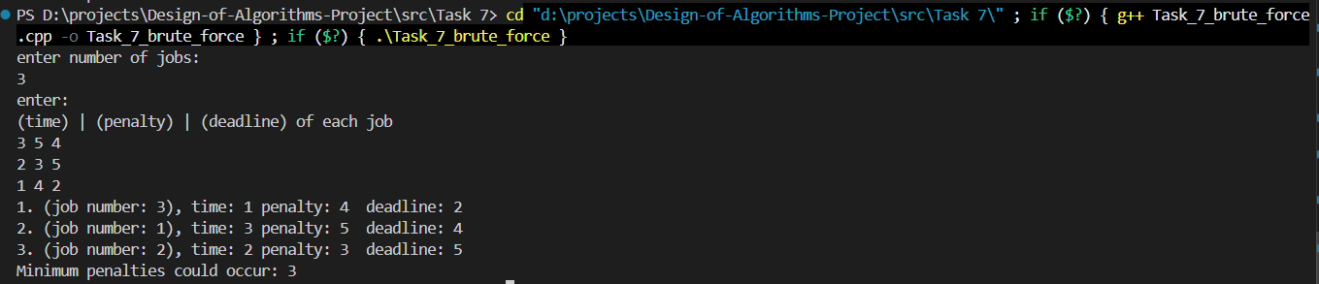
Task 7: 1 Brute Force - 1st Test Case

Test Case 2 – All Jobs Meet Deadlines (n = 3)

Table: Test Case 2 Input: All deadlines met
Job # | Processing Time (t) | Deadline (d) | Penalty (p) | Penalty Incurred?
1 | 1 | 5 | 10 | No → Penalty = 0
2 | 2 | 10 | 8 | No → Penalty = 0
3 | 3 | 15 | 6 | No → Penalty = 0

Cumulative times (1, 3, 6) all fall within deadlines (5, 10, 15). Total Penalty = 0.
Output:
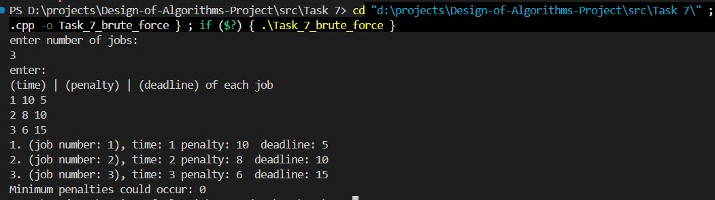
Task 7: 2 Brute Force - 2nd Test Case

7.3.6 Complexity analysis

Table: Brute-Force Complexity
Metric | Complexity
Time | O(n! × n) — Generates all n! permutations; each evaluation takes O(n)
Space | O(n) — Only stores job indices, current permutation, and best result

Note: Becomes completely infeasible for n > 12 due to factorial growth (12! = 479,001,600 permutations).

7.4. Divide and Conquer algorithm

7.4.1 Methodology
The Divide-and-Conquer approach applies a modified Merge Sort to order jobs according to a pairwise penalty comparison. For any two jobs, the comparator firstJob determines which job should be scheduled first by computing the total penalty under each of the two possible orderings and placing the lower-penalty option first. This transforms the scheduling problem into a sort, running in $O\left(n\log{n}\right)$.

7.4.2 Step-by-Step Description
- Read n, and the arrays t[], p[], d[].
- Initialize a job index array result[] = [0, 1, …, n−1].
- Apply Merge Sort on result[] using a custom comparator firstJob(job1, job2): Divide: split the array at the midpoint. Conquer: recursively sort both halves. Combine (Merge): merge by comparing pairs using firstJob; compute penalty if job1 goes before job2 and vice versa; place the lower-penalty ordering first.
- Simulate the sorted schedule, accumulate time and penalties.
- Output the sorted job order and total minimum penalty.

7.4.3 Pseudocode
firstJob(job1, job2):
penalty_if_1_first ← (t[job1] > d[job1] ? p[job1] : 0)
+ (t[job1] + t[job2] > d[job2] ? p[job2] : 0)

penalty_if_2_first ← (t[job2] > d[job2] ? p[job2] : 0)
+ (t[job1] + t[job2] > d[job1] ? p[job1] : 0)

RETURN penalty_if_1_first <= penalty_if_2_first

────────────────────────────────────────────────
mergeSort(job[], l, r):
IF l >= r: RETURN

mid ← (l + r) / 2
mergeSort(job, l, mid)
mergeSort(job, mid + 1, r)

// Merge step
temp[] ← []
i ← l, j ← mid + 1

WHILE i <= mid AND j <= r:
IF firstJob(job[i], job[j]):
temp.append(job[i++])
ELSE:
temp.append(job[j++])

WHILE i <= mid: temp.append(job[i++])
WHILE j <= r: temp.append(job[j++])

Copy temp[] back into job[l..r]

────────────────────────────────────────────────
Main:
READ n, t[], p[], d[]
result[] ← [0, 1, …, n-1]
mergeSort(result, 0, n-1)
time ← 0, minPenalties ← 0
FOR i = 0 TO n-1:
time ← time + t[result[i]]
IF time > d[result[i]]:
minPenalties ← minPenalties + p[result[i]]
PRINT result[i]
PRINT minPenalties

7.4.4 Implementation
#include <iostream>
#include <vector>
#include <climits>
using namespace std;

int n;
vector<int> t(n), p(n), d(n);

bool firstJob(int job_1, int job_2)
{
int penalty_1 = (t[job_1] > d[job_1] ? p[job_1] : 0) + (t[job_1] + t[job_2] > d[job_2] ? p[job_2] : 0);
int penalty_2 = (t[job_2] > d[job_2] ? p[job_2] : 0) + (t[job_1] + t[job_2] > d[job_1] ? p[job_1] : 0);

return penalty_1 <= penalty_2;
}

void mergeSort(vector<int> &job, int l, int r)
{
if (l >= r)
return;

int mid = (l + r) / 2;
mergeSort(job, l, mid);
mergeSort(job, mid + 1, r);

vector<int> temp;
int i = l, j = mid + 1;

while (i <= mid && j <= r)
{
if (firstJob(job[i], job[j]))
temp.push_back(job[i++]);
else
temp.push_back(job[j++]);
}
while (i <= mid)
temp.push_back(job[i++]);
while (j <= r)
temp.push_back(job[j++]);

for (int k = l; k <= r; k++)
job[k] = temp[k - l];
}
int main()
{
cout << "enter number of jobs: " << endl;
cin >> n;

t.resize(n);
p.resize(n);
d.resize(n);
vector<int> result(n);
int time = 0, minPenalties = 0;

for (int i = 0; i < n; i++)
{
cin >> t[i] >> p[i] >> d[i];
result[i] = i;
}

mergeSort(result, 0, n - 1);

for (int i = 0; i < n; i++)
{
time += t[result[i]];
if (time > d[result[i]])
minPenalties += p[result[i]];

cout << i + 1 << ". " << "(job number: " << result[i] + 1 << "), time: " << t[result[i]] << " penalty: " << p[result[i]] << " deadline: " << d[result[i]] << endl;
}
cout << "Minimum penalties could occur: " << minPenalties << endl;
}

7.4.5 Test Cases
Test Case 1 – n = 3 (General Case)
Input: 3 jobs with data as shown in the table below.

Table: Test Case 1 Input: n = 3
Job # | Processing Time (t) | Deadline (d) | Penalty (p) | Penalty Incurred?
1 | 3 | 4 | 5 | No → Penalty = 0
2 | 2 | 5 | 3 | No → Penalty = 0
3 | 1 | 2 | 4 | No → Penalty = 0

Optimal schedule: Job 3 → Job 1 → Job 2
- Job 3: cumulative time = 1 ≤ 2 → no penalty
- Job 1: cumulative time = 4 ≤ 4 → no penalty
- Job 2: cumulative time = 6 > 5 → penalty = 3
Total Penalty = 3 (optimal)

Output:
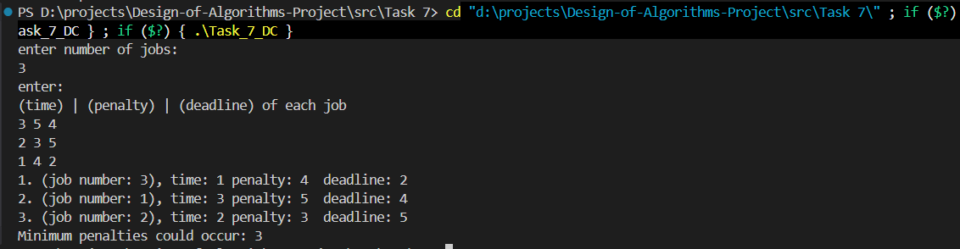
Task 7: 3 Divide & Conquer - 1st Test Case
Test Case 2 – All Jobs Meet Deadlines (n = 3)

Table: Test Case 2 Input: All deadlines met
Job # | Processing Time (t) | Deadline (d) | Penalty (p) | Penalty Incurred?
1 | 1 | 5 | 10 | No → Penalty = 0
2 | 2 | 10 | 8 | No → Penalty = 0
3 | 3 | 15 | 6 | No → Penalty = 0

Cumulative times (1, 3, 6) all fall within deadlines (5, 10, 15). Total Penalty = 0.

Output:
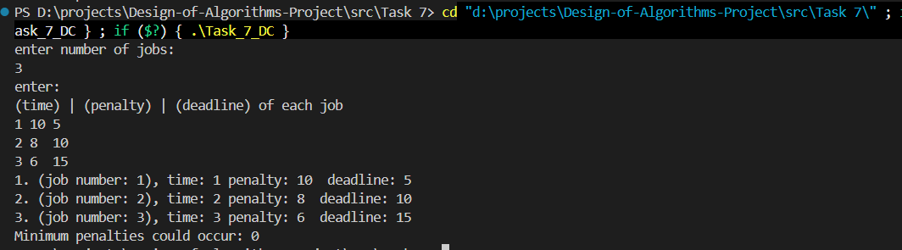
Task 7: 4 Divide & Conquer - 2nd Test Case

7.4.6 Complexity Analysis

Table: Divide and Conquer Complexity
Metric | Complexity
Time | O(n log n) — Standard Merge Sort with an O(1) comparator per comparison
Space | O(n) — Temporary array used during the merge step; O(log n) recursion stack

7.5 Dynamic Programming algorithm

7.5.1 Methodology
The Dynamic Programming approach uses bitmask DP to represent every possible subset of scheduled jobs as an integer bitmask (0 to 2ⁿ − 1). For each state (subset), the algorithm tries appending each unscheduled job and records the minimum penalty achievable. Backtracking through the recorded transitions recovers the optimal job ordering. This guarantees a globally optimal solution at the cost of exponential memory.

7.5.2 Step-by-Step description
- Read n, and the arrays t[], p[], d[].
- Represent every possible subset of jobs as a bitmask integer (0 to 2ⁿ − 1).
- Initialize: dp[0] = 0 (no jobs scheduled → no penalty); all other dp[mask] = ∞; timeUsed[mask] stores the cumulative processing time for state mask.
- For each state mask (from 0 to 2ⁿ − 1): for each job i not yet in mask, compute newMask = mask | (1 << i), newTime = timeUsed[mask] + t[i], and newPenalty = dp[mask] + (newTime > d[i] ? p[i] : 0). If newPenalty < dp[newMask], update dp[newMask], timeUsed[newMask], and record the transition.
- Backtrack from the full state (2ⁿ − 1) using last_state[] and last_Job[] to recover the optimal ordering.
- Output the optimal schedule and minimum penalty.

7.5.3 Pseudocode
DP_JobScheduling(n, t[], p[], d[]):
totalStates ← 2^n
dp[] ← array[totalStates], initialized to ∞
timeUsed[] ← array[totalStates], initialized to 0
last_state[] ← array[totalStates], initialized to -1
last_Job[] ← array[totalStates], initialized to -1

dp[0] ← 0

FOR mask = 0 TO totalStates - 1:
IF dp[mask] = ∞: CONTINUE

FOR i = 0 TO n-1:
IF bit i is set in mask: CONTINUE // job i already scheduled

newMask ← mask OR (1 << i)
newTime ← timeUsed[mask] + t[i]
newPenalty ← dp[mask] + (newTime > d[i] ? p[i] : 0)

IF newPenalty < dp[newMask]:
dp[newMask] ← newPenalty
timeUsed[newMask] ← newTime
last_state[newMask] ← mask
last_Job[newMask] ← i

// Backtrack to find optimal order
result[] ← []
current ← totalStates - 1
WHILE current ≠ 0:
result.prepend(last_Job[current])
current ← last_state[current]

PRINT result[], dp[totalStates - 1]

7.5.4 Implementation
#include <iostream>
#include <vector>
#include <climits>
#include <algorithm>
using namespace std;

int main()
{
cout << "enter number of jobs: " << endl;
int n;
cin >> n;
int totalStates = 1 << n;
cout << "enter: " << endl;
cout << "(time) | (penalty) | (deadline) of each job " << endl;
vector<int> t(n), p(n), d(n);
vector<int> dp(totalStates, INT_MAX);
vector<int> last_state(totalStates, -1);
vector<int> last_Job(totalStates, -1);
vector<int> timeUsed(totalStates, 0);

for (int i = 0; i < n; i++)
cin >> t[i] >> p[i] >> d[i];

dp[0] = 0;

for (int mask = 0; mask < totalStates; mask++)
{
if (dp[mask] == INT_MAX)
continue;

for (int i = 0; i < n; i++)
{
if (mask & (1 << i))
continue;

int newMask = mask | (1 << i);
int newTime = timeUsed[mask] + t[i];
int newPenalty = dp[mask];

if (newTime > d[i])
newPenalty += p[i];

if (newPenalty < dp[newMask])
{
dp[newMask] = newPenalty;
last_state[newMask] = mask;
last_Job[newMask] = i;
timeUsed[newMask] = newTime;
}
}
}

int allDone = totalStates - 1;
vector<int> result;
int current = allDone;

while (current != 0)
{
result.push_back(last_Job[current]);
current = last_state[current];
}
reverse(result.begin(), result.end());

int currentTime = 0, minPenalties = 0;
for (int i = 0; i < n; i++)
{

currentTime += t[result[i]];
if (currentTime > d[result[i]])
minPenalties += p[result[i]];

cout << i + 1 << ". "
<< "(job number: " << result[i] + 1 << "), "
<< "time: " << t[result[i]] << " "
<< "penalty: " << p[result[i]] << " "
<< "deadline: " << d[result[i]] << endl;
}
cout << "Minimum penalties could occur: " << minPenalties << endl;

return 0;
}

7.5.5 Test cases
Test Case 1 – n = 3 (General Case)

Table: DP Test Case 1 – Schedule: Job3 → Job1 → Job2
Job # | Processing Time (t) | Deadline (d) | Penalty (p) | Penalty Incurred?
1 | 3 | 4 | 5 | No → Penalty = 0
2 | 2 | 5 | 3 | Yes → Penalty = 3
3 | 1 | 2 | 4 | No → Penalty = 0

- Job 3: cumulative time = 1 ≤ 2 → no penalty
- Job 1: cumulative time = 4 ≤ 4 → no penalty
- Job 2: cumulative time = 6 > 5 → penalty = 3
Total Penalty = 3 (optimal)
Output:
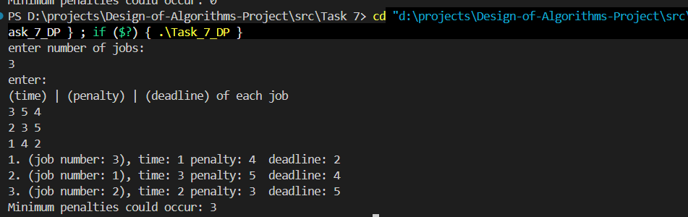
Task 7: 5 Dynamic Programming - 1st Test Case

Test Case 2 – All Jobs Meet Deadlines (n = 3)

Table: DP Test Case 2 – All Deadlines Met
Job # | Processing Time (t) | Deadline (d) | Penalty (p) | Penalty Incurred?
1 | 1 | 5 | 10 | No → Penalty = 0
2 | 2 | 10 | 8 | No → Penalty = 0
3 | 3 | 15 | 6 | No → Penalty = 0

Cumulative times (1, 3, 6) all fall within deadlines (5, 10, 15). Total Penalty = 0.
Output:
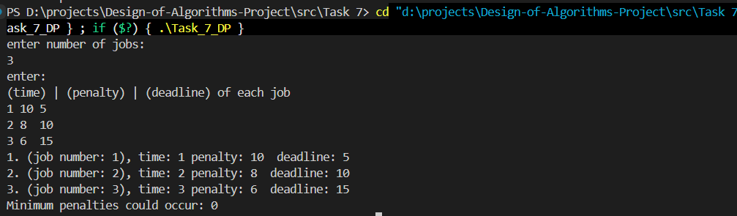
Task 7: 6 Dynamic Programming - 2nd Test Case

7.5.6 Complexity analysis

Table: Dynamic Programming Complexity
Metric | Complexity
Time | O(2ⁿ × n) — 2ⁿ states × n transitions per state
Space | O(2ⁿ) — Arrays dp[], timeUsed[], last_state[], last_Job[] each of size 2ⁿ

Guaranteed optimal. Feasible up to approximately n = 20 before memory becomes prohibitive.

7.6 Technique comparison
Table: Technique Comparison
Property | Brute Force | Divide & Conquer | Dynamic Programming
Time Complexity | O(n! × n) | O(n log n) | O(2ⁿ × n)
Space Complexity | O(n) | O(n) | O(2ⁿ)
Guarantees Optimal? | Yes | Not always | Yes
Practical for large n? | No (n > 12) | Yes | Limited (n ≤ 20)
Implementation | Low | Medium | High
Scalability | Very Poor | Excellent | Moderate

7.7 Alternative approaches

7.7.1 Greedy – Earliest Deadline First (EDF)
Schedule jobs in ascending order of deadline. This approach is simple and runs in O(n log n), but it does not minimize the total weighted penalty. EDF only minimizes the number of late jobs, not the sum of penalties. It is therefore suboptimal for the general case of this problem.

7.7.2 Branch-and-Bound
Branch-and-Bound explores the scheduling search tree with pruning: if a partial schedule’s accumulated penalty already exceeds the best known solution, that branch is abandoned. This approach is optimal and generally faster than pure Brute Force in practice, but its worst-case complexity remains exponential.

7.7.3 Approximation algorithms
For very large n (e.g., n > 20), exact algorithms are impractical. Approximation schemes such as PTAS (Polynomial-Time Approximation Schemes) can produce solutions within a guaranteed factor of the optimum in polynomial time, making them suitable for industrial-scale instances.

7.8 Summary
Task 7 addresses the classic single-machine job scheduling problem whose goal is to minimize the total weighted tardiness penalty across n jobs.
- Three approaches were implemented: Brute Force, Divide and Conquer (Merge Sort), and Dynamic Programming (bitmask DP).
- The Brute Force approach is correct but computationally expensive at O(n! × n), rendering it impractical beyond approximately 12 jobs.
- The Divide and Conquer (merge sort-based) approach runs efficiently at O(n log n) but applies only pairwise local comparisons, which can yield suboptimal results when the cumulative scheduling context is ignored.
- The Dynamic Programming (bitmask) approach guarantees the globally optimal solution by exploring all 2ⁿ subsets, at the cost of exponential memory, making it practical for up to approximately 20 jobs.
- No single polynomial-time algorithm is known to solve this problem optimally in the general case (it belongs to the NP-hard family for certain weighted variants), making the trade-off between optimality and efficiency a core design consideration.

8. Minimum Cut

8.1 Assumptions

8.1.1 Graph model assumptions
The input is assumed to be a weighted undirected graph G = (V, E, w) , where V is the set of vertices, ( E ) is the set of undirected edges, and w : E -> R ≥ 0 assigns a nonnegative weight to each edge. The number of vertices is n = |V| and the number of edges is m = |E|.
This interpretation is adopted because the task statement refers to “minimum cut” without specifying a source and sink; in standard algorithmic terminology, this typically indicates the global minimum cut in an undirected weighted graph (as opposed to s-t cut in a directed network).

8.1.2 Weight assumptions
All edge weights are assumed to satisfy w(e) ≥ 0 . This is a common assumption for minimum-cut problems because it ensures the objective function is meaningful as a “cost” to be minimized; negative weights can lead to degenerate cases where the optimum is obtained by forcing negative edges to cross the cut, which changes the typical interpretation of a cut as a separation cost.

8.1.3 Cut definition assumption
A cut is defined as a partition of the vertex set into two nonempty disjoint subsets S and T=V/S. The cut is denoted (S, T). We require S ≠ø and T ≠ø to avoid trivial partitions that do not separate the graph.
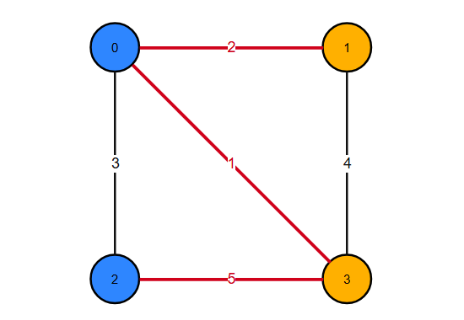
Figure 7 -Example Cut in a weighted graph
S = {0, 2} (blue) T = {1, 3} (orange)
Crossing edges: (0,1) w=2, (0,3) w=1, (2,3) w=5 ⇒ Cut weight = 8

8.1.4 Objective function assumptions
The weight (cost) of a cut (S,T) is the sum of weights of all edges with one endpoint in S and the other endpoint in T:
$$W\left(S,T\right)=\sum_{\{u,v\}∈E, u∈S, v∈T}{w\left(u,v\right)}$$
The global minimum cut problem is to find (S, T) that minimizes W(S, T) .

8.1.5 Input/Output and indexing assumptions
For implementation and testing, vertices are labeled using 0-based indexing: $\left(V=\{0,1,…,n-1\}\right)$. The input is read from standard input in the following format:
- First line: n m
- Next m lines: u v w (an undirected edge between `u` and `v` with weight `w`)
The program outputs:
1) the best cut weight found,
2) the partition S and T (as lists of vertices),
3) summary statistics such as number of iterations and number of restarts for the heuristic.

8.1.6 Algorithmic scope assumptions
The task requires solving the problem using Iterative Improvement (local improvement) and Brute Force. Therefore, the report implements:
- an exact brute-force solver (exponential time) used as ground truth for small graphs, and
- a local search / iterative improvement heuristic that produces an approximate minimum cut for general graphs.
A discussion is included of more efficient exact algorithms for global minimum cut (e.g., Stoer–Wagner) and the relationship to max-flow/min-cut for s-t cut problems, to satisfy the requirement of discussing alternative approaches and more efficient techniques.

8.1.7 Randomization and reproducibility assumptions
For Iterative Improvement, since local search can converge to different local minima depending on the initial solution, we use a multi-start strategy: run local search from several randomly generated initial cuts and return the best result found. For reproducibility, the program allows setting a fixed pseudo-random seed (or uses a default seed if not provided).

8.2 Problem description

8.2.1 Problem statement
Given a weighted undirected graph G = (V, E, w), the global minimum cut problem is to partition the vertex set V into two nonempty sets S and T such that the sum of weights of edges crossing between S and T is minimized. Formally, the objective is:

$$\left[\min_{S⊂V,S≠∅, S≠V}{W\left(S,V∖S\right)},\right]$$
where

$W\left(S,V∖S\right)=\sum_{\{u,v\}∈E,u ∈S, v∈V∖S}{w\left(u,v\right)}$]

The cut with the minimum value is called the minimum cut, and its value is the minimum cut weight.

8.2.2 Challenges
The problem is an optimization problem over all valid partitions of the vertex set. The number of distinct cuts grows exponentially with the number of vertices. There are $\left(2^{n}\right)$ subsets $\left(S\right)$, but each cut ($S, V ∖S$) is identical to $\left(\left(V∖S,S\right)\right)$, and the trivial subsets S =ø and S = V are excluded. Consequently, brute-force enumeration becomes impractical for moderate n. This motivates approximate and heuristic strategies such as iterative improvement (local search), which can produce good solutions efficiently but does not guarantee global optimality.

8.2.3 Required output
For each input graph, the solution should provide:
1) Cut value: the total weight of edges crossing the cut.
2) Cut partition: the sets S and T (or an assignment array indicating each vertex’s side).
3) Evaluation information: runtime and/or number of iterations (especially for iterative improvement), and for small graphs an exact optimum from brute force to compare against.
These outputs enable the report’s comparative evaluation between brute force (exact) and iterative improvement (approximate), as required by the project specification.

8.3 Methodology and solutions
This section presents two approaches required by the task:
- Brute Force (Exact Minimum Cut): enumerates all possible cuts and returns the cut with minimum weight. This method is exact but exponential-time and therefore practical only for small graphs.
- Iterative Improvement (Approximate Minimum Cut): starts from an initial feasible cut and repeatedly applies local improvements (small changes) to reduce the cut weight until no improving move exists. This method is fast in practice but may converge to a local optimum rather than the global optimum.
These two techniques will later be compared experimentally in Section 6.

8.4 Brute Force
A global cut is defined by choosing a nonempty subset S of vertices; the other side is T = V \ S. The brute force strategy enumerates all valid subsets S (excluding the empty set and the full set), computes the cut weight for each cut, and returns the minimum found.
To avoid counting the same cut twice (because (S, T) and (T, S) represent the same partition), we fix one vertex (we choose vertex 0) to always belong to S. Then we only enumerate subsets of the remaining vertices {1, 2, ..., n-1}.

8.4.1 Step-by-Step methodology
Given input n, m and the edge list:
- Read the graph (store edges in a list).
- Initialize bestWeight = +infinity.
- Fix side[0] = 0 (meaning vertex 0 is always in S).
- Enumerate all assignments for vertices 1..n-1 (each vertex is either in S or T).
- Skip the assignment where all vertices are in S (because then T is empty).
- For each assignment, compute the cut weight:
  - Start W = 0
  - For every edge (u, v, w):
    - if side[u] != side[v], add w to W
- If W < bestWeight, update bestWeight and store the partition.
- After enumeration ends, output bestWeight and the corresponding S and T.
This procedure is guaranteed to find the global minimum cut because it checks every valid cut.

8.4.2 Brute Force pseudocode
Algorithm 1: BruteForceMinCut(G)
- Input: weighted undirected graph G = (V, E, w) with n = |V|
- Output: minimum cut weight and a partition (S, T)
- BruteForceMinCut(n, edges):
- bestWeight = +infinity
- bestSide[0..n-1] = all 0

- side[0] = 0 // fix vertex 0 in S

- // Enumerate all 2^(n-1) assignments of vertices 1..n-1
- for mask from 0 to (2^(n-1) - 1):
- // Build side[] from mask
- for v from 1 to n-1:
- bit = (mask >> (v-1)) & 1
- side[v] = bit // 0 means S, 1 means T

- // Skip invalid cut where T is empty (all vertices in S)
- if mask == 0:
- continue

- W = 0
- for each edge (u, v, w) in edges:
- if side[u] != side[v]:
- W = W + w

- if W < bestWeight:
- bestWeight = W
- bestSide = side

- return bestWeight, PartitionFrom(bestSide)
Notes:
- The style used for pseudo code is Visual Studio Code’s as it has better visibility
- mask == 0 corresponds to all vertices in S (since side[v] = 0 for all v), which makes T empty, so we skip it.
- We do not need to skip the “all in T” case because side[0] = 0 forces vertex 0 to remain in S, so S can never be empty.

8.4.3 Worked example
Consider the following small, weighted graph:
Vertices: {0, 1, 2, 3}
Edges (u, v, w):
- (0,1,2)
- (0,2,3)
- (0,3,1)
- (1,3,4)
- (2,3,5)
Fix vertex 0 in S. Then vertices {1,2,3} can be assigned to either side. We enumerate masks from 0 to 7 (binary 000 to 111), skipping mask 000 (invalid because T would be empty).
Example assignment: mask = 010 means:
- vertex 1 -> bit0 = 0 -> in S
- vertex 2 -> bit1 = 1 -> in T
- vertex 3 -> bit2 = 0 -> in S
So:
- S = {0,1,3}
- T = {2}
Compute crossing edges:
- (0,2,3) crosses => +3
- (2,3,5) crosses => +5 Total cut weight = 8.

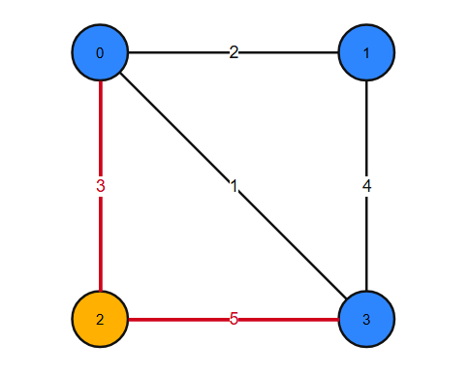
Figure 8 -Previous example
S = {0, 1, 3} (blue) T = {2} (orange)
Crossing edges: (0,2) w=3, (2,3) w=5 ⇒ Cut weight = 8
The brute force algorithm repeats this for all masks and picks the minimum cut weight.

8.4.4 Time and space complexity
Time complexity:
There are $2^{\left(n-1\right)}$ assignments for vertices $1..n-1$. We skip one invalid assignment (mask = 0), but this does not change asymptotic complexity. For each assignment, we compute the cut weight by scanning all m edges, which costs $O\left(m\right)$ time.
Therefore total time is:
- $O\left(2^{\left(n-1\right)}*m\right) = O\left(2^{n}*m\right)$.
Space complexity:
- Storing the graph: $O\left(n+m\right)$ (adjacency list) or $O\left(m\right)$ (edge list).
- Storing partitions: $O\left(n\right)$.
Overall$: O\left(n+m\right)$ space (dominated by graph storage).

8.5 Iterative Improvement
Iterative improvement (also called local search) is a general technique for optimization problems. The method starts from a feasible solution and repeatedly applies a small modification (a “local move”) that improves the objective value. The algorithm stops when no improving local move can be found; at that point, the solution is a local optimum with respect to the chosen neighborhood structure. This local optimum is not necessarily a global optimum.
In this minimum cut problem, a feasible solution is any valid cut (S, T) where neither side is empty. A natural “small change” is to move a single vertex from one side of the cut to the other (i.e., flip its side assignment). This produces a neighboring cut.

8.5.1 Solution representation
We represent a cut using an array:
- side[v] in {0, 1} for each vertex v
  - side[v] = 0 means vertex v is in set S
  - side[v] = 1 means vertex v is in set T
Given side[], the cut weight is computed as:
$$W=\sum_{\{u,v\}∈E, side\left[u\right]≠side\left[v\right]}{w\left(u,v\right)}$$
This is the same objective as in brute force, but now we attempt to reduce W using local moves instead of enumerating all cuts.

8.5.2 Neighborhood structure
Neighborhood definition: A neighboring solution is obtained by selecting one vertex v and flipping it:
- side[v] = 1 - side[v]
Validity constraint: The cut must remain nontrivial, i.e., both sides must stay nonempty after the flip. Therefore, we reject any flip that would make all vertices belong to S or all vertices belong to T. (In implementation, we track countS and countT to enforce this.)

8.5.3 Delta for flipping one vertex
To perform local improvement efficiently, we need to compute how the cut weight changes if we flip a vertex v.
Let Delta(v) be the change in cut weight when v is flipped:
- New weight W_new = W + Delta(v)
For each neighbor u of v:
- If u is currently on the same side as v, then edge (v,u) is currently NOT crossing; after flipping v, it WILL cross, increasing the cut by +w(v,u).
- If u is currently on a different side than v, then edge (v,u) is currently crossing; after flipping v, it will become internal, decreasing the cut by -w(v,u).
So:
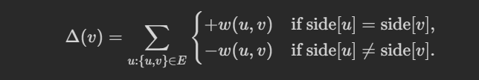
A flip is improving if it decreases the cut weight, i.e., if:
$$Δ\left(v\right)<0$$
This delta-based computation is a standard local search technique: evaluate the objective change of a local move without recomputing the full objective from scratch.

8.5.4 Best-Improvement strategy
In each iteration, there may be many vertices whose flip reduces the cut weight. We use the best-improvement strategy (also called steepest descent):
- Compute $Δ\left(v\right)$ for every vertex v (that can be flipped without violating nonempty sides).
- Select the vertex v* with the smallest delta (most negative).
- If $Δ\left(v*\right)$< 0, flip v* and update the current solution.
- Otherwise, stop (local optimum reached).
Best-improvement tends to use fewer iterations than first-improvement, but each iteration does more work because it evaluates all possible moves.

8.5.5 Multi-Start strategy
A single local search run can get stuck in a poor local minimum depending on the starting cut. To improve solution quality, we use multi-start local search:
- Repeat local search from R different random initial cuts.
- Return the best cut found among all runs.
This is a standard way to mitigate local optima issues in heuristic optimization.

8.5.6 Step-by-Step methodology (Iterative Improvement + Multi-Start)
For a chosen number of restarts R:
For each restart r = 1..R:
- Generate a random initial valid cut side[] (ensure both sides nonempty).
- Compute the initial cut weight W.
- Repeat:
  - For each vertex v, compute $Δ\left(v\right)$ (skip invalid flips that empty a side).
  - Choose the best improving vertex v* with minimum delta.
  - If $Δ\left(v*\right)$ < 0, flip v* and update W.
  - Else stop.
- Save the final solution of this restart.
- Keep the best solution across all restarts.
Output: the best cut found, its weight, and diagnostic statistics such as number of iterations per restart and total restarts.

8.5.7 Iterative Improvement pseudocode
Algorithm 2: LocalImprovementMinCut(G, R)
- Input: weighted undirected graph with n vertices and adjacency list adj, number of restarts R
- Output: best cut found (approximate) and its weight
- LocalImprovementMinCut(n, adj, R, seed):
- rng = Random(seed)
- bestWeight = +infinity
- bestSide[0..n-1] = all 0

- for restart from 1 to R:
- side = RandomInitialCut(n, rng) // ensure both sides nonempty
- countS = number of vertices with side[v] = 0
- countT = n - countS

- W = CutWeight(side, edges) // compute initial weight O(m)

- improved = true
- while improved:
- improved = false
- bestDelta = 0
- bestV = -1

- for v from 0 to n-1:
- // Do not allow flips that make one side empty
- if side[v] == 0 and countS == 1: continue
- if side[v] == 1 and countT == 1: continue

- delta = 0
- for each (u, w_uv) in adj[v]:
- if side[u] == side[v]:
- delta = delta + w_uv
- else:
- delta = delta - w_uv

- if delta < bestDelta:
- bestDelta = delta
- bestV = v

- if bestV != -1: // we found an improving move
- // apply the flip
- if side[bestV] == 0: countS--; countT++
- else: countT--; countS++
- side[bestV] = 1 - side[bestV]
- W = W + bestDelta
- improved = true

- if W < bestWeight:
- bestWeight = W
- bestSide = side

- return bestWeight, PartitionFrom(bestSide)

8.5.8 Worked example
We use the same 4-vertex graph from Section 8.4:
Edges:
- (0,1,2)
- (0,2,3)
- (0,3,1)
- (1,3,4)
- (2,3,5)
Suppose we start with the random cut:
- S = {0,2}
- T = {1,3}
Compute crossing edges:
- (0,1) crosses: +2
- (0,3) crosses: +1
- (2,3) crosses: +5 Total W = 8.
Now consider flipping vertex 2 from S to T.
- Before flip, 2 is in S; after flip, 2 moves to T.
Edges incident to 2:
- (0,2,3): currently crossing (0 in S, 2 in S? actually 0 in S, 2 in S -> internal), after flip it becomes crossing -> +3
- (2,3,5): currently crossing (2 in S, 3 in T), after flip becomes internal -> -5
So Delta(2) = +3 - 5 = -2, which is improving. New weight: W_new = 8 + (-2) = 6.
After the flip:
- S = {0}
- T = {1,2,3} New crossing edges:
- (0,1) +2
- (0,2) +3
- (0,3) +1 Total = 6.
If no further single-vertex flip reduces the cut weight, local search stops here, returning cut weight 6.
This illustrates how local improvement can reduce the cut weight step-by-step, but it may stop at a local optimum depending on the neighborhood definition and initial cut.

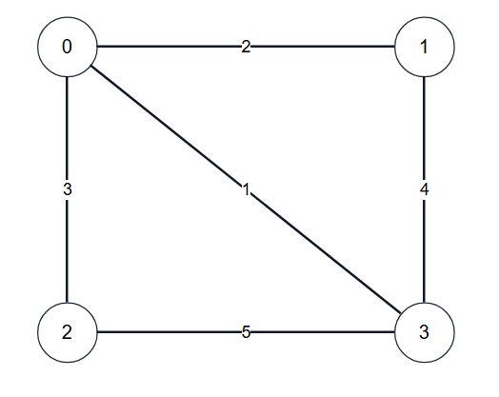
Figure 9 - Weighted Graph for this example

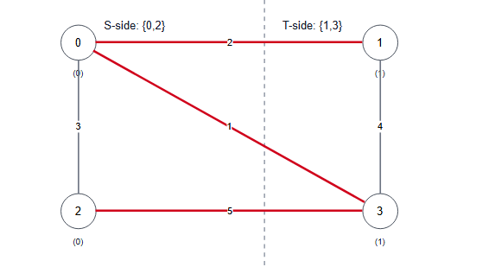
Figure 10 - Initial partition and its cut weight computed from crossing edges.
Crossing edges (X):
(0,1)=2
(0,3)=1
(2,3)=5
Cut weight W = 2 + 1 + 5 = 8
Non-crossing edges (·):
(0,2)=3
(1,3)=4

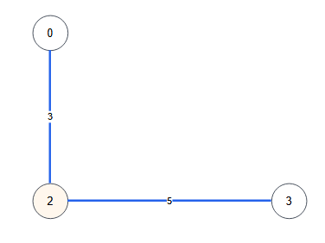
Figure 11 - Delta calculation for flipping one vertex using only incident edges.

Before flip: side[2] = S
After flip: side[2] = T
(0,2) = 3
Before: 0 in S and 2 in S ⇒ NOT crossing
After : 0 in S and 2 in T ⇒ crossing
Contribution to Δ(2): +3
(2,3) = 5
Before: 2 in S and 3 in T ⇒ crossing
After : 2 in T and 3 in T ⇒ NOT crossing
Contribution to Δ(2): -5
Δ(2) = +3 + (-5) = -2
W_{new} = W + Δ(2) = 8 + (-2) = 6
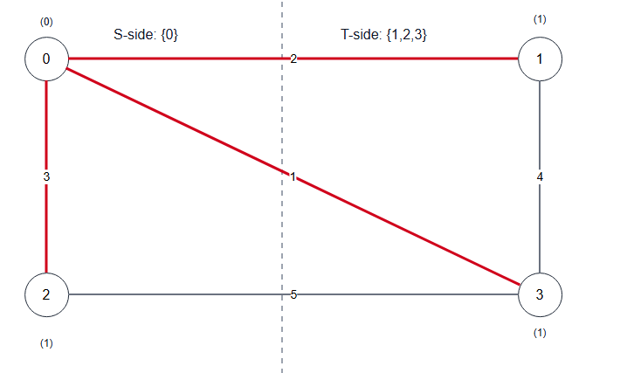
Figure 12 -Partition after one improving move, resulting in a smaller cut weight.
Crossing edges (X):
(0,1)=2
(0,2)=3
(0,3)=1
Cut weight W = 2 + 3 + 1 = 6
Non-crossing edges (·):
(1,3)=4
(2,3)=5

8.5.9 Notes on limitations
Iterative improvement with single-vertex flips guarantees that the cut weight decreases in each improving step, so it must eventually terminate. However, termination only guarantees a solution that is locally optimal with respect to the chosen neighborhood (single-vertex flips). A better cut may exist that requires moving multiple vertices simultaneously, which single-vertex local search cannot reach without allowing non-improving moves or restarts.

8.5.10 Time and space complexity
Time Complexity
In one local-search iteration, the algorithm considers flipping each vertex v (when flipping does not make one side empty). For each candidate vertex v, it computes Delta(v) by scanning all neighbors of v, which costs $O\left(deg\left(v\right)\right)$.
When this is done for all vertices in the same iteration, the total work is: sum of deg(v) over all vertices = 2m in an undirected graph.
So, the time per iteration is:
- $O\left(m\right)$
Let I be the number of improving flips (iterations) performed until the algorithm stops (reaches a local optimum) in one restart. Then the runtime for one restart is: $O\left(I*m\right)$
If we run the algorithm for R restarts, the total time becomes: $O\left(R*I_{a}vg*m\right)$, where I_avg is the average number of iterations per restart.
Space Complexity
The algorithm stores:
- the graph (adjacency list and/or edge list): $O\left(n+m\right)$
- the current cut assignment side[]: $O\left(n\right)$
- a few counters and variables: $O\left(1\right)$
Therefore, the total space complexity is:
- $O\left(n+m\right)$

8.6 Implementation details

8.6.1 Implementation overview
This section describes how the two required techniques are implemented in C++:
- Brute Force (Exact): Enumerates all cuts by iterating over bitmasks representing membership of vertices in set T (with vertex 0 fixed in S to avoid duplicate cuts). For each mask, the cut weight is computed by scanning all edges.
- Iterative Improvement (Approximate): Uses multi-start local search. Each restart begins with a random valid cut, then repeatedly applies the best-improving single-vertex flip until no improvement exists. The best final cut across all restarts is returned.
This design follows standard local-search methodology and directly reflects the iterative improvement paradigm: start from a feasible solution, improve locally, and stop when no local improvement can be found.

8.6.2 Data structures
To support both algorithms efficiently and clearly, we store the graph in two forms:
- Edge list edges for brute force cut weight evaluation:
  - Edge { int u, v; long long w; }
- Adjacency list adj for local improvement delta computations:
  - adj[v] contains pairs (neighbor, weight)
We use long long for weights and cut sums to reduce overflow risk when weights are integers and sums become large.
Note: If the input contains duplicate edges (u, v) multiple times, the implementation can either:
- accept them as parallel edges (still valid; they simply add to the cut weight), or
- optionally merge them by summing weights (not required for correctness).
For simplicity and correctness, we accept parallel edges as-is; this matches the mathematical model where each edge contributes to the cut weight independently.

8.6.3 Helper functions
The implementation is organized around these helper operations:
- computeCutWeight(side)
Returns total cut weight given side[v] in {0,1}.
- partitionFromSide(side)
Builds explicit vertex lists S and T for printing.
- randomInitialCut(n, rng)
Generates a random cut with both sides nonempty.
- localImproveOnce(side)
Runs the best-improvement loop until a local optimum is reached; returns the final weight and side array.
- multiStartLocalSearch(R)
Runs R restarts and keeps the best result.
This modular structure improves clarity and helps satisfy the report requirement for step-by-step methodology.

8.6.4 Implementation code
#include <bits/stdc++.h>
using namespace std;

struct Edge {
int u, v;
long long w;
};

struct Result {
long long weight = (1LL<<62);
vector<int> side; // 0 => S, 1 => T
long long iterations = 0; // local search iterations (moves)
int restarts = 0;
};

static long long computeCutWeight(const vector<int>& side, const vector<Edge>& edges) {
long long W = 0;
for (const auto& e : edges) {
if (side[e.u] != side[e.v]) W += e.w;
}
return W;
}

static pair<vector<int>, vector<int>> partitionFromSide(const vector<int>& side) {
vector<int> S, T;
for (int v = 0; v < (int)side.size(); v++) {
if (side[v] == 0) S.push_back(v);
else T.push_back(v);
}
return {S, T};
}

static vector<int> randomInitialCut(int n, mt19937_64& rng) {
// Ensure both sides are nonempty.
// Simple approach: assign random sides, then fix if all ended up same.
vector<int> side(n, 0);
uniform_int_distribution<int> bit(0, 1);

while (true) {
int countT = 0;
for (int v = 0; v < n; v++) {
side[v] = bit(rng);
countT += side[v];
}
if (countT != 0 && countT != n) break;
}
return side;
}

static Result localImproveBestFlip(
const vector<vector<pair<int,long long>>>& adj,
const vector<Edge>& edges,
vector<int> sideInit
) {
int n = (int)sideInit.size();
vector<int> side = std::move(sideInit);

int countT = 0;
for (int v = 0; v < n; v++) countT += side[v];
int countS = n - countT;

long long W = computeCutWeight(side, edges);

long long iterations = 0;

while (true) {
long long bestDelta = 0; // we need delta < 0 to improve
int bestV = -1;

for (int v = 0; v < n; v++) {
// enforce nonempty sides after flip
if (side[v] == 0 && countS == 1) continue; // would empty S
if (side[v] == 1 && countT == 1) continue; // would empty T

long long delta = 0;
for (auto [u, w_uv] : adj[v]) {
if (side[u] == side[v]) delta += w_uv;
else delta -= w_uv;
}

if (delta < bestDelta) {
bestDelta = delta;
bestV = v;
}
}

if (bestV == -1) break; // no improving move

// apply the best move
if (side[bestV] == 0) { countS--; countT++; }
else { countT--; countS++; }

side[bestV] = 1 - side[bestV];
W += bestDelta;
iterations++;
}

Result res;
res.weight = W;
res.side = std::move(side);
res.iterations = iterations;
return res;
}

static Result multiStartLocalImprovement(
const vector<vector<pair<int,long long>>>& adj,
const vector<Edge>& edges,
int R,
unsigned long long seed
) {
int n = (int)adj.size();
mt19937_64 rng(seed);

Result best;
best.weight = (1LL<<62);
best.restarts = R;

for (int r = 1; r <= R; r++) {
vector<int> init = randomInitialCut(n, rng);
Result cur = localImproveBestFlip(adj, edges, init);
if (cur.weight < best.weight) best = cur;
best.iterations += cur.iterations; // total iterations across restarts (for reporting)
}
return best;
}

static Result bruteForceMinCut(int n, const vector<Edge>& edges) {
// Brute force enumerates subsets of vertices 1..n-1.
// side[0]=0 is fixed in S.
// side[v]=1 means vertex v is in T.
Result best;
best.weight = (1LL<<62);
best.side.assign(n, 0);

if (n <= 1) {
// No valid nontrivial cut exists; keep default.
best.weight = 0;
return best;
}

long long totalMasks = 1LL << (n - 1); // works for n-1 <= 62; brute force is anyway small-n
vector<int> side(n, 0);
side[0] = 0;

for (long long mask = 0; mask < totalMasks; mask++) {
if (mask == 0) continue; // would make T empty

for (int v = 1; v < n; v++) {
side[v] = (int)((mask >> (v - 1)) & 1LL);
}

long long W = computeCutWeight(side, edges);
if (W < best.weight) {
best.weight = W;
best.side = side;
}
}
return best;
}

int main() {
ios::sync_with_stdio(false);
cin.tie(nullptr);

int n, m;
cin >> n >> m;

vector<Edge> edges;
edges.reserve(m);

vector<vector<pair<int,long long>>> adj(n);

for (int i = 0; i < m; i++) {
int u, v;
long long w;
cin >> u >> v >> w;
edges.push_back({u, v, w});
adj[u].push_back({v, w});
adj[v].push_back({u, w});
}

// Parameters (can be adjusted for experiments)
int R = 50; // number of restarts for local improvement
unsigned long long seed = 123456789ULL;

// Run approximate method
Result approx = multiStartLocalImprovement(adj, edges, R, seed);

cout << "=== Iterative Improvement (Approx) ===\n";
cout << "Best cut weight = " << approx.weight << "\n";
auto [S1, T1] = partitionFromSide(approx.side);
cout << "S: ";
for (int v : S1) cout << v << " ";
cout << "\nT: ";
for (int v : T1) cout << v << " ";
cout << "\nTotal local moves (across restarts) = " << approx.iterations << "\n";
cout << "Restarts = " << approx.restarts << "\n\n";

// Run exact brute force only for small n
if (n <= 25) {
Result exact = bruteForceMinCut(n, edges);
cout << "=== Brute Force (Exact) ===\n";
cout << "Minimum cut weight = " << exact.weight << "\n";
auto [S2, T2] = partitionFromSide(exact.side);
cout << "S: ";
for (int v : S2) cout << v << " ";
cout << "\nT: ";
for (int v : T2) cout << v << " ";
cout << "\n";
} else {
cout << "=== Brute Force (Exact) ===\n";
cout << "Skipped (n too large for brute force enumeration).\n";
}

return 0;
}

8.6.5 Notes
- Correctness of brute force: It checks all valid cuts (with vertex 0 fixed to remove symmetry), so it always finds the global minimum cut for small enough n.
- Correctness of iterative improvement termination: The local search accepts only strictly improving moves (Delta < 0), so the cut weight decreases each iteration. Since there are finitely many cuts, the algorithm must terminate. The final cut is a local minimum with respect to single-vertex flips, not necessarily the global minimum.
- Randomness and reproducibility: Using a fixed seed produces reproducible runs. Changing the seed can yield different solutions; multi-start improves the chance of finding a near-optimal cut.

8.7 Comparative evaluation

8.7.1 Evaluation criteria
Solution quality:
For a given graph:
- Let W_opt be the minimum cut weight found by brute force (exact).
- Let W_approx be the cut weight found by iterative improvement (approx).
We compare:
- Absolute gap: W_approx - W_opt
- Approximation ratio (empirical): W_approx / W_opt (only when W_opt > 0)
A ratio of 1.0 means the heuristic matched the exact optimum on that instance.
Computational cost:
We compare:
- Whether brute force is feasible (it grows exponentially with n)
- Number of local search moves (iterations) and restarts
- Runtime (optional but recommended if you can measure it consistently)
Because brute force has exponential time complexity, it is expected to become impractical even for moderate n, while iterative improvement should remain usable for much larger graphs.

8.7.2 Experimental setup
To make the evaluation meaningful , we use multiple categories of graphs:
- Small graphs (n <= 25):
Brute force is run, so we can directly compare W_approx against W_opt.
- Larger graphs (n > 25):
Brute force is skipped. We evaluate the heuristic using:
  - best weight found across restarts
  - variability across different runs (optional: different seeds)
  - runtime / iteration counts
Parameters used:
The iterative improvement algorithm depends on:
- R: number of restarts
- seed: random seed
In the provided implementation, R is set to 50 and a fixed seed is used for reproducibility. (For deeper evaluation, R can be varied such as 10, 50, 100 to show the trade-off between runtime and quality.)

8.7.3 Comparative results on sample graphs
This subsection reports the results you obtained from three representative test cases. These examples demonstrate both correctness (weights match the computed cut) and how the heuristic compares to the exact optimum on small graphs.
Table 1. Comparison of iterative improvement vs brute force on sample inputs.
Case | n | m | W_approx | W_opt | Gap (W_approx-W_opt) | Ratio (W_approx/W_opt)
1 | 4 | 5 | 6 | 6 | 0 | 1.00
2 | 2 | 1 | 7 | 7 | 0 | 1.00
3 | 6 | 7 | 1 | 1 | 0 | 1.00

Discussion:
- In all three sample cases, the iterative improvement method found a cut with the same weight as the brute-force optimum (ratio = 1.00).
- Note that the partition returned by the heuristic may differ from the exact solver even when the weights match, because minimum cuts are not always unique.

8.7.4 Interpretation and scalability discussion
Brute force is valuable as:
- an exact solver for very small graphs,
- a verification tool to confirm correctness of the heuristic implementation,
- a baseline for measuring the heuristic’s empirical approximation quality.
However, due to exponential growth in the number of cuts, brute force becomes impractical as n increases.
Iterative improvement evaluates local changes and usually converges in a relatively small number of iterations compared to enumerating all cuts. With multi-start, it often produces near-optimal cuts in practice, but it has no guarantee to always find the global minimum cut.

8.8 Alternative approaches

8.8.1 Exact Global Minimum Cut in Undirected Graphs (Stoer–Wagner)
For undirected weighted graphs, the Stoer-Wagner algorithm finds the global minimum cut exactly in polynomial time. This is important because it shows that, under the assumptions used in this report (undirected graph, global min cut), there exists an exact method that is dramatically faster than brute force enumeration and does not suffer from local optimum issues like iterative improvement.
In practice, Stoer-Wagner repeatedly performs a “minimum cut phase” that grows a set of vertices using maximum adjacency weights, producing a cut candidate at the end of each phase, and then contracting vertices to reduce the problem size. The minimum over all phases is the global minimum cut. While the internal details are not implemented in this project, the main takeaway is that it provides an exact solution with much better scalability than brute force.

8.8.2 Exact s–t Minimum Cut via Maximum Flow (Max-Flow Min-Cut)
If a problem instance specifies two special vertices s (source) and t (sink), then the task becomes the s–t minimum cut problem. In that case, the minimum cut can be solved exactly by computing a maximum flow, due to the max-flow min-cut theorem. This approach is widely used in network design, routing, and many optimization applications.
Several polynomial-time max-flow algorithms exist (e.g., Edmonds–Karp, Dinic, and push–relabel). Their performance depends on the graph size and density, but they are typically efficient on large inputs compared to brute force. Max-flow is an important alternative to mention because it is a standard exact method for cut problems when the cut is defined with respect to specific terminals.

8.8.3 Randomized Algorithms for Min Cut (Alternative Exact/Probabilistic Perspective)
Another direction is randomized algorithms. For undirected graphs, contraction-based randomized algorithms can find a global minimum cut with some probability, and repeating the algorithm increases the success probability. These methods can be attractive when:
- a fast algorithm is needed,
- some probability of failure is acceptable, or
- the algorithm is repeated enough times to make failure extremely unlikely.
This perspective is different from local improvement: instead of improving a single solution, randomized methods sample the solution space through random contractions.

8.8.4 Stronger Heuristics than Basic Local Improvement (Escaping Local Minima)
The iterative improvement implemented in this project uses strict descent (only accept moves that reduce the cut weight). A known limitation of strict descent local search is that it can become trapped in a poor local optimum. Multi-start partially mitigates this, but other heuristic frameworks can further improve solution quality:
- Simulated annealing: occasionally accepts worse moves early to escape local minima, then becomes more selective later.
- Tabu search: uses short-term memory (tabu list) to avoid cycling and to encourage exploration.
- Genetic algorithms: maintain a population of cuts and combine them to create new candidate solutions.
These techniques typically require parameter tuning and more complex implementation, but they can outperform basic local improvement on difficult instances where local minima are common.

8.9 Sample input and output
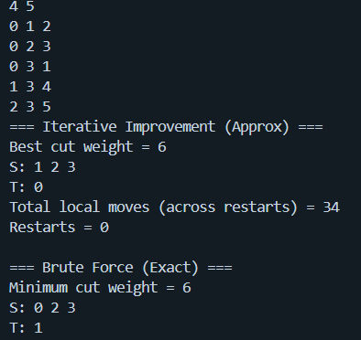
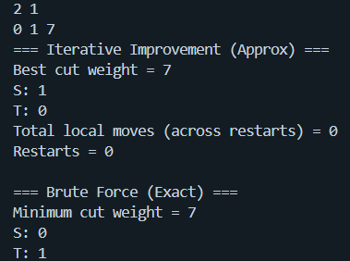
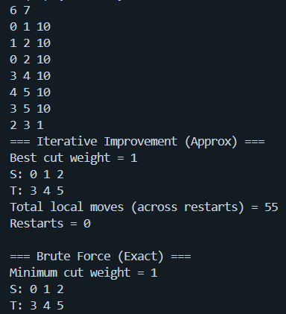

9. Cluster Points into Clusters

9.1 Problem description
Cluster points into k clusters. Use iterative improvement, divide-and-conquer, and Brute Force to solve this problem.
Clustering is a fundamental task in data mining and unsupervised learning, focused on partitioning a set of objects into groups, or clusters, such that objects within the same group are more like each other than to those in other groups. This section explores the implementation and performance of three distinct algorithmic paradigms: Divide and Conquer (Agglomerative), Brute Force (Exhaustive Search), and Iterative Improvement (K-Means).

9.2 Assumptions
- Points are 2D with x- and y-coordinates.
- Euclidean distance: similarity between points and clusters is measured using Euclidean distance.
- Fixed cluster distance metric: the distance between two clusters is defined as the distance between their centroids.
- Centroid-based clustering: each cluster is represented by its centroid.
- Clustering Bias: points are assigned to clusters based on the minimum distance to a cluster’s centroid.
- Convergence criterion: In iterative improvement, convergence is declared when all new centroids in an iteration are exactly equal to the previous one.
- Initial centroids are data points: For iterative improvement, initial centroids are randomly chosen from the given points, not generated arbitrarily in continuous space.
- Base case: defined as `k == 1` or `k >= number of points`, handled by returning either all points in one cluster or each point as its own cluster.
- Deterministic brute force: Brute force enumerates all distinct assignments.
- Divide‑and‑conquer order: points are split by index order (first half / second half).
- No ties in nearest centroid: in nearest‑centroid assignment, if a point is equidistant from two centroids, the code picks the first encountered centroid.
- No randomness control: Random shuffling for iterative improvement uses `random_shuffle` without seeding, so results may vary across runs.
- Single‑run output: each algorithm returns the first converged/optimal solution without multiple restarts to avoid local optima.

9.3 Methodology

9.3.1 Brute-Force
Step-by-Step description (pseudocode in English).
- Generate all possible combinations of clustering points into k clusters.
- Try each one using the points.
- Compute the score of each combination.
  - The score is the distance between each cluster’s centroid and the points inside of it for a given combination.
  - The best score is the minimum distance across all clusters.
- The combination with the best score is the optimal result.
- Print the best combination.

9.3.2 Divide and Conquer
- Divide the points two parts: left and right.
- For each part divide again until the number of points is equal to or less than the number of clusters (k).
- Then merge all the parts together.
  - Append the right clusters to the left clusters, generating 2k clusters.
  - While the number of clusters in the combined list is greater than k, repeatedly merge the two closest clusters.
  - For every pair of distinct clusters i and j, calculate the distance between them using the centroid distance method:
    - Compute the centroid (average point) of each cluster.
    - Calculate the Euclidean distance between these two centroids.
  - Find the closest pair and merge it by adding all points from the second cluster to the first cluster.
  - Remove the second cluster from the list.
  - Repeat until only k clusters remain.
- Return the merged clusters.
- At the end of the recursion cycle, the final clustering remains.

9.3.3 Iterative Improvement
- Create k clusters each containing a random point from the points list; thus, a cluster is never empty.
- Repeat until convergence:
  - Assign each point to its nearest cluster.
  - Find the mean point of these points, this will be the new centroid of the cluster (iterative improvement step).
  - If the new centroid is nearly equal to the old one, then convergence occur. If not, repeat.
- Return the final clusters.

9.4 Pseudocode

9.4.1 Helper Functions
function eachPointAsCluster(points):
clusters <- empty list
for each point in points:
clusters.append([point]) // singleton cluster
return clusters
function clusterDistance(clusterA, clusterB):
centroidA <- computeCentroid(clusterA)
centroidB <- computeCentroid(clusterB)
return distance(centroidA, centroidB)
function computeCentroid(cluster):
// The centroid is the mean point of all the points in a cluster
if cluster is empty:
return Point(0, 0)
sumX <- 0
sumY <- 0
for each point in cluster:
sumX <- sumX + point.x
sumY <- sumY + point.y
return Point(sumX / length(cluster), sumY / length(cluster))
function distance(pointA, pointB):
// Euclidean distance
dx = pointA.x - pointB.x
dy = pointA.y - pointB.y
return sqrt(dx*dx + dy*dy)
function isBaseCase(points, k):
return (k == 1) or (k >= length(points))

9.4.2 Brute-Force
function bruteForceClusters(points, k):
if k = 1:
return [points]
if length(points) <= k:
return eachPointAsCluster(points)

// Generate all valid partitions
allAssignments <- empty list
combination <- array (length(points))
generateAllCombinations(points, 0, combination, k, 0, allAssignments)

// Find assignment with minimum score
bestScore <- INFINITY
bestAssignment <- empty list

for each combination in allAssignments:
score <- calculatePartitionScore(points, combination, k)
if score < bestScore:
bestScore <- score
bestAssignment <- assignment

// Build clusters from best combination
clusters <- empty list
for i <- 0 to length(points)-1:
clusterId = bestAssignment[i]
clusters[clusterId].append(points[i])
return clusters
function generateAllCombinations(points, index, combination, k, usedClusters, allAssignments):
n <- length(points)
remaining <- n - index
neededClusters <- k - usedClusters

// Pruning: not enough remaining points to fill needed clusters
if remaining < neededClusters:
return
// Base case: all points assigned
if index = n:
if usedClusters = k: // only keep full cluster assignments
allAssignments.append(copy of combination)
return

// First point always goes to cluster 0 (to avoid symmetric duplicates)
if index = 0:
combination[index] <- 0
generateAllCombinations(points, index+1, combination, k, 1, allAssignments)
return

// Case 1: assign to an existing cluster
for cluster <- 0 to usedClusters-1:
combination[index] <- cluster
generateAllCombinations(points, index+1, combination, k, usedClusters, allAssignments)

// Case 2: assign to a new cluster (if available)
if usedClusters < k:
combination[index] <- usedClusters
generateAllCombinations(points, index+1, combination, k, usedClusters+1, allAssignments)
function calculatePartitionScore(points, combination, k):
// Output: sum of distances from each point to its cluster's centroid

// Build clusters from combination
clusters <- empty list
for i <- 0 to k-1:
clusters.append(empty list)

for i <- 0 to length(points)-1:
clusterId <- combination [i]
clusters[clusterId].append(points[i])

// Calculate total score
totalScore <- 0
for each cluster in clusters:
centroid <- computeCentroid(cluster)
for each point in cluster:
totalScore <- totalScore + distance(point, centroid)
return totalScore

9.4.3 Divide and Conquer
function divideAndConquerClusters(points, k):
if length(points) <= k:
return eachPointAsCluster(points)

// Divide
middle <- floor(length(points) / 2)
leftPoints <- points[0 .. middle-1]
rightPoints <- points[middle .. end-1]

// Conquer
leftClusters <- divideAndConquerClusters(leftPoints, k)
rightClusters <- divideAndConquerClusters(rightPoints, k)

// Combine
combined <- leftClusters + rightClusters // concatenate lists
return mergeClusters(combined, k)
function mergeClusters(clusters, targetCount):
// integer targetCount is k
while length(clusters) > targetCount:
// Find closest pair of clusters
minDistance <- INFINITY
firstIndex <- 0
secondIndex <- 1

for i <- 0 to length(clusters)-1:
for j <- i+1 to length(clusters)-1:
distance <- clusterDistance(clusters[i], clusters[j])
if distance < minDistance:
minDistance <- distance
firstIndex <- i
secondIndex <- j

// Merge the closest pair
for each point in clusters[secondIndex]:
clusters[firstIndex].append(point)
remove clusters[secondIndex] // Remove the second cluster
return clusters

9.4.4 Iterative Improvement
function iterativeImprovementClusters(points, k):
// Base cases
if k = 1:
return [points] // single cluster containing all points
if length(points) <= k:
return eachPointAsCluster(points)

// Initialize centroids with k random distinct points from the input
indices <- [0, 1, 2, ..., length(points)-1]
randomShuffle(indices) // generates random order

centroids <- empty list
for i <- 0 to k-1:
randomIndex <- indices[i]
centroids.append(points[randomIndex])

// Iterative improvement loop
while true:
// Assignment step: assign each point to nearest centroid
clusters <- assignPointsToNearestCluster(points, centroids)

// Update step: compute new centroids
newCentroids <- empty list
converged <- true
for i <- 0 to k-1:
newCentroid <- computeCentroid(clusters[i])
newCentroids.append(newCentroid)
if newCentroid != centroids[i]:
converged <- false
if converged:
return clusters
// Prepare for next iteration
centroids <- newCentroids

function assignPointsToNearestCluster(points, centroids):
clusters <- empty list
for i <- 0 to length(centroids)-1:
clusters.append(empty list)

for each point in points:
nearestIndex <- 0
minDistance <- distance(point, centroids[0])

for i <- 1 to length(centroids)-1:
dist <- distance(point, centroids[i])
if dist < minDistance:
minDistance <- dist
nearestIndex <- i

clusters[nearestIndex].append(point)

return clusters

9.5 Code implementation

9.5.1 Helper code
#pragma once
#include <bits/stdc++.h>
using namespace std;

class Point
{
private:
double x, y;
static constexpr double EPSILON = 1.0;

public:
Point(double x, double y) : x(x), y(y) {}

double getX() const { return x; }
double getY() const { return y; }

double distanceTo(const Point &other) const
{
double dx = x - other.x;
double dy = y - other.y;
return sqrt(dx * dx + dy * dy);
}

bool operator==(const Point &other) const
{
return abs(x - other.x) < EPSILON && abs(y - other.y) < EPSILON;
}

bool operator!=(const Point &other) const
{
return abs(x - other.x) >= EPSILON || abs(y - other.y) >= EPSILON;
}

void print() const
{
cout << "(" << x << ", " << y << "), ";
}
};

using Cluster = vector<Point>;

bool isBaseCase(const vector<Point> &points, int k)
{
return k == 1 || k >= (int)points.size();
}

vector<Cluster> eachPointAsCluster(const vector<Point> &points)
{
vector<Cluster> clusters;
for (const Point &p : points)
clusters.push_back({p});
return clusters;
}

Point computeCentroid(const vector<Point> &points)
{
double totalX = 0, totalY = 0;
for (const Point &p : points)
{
totalX += p.getX();
totalY += p.getY();
}
return Point(totalX / points.size(), totalY / points.size());
}

double clusterDistance(const Cluster &a, const Cluster &b)
{
Point centroidA = computeCentroid(a);
Point centroidB = computeCentroid(b);
return centroidA.distanceTo(centroidB);
}

void printClusters(const vector<Cluster> &clusters)
{
for (int i = 0; i < (int)clusters.size(); i++)
{
cout << " Cluster " << i + 1 << ": ";
for (const Point &p : clusters[i])
p.print();
cout << "\n";
}
}

9.5.2 Brute-Force
#include "ClustersHelper.hpp"
using namespace std;

// Using Stirling numbers of the second kind
void generateAllCombinations(
const vector<Point> &points,
int index,
vector<int> &combination,
int k,
int usedClusters,
vector<vector<int>> &allAssignments)
{
int n = points.size();

// Prune when not enough remaining points
int remaining = n - index;
int neededClusters = k - usedClusters;
if (remaining < neededClusters)
return;

// Return when all points assigned
if (index == n)
{
if (usedClusters == k) // Only assignments that have filled clusters
allAssignments.push_back(combination);

return;
}

// Always assign to cluster 0 to avoid symmetric duplicates
if (index == 0)
{
combination[index] = 0;
generateAllCombinations(points, index + 1, combination, k, 1, allAssignments);
return;
}

// Assign to existing clusters
for (int cluster = 0; cluster < usedClusters; cluster++)
{
combination[index] = cluster;
generateAllCombinations(points, index + 1, combination, k, usedClusters, allAssignments);
}

// Assign to new cluster if there are any
if (usedClusters < k)
{
combination[index] = usedClusters;
generateAllCombinations(points, index + 1, combination, k, usedClusters + 1, allAssignments);
}
}

// Score is evaluated as sum of distances to centroid
double calculatePartitionScore(const vector<Point> &points, const vector<int> &combination, int k)
{
vector<Cluster> clusters(k);
for (int i = 0; i < (int)points.size(); i++)
clusters[combination[i]].push_back(points[i]);

double totalScore = 0;
for (const Cluster &cluster : clusters)
{
Point centroid = computeCentroid(cluster);
for (const Point &point : cluster)
totalScore += point.distanceTo(centroid);
}
return totalScore;
}
vector<Cluster> bruteForceClusters(const vector<Point> &points, int k)
{
if (isBaseCase(points, k))
return k == 1 ? vector<Cluster>{points} : eachPointAsCluster(points);

vector<vector<int>> allPartitions;
vector<int> assignment(points.size(), 0);
generateAllCombinations(points, 0, assignment, k, 0, allPartitions);

double bestScore = INT_MAX; // minimum distance to centroid
vector<int> bestAssignment;
for (const vector<int> &partition : allPartitions)
{
double score = calculatePartitionScore(points, partition, k);
if (score >= bestScore)
continue;

bestScore = score;
bestAssignment = partition;
}

vector<Cluster> clusters(k);
for (int i = 0; i < points.size(); i++)
{
auto cluster = bestAssignment[i];
clusters[cluster].push_back(points[i]);
}

return clusters;
}

int main()
{
vector<Point> points = {
Point(1, 2), Point(3, 4), Point(5, 6),
Point(7, 8), Point(9, 10), Point(11, 12),
Point(13, 14), Point(15, 16), Point(17, 18), Point{19, 20}};

vector<int> testCases = {2, 3, 4, 5};
for (int test : testCases)
{
cout << "========== Brute Force Testing for " << test << " Clusters ==========\n";
printClusters(bruteForceClusters(points, test));
cout << "\n";
}
}

9.5.3 Divide and Conquer
#include "ClustersHelper.hpp"
using namespace std;

vector<Cluster> mergeClusters(vector<Cluster> clusters, int targetCount)
{
while ((int)clusters.size() > targetCount)
{
int firstIndex = 0, secondIndex = 1;
double minDistance = clusterDistance(clusters[0], clusters[1]);

for (int i = 0; i < (int)clusters.size(); i++)
{
for (int j = i + 1; j < (int)clusters.size(); j++)
{
double distance = clusterDistance(clusters[i], clusters[j]);
if (distance < minDistance)
{
minDistance = distance;
firstIndex = i;
secondIndex = j;
}
}
}

for (const Point &p : clusters[secondIndex])
clusters[firstIndex].push_back(p);
clusters.erase(clusters.begin() + secondIndex);
}
return clusters;
}

vector<Cluster> divideAndConquerClusters(const vector<Point> &points, int k)
{
if ((int)points.size() <= k)
return eachPointAsCluster(points);

int middle = points.size() / 2;
vector<Point> leftPoints(points.begin(), points.begin() + middle);
vector<Point> rightPoints(points.begin() + middle, points.end());

vector<Cluster> leftClusters = divideAndConquerClusters(leftPoints, k);
vector<Cluster> rightClusters = divideAndConquerClusters(rightPoints, k);
vector<Cluster> combined = leftClusters;
combined.insert(combined.end(), rightClusters.begin(), rightClusters.end());

return mergeClusters(combined, k);
}

9.5.4 Iterative Improvement
#include "ClustersHelper.hpp"
using namespace std;

vector<Cluster> assignPointsToNearestCluster(const vector<Point> &points, const vector<Point> &centroids)
{
vector<Cluster> clusters(centroids.size());
for (const Point &point : points)
{
int nearestIndex = 0;
double minDistance = point.distanceTo(centroids[0]);
for (int i = 1; i < (int)centroids.size(); i++)
{
double distance = point.distanceTo(centroids[i]);
if (distance < minDistance)
{
minDistance = distance;
nearestIndex = i;
}
}
clusters[nearestIndex].push_back(point);
}
return clusters;
}

vector<Cluster> iterativeImprovementClusters(const vector<Point> &points, int k)
{
if (isBaseCase(points, k))
return k == 1 ? vector<Cluster>{points} : eachPointAsCluster(points);

// Choose centroids from random points inside the points vector
vector<Point> centroids;
vector<int> pointsIndices(points.size());
iota(pointsIndices.begin(), pointsIndices.end(), 0);
random_shuffle(pointsIndices.begin(), pointsIndices.end());
for (int i = 0; i < k; i++){
int randomPoint = pointsIndices[i];
centroids.push_back(points[randomPoint]);
}

while (true)
{
vector<Cluster> clusters = assignPointsToNearestCluster(points, centroids);

vector<Point> newCentroids;
bool converged = true;
for (int i = 0; i < k; i++)
{
// compute the mean point of the points in a cluster
// this mean point is the new cluster centroid (iterative improvement step)
Point newCentroid = computeCentroid(clusters[i]);
if (newCentroid != centroids[i])
converged = false;

newCentroids.push_back(newCentroid);
}

if (converged)
return clusters;

centroids = newCentroids;
}
}

9.6 Test cases

9.6.1 Chosen test cases
Test Case for Brute Force (Only 10 Points due to its the super-exponential nature):
vector<Point> points = {
Point(1, 2), Point(3, 4), Point(5, 6),
Point(7, 8), Point(9, 10), Point(11, 12),
Point(13, 14), Point(15, 16), Point(17, 18), Point{19, 20}
};

Test Case for Iterative Improvement and Divide-and-Conquer:
vector<Point> points = {
Point(2, 3), Point(3, 2), Point(4, 5), Point(5, 4), Point(6, 3),
Point(1, 6), Point(7, 2), Point(3, 7), Point(4, 4), Point(5, 5),
Point(11, 12), Point(12, 11), Point(13, 14), Point(14, 13), Point(15, 12),
Point(10, 15), Point(16, 11), Point(12, 16), Point(13, 13), Point(14, 14),
Point(20, 21), Point(21, 20), Point(22, 23), Point(23, 22), Point(24, 21),
Point(20, 24), Point(25, 22), Point(22, 25), Point(23, 23), Point(24, 24)
};

9.6.2 Output
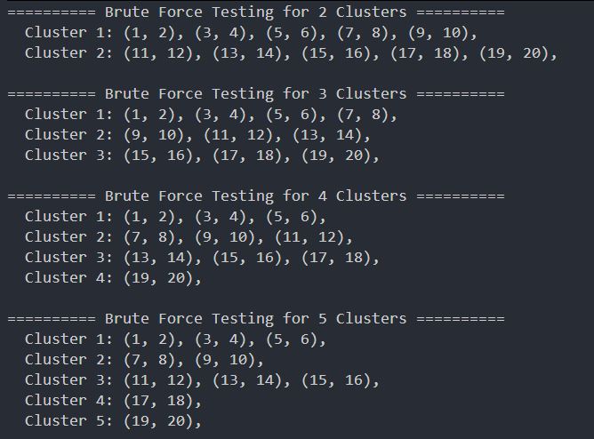
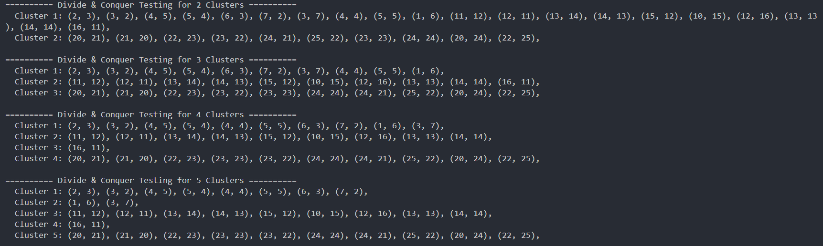

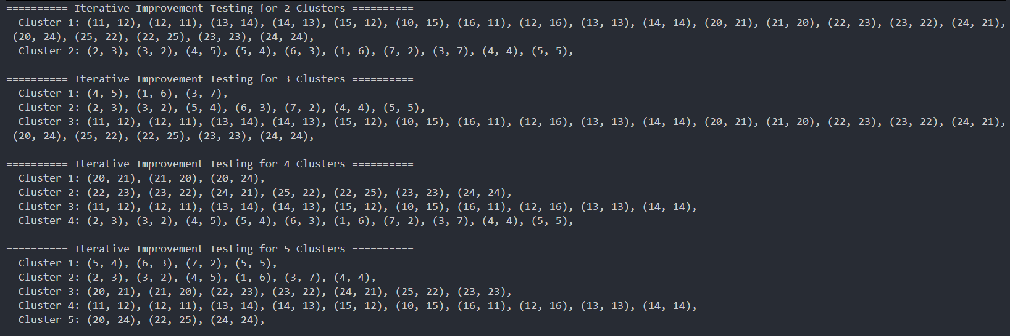
In the iterative improvement implementation, A significant drawback of selecting initial centroids randomly is the algorithm's extreme sensitivity to these starting positions, which often leads to local optima where the final clusters fail to represent the true underlying patterns of the data.
This randomness can cause "crowding," where multiple centroids begin in the same dense region, or "isolation," where a centroid is placed so far from data points that it becomes orphaned or produces suboptimal, unbalanced partitions.
Other methods to overcome these weaknesses:
- K-means++: is the industry-standard alternative; it initializes centroids by selecting points that are mathematically distant from one another, significantly improving the speed of convergence and the quality of the final clustering.
- Bradley-Fayyad-Reina (BFR) approach: which utilizes statistical summaries to handle very large datasets.
- The CURE algorithm, which uses multiple representative points instead of a single centroid to better accommodate clusters with non-spherical or irregular shapes.

9.7 Complexity analysis

9.7.1 Brute Force

9.7.1.1 Time complexity
The core of this code is generating every possible way to partition n points into k non-empty sets.
generateAllCombinations: This function generates partitions related to Stirling Numbers of the Second Kind.
- The number of ways to partition n elements into k non-empty subsets grows nearly exponentially.
- The exact number of iterations is roughly $O\left(\frac{k^{n}}{k!}\right)$, for which we can ignore the factorial term because the exponential is way higher.
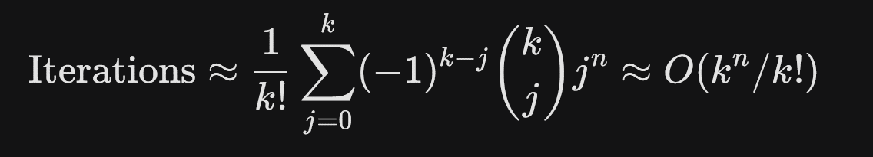
calculatePartitionScore: For every single partition generated, the code calculates a score:
- Iterate points: O(n) to assign points to clusters.
- Compute Centroids: O(n) total across all clusters.
- Calculation: O(n) to sum distances from points to centroids.
Total per partition: O(n).
Total Time Complexity:
In Big O notation, this is roughly $O\left(nk^{n}\right)$. This is why brute-forcing clusters is only feasible for very small datasets (usually n<15).

9.7.1.2 Space complexity
allPartitions Storage: Stores every valid assignment in a vector<vector<int>>.
Recursion Stack: The depth is O(n), which is negligible compared to the storage of the partitions.
Total Space: $O\left(nk^{n}\right)$.

9.7.2 Divide and Conquer

9.7.2.1 Time complexity
1. Complexity of mergeClusters
This function is the bottleneck. It repeatedly merges the two closest clusters until the count reaches targetCount.
Outer While Loop: Runs m−k times (where m is the initial number of clusters). In the merge step of the recursion, m=2k, so it runs roughly k times.
Nested For Loops: To find the minDistance, it compares every pair of clusters. If there are m clusters, this takes O(m2) comparisons.
Distance Calculation: clusterDistance calculates centroids. This depends on the number of points in the clusters, which can be up to N.
Vector Operations: clusters.erase() is O(m) because it shifts elements.
Complexity for one merge call: Since m is proportional to k during the recursion, this function behaves as $O\left(k^{3}+N\right)$.
2. Complexity of divideAndConquerClusters
Recurrence Relation:
$$T\left(N\right)=2T\left(\frac{N}{2}\right)+mergeClusters\left(2k,k\right)$$

Base Case: When N ≤ k, it returns N clusters (each point is its own cluster).
Recursive Work: The "Divide" step takes O(N) to copy points into leftPoints and rightPoints.
Combining Step: The mergeClusters function is called at every level of the tree.
- Overall Time Complexity
Because the mergeClusters step is applied at each level of the recursion and its complexity depends heavily on k (which is constant relative to N in most calls), the overall complexity is:
$$O\left(N\log{N}+\text{levels}×k^{3}\right)$$

However, if k is small, the $O\left(N\log{N}\right)$ dominates due to the slicing and copying of vectors at each level. If k is large, the $O\left(k^{3}\right)$ merges at each level become the primary cost.

9.7.2.2 Space complexity
The space complexity is dominated by the recursion stack and the creation of new vectors:
Stack Depth: O(logN) due to the halving of points.
Vector Storage: At each level, you are creating new vector<Point> objects. Since each point exists in only one branch of the tree at a time, the storage for points across one level is O(N).
Total Space: O(NlogN) in the worst case due to the way vectors are copied and passed in this specific C++ implementation. (Note: Passing by reference or using std::span could reduce this to O(N)).

9.7.3 Iterative Improvement

9.7.3.1 Time complexity
The time complexity is sensitive to the number of points (n), the number of clusters (k), and the number of iterations required to reach convergence (I).
A. Initialization
- Generating indices and shuffling: O(n) using random_shuffle (or std::shuffle).
- Selecting the first k points: O(k).
Total: O(n).
B. Assignment Phase (assignPointsToNearestCluster)
- For each of the n points, the algorithm calculates the distance to all k centroids.
Total per iteration: O(n⋅k).
C. Update Phase (computeCentroid)
- The algorithm iterates through all clusters and their constituent points to calculate the new mean.
- Since every point belongs to exactly one cluster, the total work across all clusters is O(n).
Total per iteration: O(n).
D. Overall Time Complexity
The total complexity is expressed as:
$$O\left(I×n×k\right)≈O\left(n^{3}\right)$$
- n: Number of points (30 in the example).
- k: Number of clusters.
- I: Number of iterations until convergence.

9.7.3.2 Space complexity
The algorithm is highly memory efficient as it does not need to store all possible combinations.
- Point Storage: The original points vector: O(n).
- Cluster Storage: The clusters vector (a partition of points): O(n).
- Centroid Storage: A small vector of k points: O(k).
Total Space: $O\left(n+k\right)≈O\left(n\right)$

9.8 Technique comparison
This section provides a comparative analysis of the three implemented clustering strategies: Divide & Conquer, Brute Force (Exhaustive), and Iterative Improvement (K-Means). Each approach offers distinct trade-offs between computational speed, memory usage, and result quality.

9.8.1 Comparative Summary Table
Feature | Divide & Conquer | Brute Force | Iterative Improvement
Time Complexity | $$O\left(N\log{N}+\text{levels}×k^{3}\right)$$ | O(n⋅kn) | O(I⋅n⋅k)
Space Complexity | O(NlogN) | O(n⋅kn) | O(n+k)
Optimality | Sub-optimal | Global Optimum | Local Optimum
Scalability | High | Very Low | Very High
Best Use Case | Small to medium datasets with hierarchical structures. | Establishing a "Gold Standard" for very small n (<15). | General purpose, large-scale data mining.

9.8.2 Deep dive analysis
The Brute Force approach is the only method guaranteed to find the absolute best clustering solution. However, due to its combinatorial nature (Stirling numbers of the second kind), the search space grows at a "super-exponential" rate, making it a theoretical tool rather than a practical one for real-world data.
K-Means is the most scalable of the three. By starting with k random centroids and refining them, it avoids the exponential search space. While it can get "stuck" in a local minimum (a solution that is better than its neighbors but not the best possible), its space requirement and fast convergence make it the industry standard for large datasets.
The Divide-and-Conquer approach provides a middle ground. By recursively breaking the problem into smaller subsets and merging them, it builds a "tree" of clusters. It is faster than Brute Force and provides more structural information than K-Means, but the repeated centroid recalculations and vector copying make it more memory-intensive than the iterative approach.

9.9 Alternative approaches
In addition to standard hierarchical and point assignment methods, several specialized algorithms address large datasets and non-standard cluster shapes.

9.9.1 BFR (Bradley-Fayyad-Reina) Algorithm
BFR is a variant of the k-means algorithm designed specifically for very large, disk-resident datasets.
- Assumptions: It assumes clusters are normally distributed around a centroid in Euclidean space, though standard deviations may vary across different dimensions.
- Data Processing: Data is processed one main-memory-load at a time, with points categorized into three classes:
  - Discard Set (DS): Points close enough to a cluster centroid to be summarized by simple statistics (N, SUM, and SUMSQ).
  - Compression Set (CS): Groups of points that are close to each other but not to any existing cluster centroid.
  - Retained Set (RS): Isolated points that cannot be summarized.
- Efficiency: Summarizing sets using N, SUM, and SUMSQ allows any number of points to be represented by 2d+1 values, where d is the number of dimensions.

9.9.2 CURE (Clustering Using REpresentatives) Algorithm
CURE addresses limitations in BFR and standard k-means, which often struggle with non-spherical cluster shapes or clusters at varying angles.
- Cluster Shape: Unlike centroid-based methods, CURE allows clusters to assume any shape in Euclidean space.
- Representative Points: Instead of a single centroid, each cluster is represented by a set of dispersed points moved approximately 20% toward the cluster's center.
- Process:
  - Pick a random sample of points for initial hierarchical clustering.
  - Select a sample of widely dispersed points for each resulting cluster.
  - Move these points toward the cluster centroid to create representatives.
  - Assign all remaining points in the dataset to the cluster with the nearest representative point.

9.10 Summary
- For Accuracy: Use Brute Force only for validation and testing on datasets where $n ≤15$.
- For Speed and Scale: Use Iterative Improvement for any dataset exceeding 50 points or for applications requiring real-time results.
- For Relationship Mapping: Use Divide & Conquer if the goal is to understand how smaller clusters naturally merge into larger ones (hierarchical relationships).

Coin Flipping

10.1 Problem description
Given a line of n coins. Each coin shows either Heads ‘H’ or Tails ‘T’ in an arbitrary order. The goal is to remove all coins using a sequence of moves. A move consists of:
- Choose a coin that is currently Heads-up.
- Remove that coin from the line.
- If the removed coin had an immediate neighbor on the left or right that is still present, flip that neighbor.
A gap is formed when a coin is removed. Neighbors are the coins immediately beside the removed coin, and you can’t flip past a gap. The puzzle’s goal is to remove all coins on the table and output the sequence of moves done to reach the goal or output impossible if there is no possible sequence.

10.2 Assumptions
- The input is a string consisting only of the characters 'H' and 'T', with length n ≥ 1.
- Coin indices are 1-based in the output, matching the natural counting from left to right.
- Flipping happens only on the immediate original neighbors that are still present
- If a neighbor does not exist (edge coins) or has already been removed, no flip occurs for that side.
- The program must output one valid sequence if one exists; if multiple sequences exist, any is acceptable.
- The program outputs “Impossible” if no sequence can empty the board.

10.3 Algorithm Design
Backtracking (Brute Force with pruning) is chosen as it tries every legal move sequence, undoing choices when a dead end is reached. This makes sure that if a solution exists it will be found.

10.3.1 Step-by-step Execution:
- Base Case: If coins_left == 0, all coins have been removed, success.
- Iterate: For every index i from 0 to n−1:
- Check if coin i is still on the board (! removed[i]) and shows 'H'.
- Make a move:
- Mark removed[i] = true, record the 1-based index i+1 in path.
- Flip the left neighbor i-1 if it exists and is still present.
- Flip the right neighbor i+1 if it exists and is still present.
- Recurse: Call solve with coins_left - 1. If it returns true it means a solution is found so it returns true to the previous call.
- Backtrack if failure:
- Undo the flips in the exact reverse order (right neighbor then left neighbor) to restore the state.
- Mark removed[i] = false and remove the index from path.
- After loop: If no 'H' coin is available and coins_left > 0, return false.

10.3.2 Pseudocode:
Algorithm: Coin Removal Backtracking

function Solve(board, removed, path, coins_left)
if coins_left = 0 then
return true // all coins successfully removed

for each position i from 1 to n (1-based) do
if coin i is still present and shows Heads then
// choose coin i as the next move
mark coin i as removed
add i to the end of path

if coin i has a left or right neighbor that is still present then
flip those neighbors over

// try to continue from the new state
if Solve (board, removed, path, coins_left – 1) then
return true

// undo the move (backtrack)
if coin i has a right neighbor that is still present then
Turn that neighbor over
if coin i has a left neighbor that is still present then
turn that neighbor over
mark coin i as present again
remove the last index from path

return false // no move possible from this state

function Main()
for each test_case in test_cases do
path = empty list
removed = array of false
if Solve(test_case, removed, path, length of test_case) then
print elements of path separated by spaces
else
print "Impossible"

10.3.3 Code Implementation:

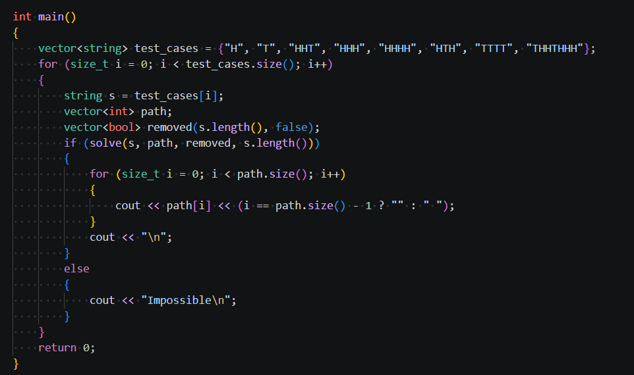
Figure 13 Main function

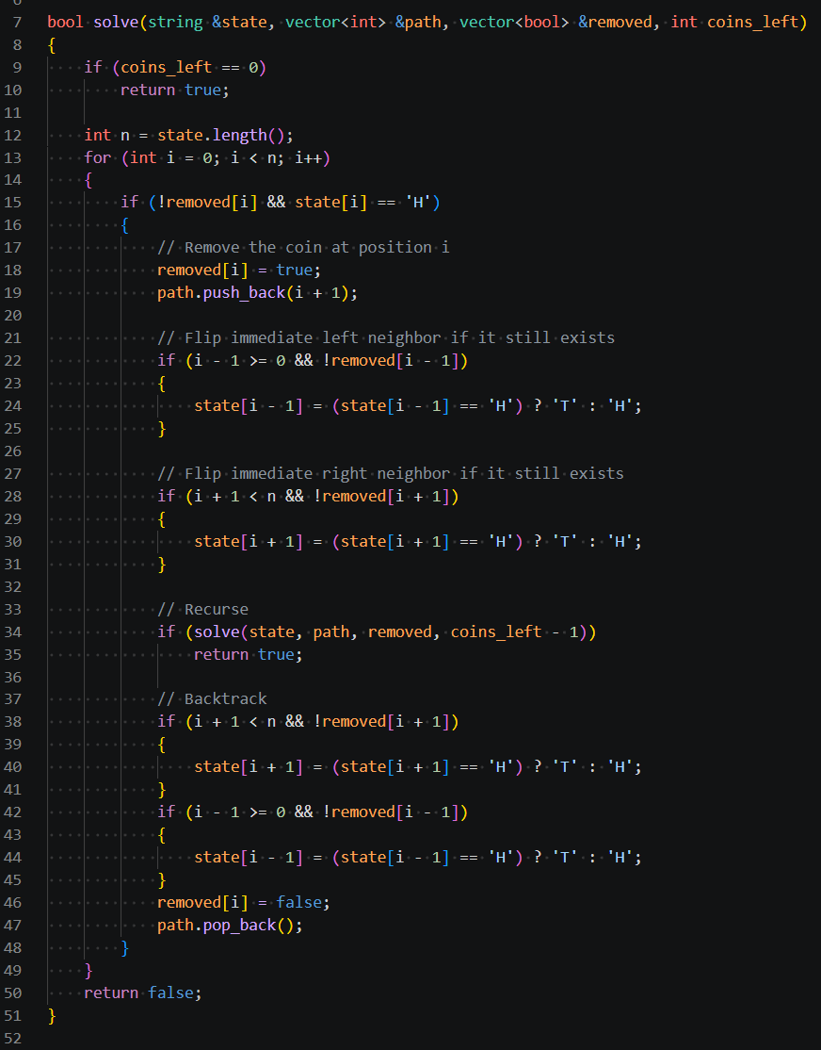
Figure 14 Backtracking function

10.4 Correctness and case coverage
Correctness:
Before removing coin i, the code verifies !removed[i] and state[i] == 'H'. Then flips its neighbors ‘i-1’ and ‘i+1’ but making sure that those positions are not empty or out of bounds first. The undo block re-flips the same two positions in the same conditional order, and since flipping is its own inverse, the state is restored exactly.
The algorithm iterates over every index from 0 to n-1 at each recursion level and attempts a move on every coin that is present and heads-up. A branch returns false only when the inner loop completes without finding any valid move while coins_left > 0. At that point no ‘H’ coin is present, which means no legal move exists in that state, so, no valid branch is ever skipped. If a solution exists anywhere in the search tree, the algorithm reaches it.
Each recursion level decrements coins_left by exactly one. The depth is therefore bounded by ‘n’, and at each level a finite loop runs. The algorithm always terminates.
Case Coverage:
Single coin (H/T): If it's ‘H’ it gets removed immediately with no neighbors to flip, done in one move. If it's ‘T’ the algorithm has nothing to work with and returns Impossible straight away.
All heads: Solvability depends on whether n is odd or even. When n is odd, a valid sequence always exists. When n is even, the puzzle is always Impossible. This parity rule arises because each removal flips one or two neighbors, and with an even-length all-heads line the flipping pattern always leaves at least one stranded T coin with no path to recovery.
All tails: Nothing to remove from the start. Returns Impossible without doing any work.

10.5 Complexity Analysis
Time Complexity:
In the worst case when the puzzle has no solution the code must try every sequence of heads-up removals. At the first call, there can be up to n heads, after we remove one, up to n-1 remain, and so on. That gives a search tree of size $O\left(n!\right)$. Fortunately, most configurations don’t stay that dense; many branches hit a dead end early because the board quickly turns all tails.
Space Complexity:
The recursion depth is at most n, because only one coin is removed per level. Each level only needs a few local variables plus our removed array and path list. So, the space usage is O(n).

10.6 Algorithms Comparative Analysis
Brute Force: A pure brute-force approach would generate all n! orderings of coins and simulate each one. This works but is wasteful as it explores sequences that contain moves on ‘T’ coins or already-removed coins, which are invalid and can be discarded immediately. The backtracking approach makes the search space bounded, and strict un-doing of local flips guarantees isolation between recursive states.
Greedy: A greedy approach picks one H coin at each step according to a fixed rule say, always the leftmost, or the one whose removal creates the newest ‘H’ coins. This runs in O(n²) and is simple to implement.
The problem is that greedy is not correct in general. Any greedy ordering gets stuck because every path leads to a configuration with no ‘H’ coins but coins remaining. The greedy method cannot backtrack, so it cannot discover this. Only exhaustive search reveals that the configuration is impossible.
Divide and Conquer: Removing a coin creates a gap that splits the remaining coins into two independent subgames because the new gap prevents any future flip from crossing it. The left and right halves do not interact at all, a valid sequence in one cannot invalidate a sequence in the other. However, the two sequences produced independently must then be merged in order into a single chronological ordering. Finding a correct merging across potentially many split points is highly complex and is what makes divide-and-conquer an impractical compared to backtracking.
Iterative Improvement: It starts with some solution and refines it. This problem has no natural notion of a partial or approximate solution.
Dynamic Programming: Could work in theory since states can be cached, but maintaining the sequence order across subproblems makes it more complex to implement than backtracking.
Table 1 Algorithmic Comparison.
Technique | Applicability | Advantages/Disadvantages
Brute Force  (full enumeration) | Generate all n! orderings and simulate each. | Simple to implement but so slow O(n!).
Backtracking | Explore moves, undo when stuck. | Always correct and far smaller search tree than naive enumeration but still worst-case exponential.
Greedy | Always pick a specific ‘H’  Like leftmost first | Very fast (O(n²)) but incorrect for many inputs because a wrong local choice can block the solution.
Divide & Conquer | Independent subgames are created after each removal, but merging the resulting sequences into one valid chronological ordering is complex | Correct in theory but harder to implement than backtracking.
Dynamic Programming | Use subproblem solvability on intervals with boundary conditions | Could reduce redundant work by caching already-explored states, avoiding re-exploration of the same configuration reached via different orderings. Still exponential in the worst case but significantly faster in practice, but sequence reconstruction across independent chunks is too complex
Iterative Improvement | Start with a solution and refine it. | there’s no way to take a partial solution and refine it.

Conclusion: Backtracking balances between correctness and implementation complexity for this task. The factorial worst-case time is acceptable for small n, and the algorithm is simple to understand, debug, and prove correct.

10.7 Sample outputs
Tests:
Figure 15 Test cases

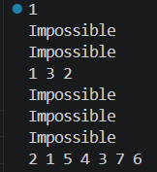
Output:

Figure 16 Console outputs
Explanation:

- “H”: Only one coin, heads-up, removed immediately. Sequence: 1.
- “T”: No heads-up coin, Impossible.
- “HHT”: Unsolvable. Removing coin 1 leaves - T T. Removing coin 2 leaves T - T
- “HHH”: Works; sequence 1 3 2 is printed.
- “HHHH”: Unsolvable. Removing coin 1 leaves - T H H. The only valid next move is coin 3, which leaves - T - T. starting with any other coin also gives only 'T' configurations. The algorithm exhausts all paths and returns Impossible.
- “HTH”: Unsolvable. Removing coin 1 leaves - H H. Removing coin 3 leaves H H -. Removing the middle coin 2 leaves T - T.
- “TTTT”: No head so it’s Impossible.
- “THHTHHH” Backtracking finds a valid removal sequence: 2 1 5 4 3 7 6
Steps:
  - Remove coin 2, flips 1 and 3, state: H - T T H H H
  - Remove coin 1, state: - - T H H H
  - Remove coin 5, flips 4 and 6, state: - - T H - T H
  - Remove coin 4, flips 3, state: - - H - - T H
  - Remove coin 3, state: - - - - - T H
  - Remove coin 7, flips 6, state: - - - - - H -
  - Remove coin 6, state: - - - - - - -

10.8 Approach downsides
The algorithm’s factorial worst-case complexity renders it impractical for large inputs. Because it lacks state memoization, the algorithm fails to recognize previously encountered board configurations reached via different move sequences. Consequently, it redundantly recomputes identical sub-problems, leading to exhaustive, inefficient searches, particularly in unsolvable cases where every possible sequence must be evaluated before termination.

10.9 Improvements
A Dynamic Programming approach could reduce the redundant work by caching the states that have already been explored. Since the full state of the coins at any point is which coins are still present and what face each one shows, it can be represented compactly and stored. If the algorithm reaches a state which has seen before and already determined unsolvable, it can skip it immediately instead of re-exploring it. This would not change the worst case in theory but in practice would cut out a significant amount of repeated work, especially on larger inputs where the number of possible orderings explodes quickly.

10.10 Conclusion
The backtracking implementation correctly finds a valid solution sequence when one exists. The main limitation is the factorial worst-case time, which becomes a real problem as n grows since impossible configurations force the algorithm to exhaust every possible branch before concluding. A Dynamic Programming approach could improve this by caching already explored states and avoiding redundant work, since the same board configuration can be reached through different removal orderings.

11. Research Conclusions
This research project has provided a rigorous exploration of ten diverse computational challenges, ranging from geometric puzzles like Tromino Tiling and Lattice Crossing to optimization problems such as Job Scheduling and Minimum Cut. By applying multiple algorithmic paradigms, including Divide-and-Conquer, Dynamic Programming, Greedy algorithms, Brute Force, and Iterative Improvement, this study has highlighted the critical trade-offs between computational optimality and practical scalability.
A recurring theme across all tasks is the limitation of Brute Force methods. While these approaches guarantee global optimality and serve as a "Gold Standard" for validating small-scale inputs, their exponential or factorial time complexity renders them impractical as problem sizes grow. This was notably observed in the Coin Flipping and Clustering tasks, where the lack of state memoization or the super-exponential growth of the search space led to computational stagnation.
In contrast, optimized paradigms provided more viable solutions:
- Divide-and-Conquer proved highly effective for problems with recursive geometric structures, such as the Tromino puzzle and the Moving Target hunt, offering systematic and efficient coverage of the search space.
- Dynamic Programming was essential for solving complex optimization problems like the Four-Peg Tower of Hanoi and Job Scheduling, demonstrating how storing subproblem results can drastically reduce redundant calculations.
- Iterative Improvement and Heuristics, such as K-Means for clustering and Multi-Start for Min Cut, emerged as the most scalable techniques for large-scale data. Although these methods may sometimes converge to local rather than global optima, their performance and memory efficiency make them the industry standard for real-world applications.
In conclusion, this project reinforces the principle that no single algorithm is universally superior. Successful software engineering requires a deep understanding of a problem’s constraints and the ability to select an approach that balances accuracy with resource efficiency. The analytical frameworks developed through these ten tasks serve as a foundation for applying principled algorithmic thinking to future computational challenges.

12. References
- Aarts, E., & Lenstra, J. K. (Eds.). (2003). Local search in combinatorial optimization. Princeton University Press.
- Ahuja, R. K., Magnanti, T. L., & Orlin, J. B. (1993). Network flows: Theory, algorithms, and applications. Prentice Hall.
- Applegate, D., Bixby, R., Chvátal, V., & Cook, W. (2006). The traveling salesman problem: A computational study. Princeton University Press.
- Arora, A. (2017). Analysis and design of algorithms (2nd ed.). Cognella Academic Publishing.
- Bellman, R. E. (1957). Dynamic programming. Princeton University Press.
- Bousch, T. (2014). La quatrieme tour de Hanoi. Bulletin of the Belgian Mathematical Society, 21(5), 895–912.
- Cormen, T. H., Leiserson, C. E., Rivest, R. L., & Stein, C. (2009). Introduction to algorithms (3rd ed.). MIT Press.
- Cormen, T. H., Leiserson, C. E., Rivest, R. L., & Stein, C. (2022). Introduction to algorithms (4th ed.). MIT Press.
- Dasgupta, S., Papadimitriou, C., & Vazirani, U. (2006). Algorithms. McGraw-Hill. https://people.eecs.berkeley.edu/~vazirani/algorithms/chap2.pdf
- de Berg, M., Cheong, O., van Kreveld, M., & Overmars, M. (2008). Computational geometry: Algorithms and applications (3rd ed.). Springer.
- Gardner, M. (1978). Aha! Insight. W. H. Freeman.
- GeeksforGeeks. (2024). Job sequencing problem. https://www.geeksforgeeks.org/job-sequencing-problem/
- GeeksforGeeks. (2026). Introduction to divide and conquer algorithm. https://www.geeksforgeeks.org/introduction-to-divide-and-conquer-algorithm/
- GeeksforGeeks. (n.d.). Dynamic programming or DP. Retrieved from https://www.geeksforgeeks.org/dsa/dynamic-programming/
- Golomb, S. W. (1954). Checker boards and polyominoes. American Mathematical Monthly, 61(10), 675–682.
- Golomb, S. W. (1994). Polyominoes: Puzzles, patterns, problems, and packings (2nd ed.). Princeton University Press.
- Iacono, A. (2017, October 7). Backtracking explained. Medium. https://medium.com/@andreaiacono/backtracking-explained-7450d6ef9e1a
- Knuth, D. E. (1997). The art of computer programming: Vol. 1. Fundamental algorithms (3rd ed.). Addison-Wesley.
- Korf, R. E. (1985). Depth-first iterative deepening: An optimal admissible tree search. Artificial Intelligence, 27(1), 97–109.
- Leskovec, J., & Rajaraman, A. (n.d.). Clustering algorithms [Lecture slides]. CS345a: Data Mining, Stanford University.
- Levitin, A. (2012). Introduction to the design and analysis of algorithms (3rd ed.). Pearson.
- Pearl, J. (1984). Heuristics: Intelligent search strategies for computer problem solving. Addison-Wesley.
- Pinedo, M. L. (2016). Scheduling: Theory, algorithms, and systems (5th ed.). Springer.
- Preparata, F. P., & Shamos, M. I. (1985). Computational geometry: An introduction. Springer.
- Russell, S., & Norvig, P. (2020). Artificial intelligence: A modern approach (4th ed.). Pearson.
- Sedgewick, R., & Wayne, K. (2011). Algorithms (4th ed.). Addison-Wesley.
- Skiena, S. S. (2008). The algorithm design manual (2nd ed.). Springer.
- Stewart, B. M. (1941). Solution to problem 3918. American Mathematical Monthly, 48(3), 217–219.
- Stoer, M., & Wagner, F. (1997). A simple min-cut algorithm. Journal of the ACM, 44(4), 585–591.
- Stroustrup, B. (2013). The C++ programming language (4th ed.). Addison-Wesley.
- Talbi, E.-G. (2009). Metaheuristics: From design to implementation. Wiley.
- Wikipedia contributors. (2026, April 30). Stirling numbers of the second kind. Wikipedia, The Free Encyclopedia. https://en.wikipedia.org/wiki/Stirling_numbers_of_the_second_kind
- Wikipedia contributors. (2026, May 4). Divide-and-conquer algorithm. Wikipedia, The Free Encyclopedia. https://en.wikipedia.org/wiki/Divide-and-conquer_algorithm
- Wikipedia contributors. (n.d.). Tromino. Wikipedia, The Free Encyclopedia. Retrieved May 4, 2026, from https://en.wikipedia.org/wiki/Tromino

